Expogràfica in Guadalajara – Finally Face to Face Again

After being postponed twice – first from 2020 to 2021 and then to 2022 due to the corona pandemic – Expogràfica finally took place this May.

The traditional fair, which lasted four days, occupied an area of 25,000 m² and was attended by more than 550 leading companies, attracted more than 20,000 people to Guadalajara, Mexico. Many of them also came to Muller Martini Mexico's 60 m² information stand. On two large screens, they not only saw presentations of the latest generation of machines, but were also able to discuss technology, workflow and service issues with Muller Martini specialists.

Hector Castro, Regional Director Latin America, drew an all-round positive conclusion from the exhibition: "In addition to Mexican customers, many company owners and important decision-makers from several other countries – Guatemala, El Salvador, Costa Rica, Colombia, Ecuador – also visited our stand. After working with many during two years mainly via Zoom, we were all happy to meet face to face again." According to Hector Castro, there were many interesting conversations with customers, "which not only provided important follow-up on existing projects, but also revealed other interesting business opportunities for Muller Martini."

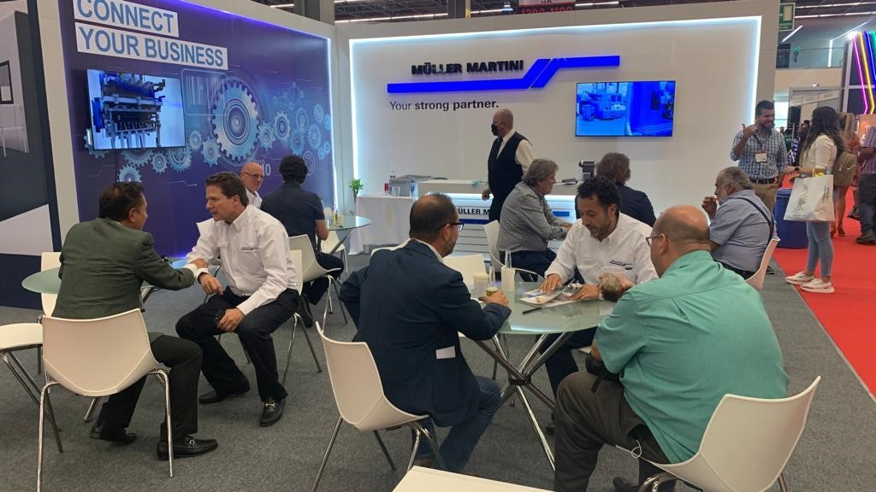
After two years of Zoom meetings, Expogràfica finally offered the opportunity to meet again at a table.

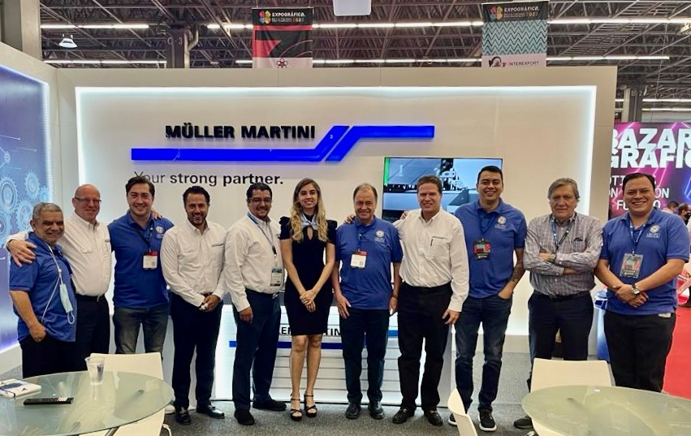
The Muller Martini booth team at Expogràfica in Guadalajara.

