Press Release

Date 19.03.2019
No. PI 2177
Number of characters 1976
Contact Muller Martini AG
Untere Brühlstrasse 13, CH-4800 Zofingen/Switzerland
Tel. +41 (0)62 745 45 75, Fax +41 (0)62 751 55 50
info@mullermartini.com, www.mullermartini.com

Optimization through Investments

With the commissioning of a Primera MC, Groupe Morault, located in Compiègne, France, increased its saddle stitching productivity by more than 10%.

The printing company now relies on four Muller Martini systems for print finishing at this one production location alone. The economic environment is forcing companies to make investments to remain competitive. The new machines will also help the family company, which operates in northern France, to optimize processes, time frames and the use of personnel. As a result, printing and print finishing are being developed in parallel at the modern operation in Compiègne, which has two web printing presses and three sheet-fed offset machines.

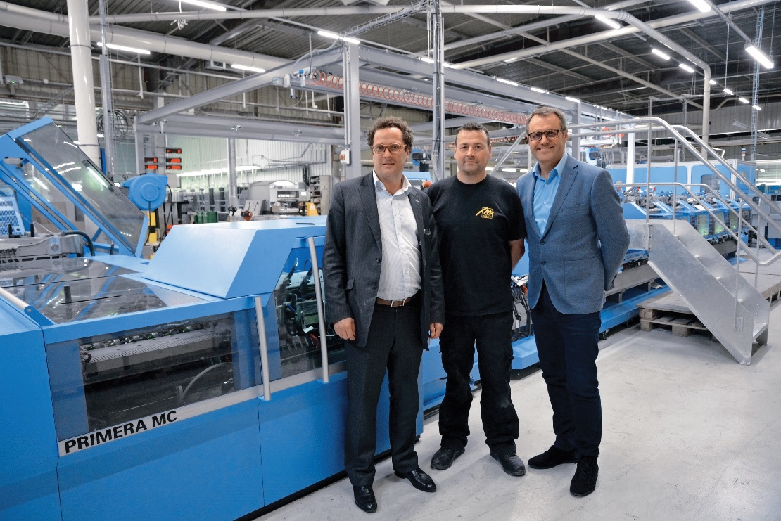
From left: General Director François Morault, Sébastien Lecaille (Head of Print Finishing), and Philippe Michelon (Sales Manager at Muller Martini France) in front of the Primera MC in Compiègne.

“We can’t buy first-class printing presses and then leave print finishing to old systems,” says General Director François Morault. The progress in terms of productivity as a result of the Primera MC has specific technical reasons. Motion Control Technology enables fine-tuning on the fly. Synchronization is performed automatically and changeovers are quick. In addition, there is almost no production waste with the new saddle stitcher.

“We can operate at full speed with the Primera MC,” says François Morault. The 14,000 cycles per hour are not an ideal scenario, but rather a reality, which is important to the printing company in Compiègne, with its 100 employees. This is because at Groupe Morault, they produce the highest-volume runs. This mainly involves jobs in A4 size – often for publishers of special-interest magazines and customers in the public sector. With its pre-press, printing, print finishing, distribution and delivery services, Groupe Morault acts as a one-stop shop for its customers, which are mainly based in the greater Paris area.

