Press Release

Date 04.07.2019
No. PI 2204
Number of characters 2076
Contact Muller Martini AG
Untere Brühlstrasse 13, CH-4800 Zofingen/Switzerland
Tel. +41 (0)62 745 45 75, Fax +41 (0)62 751 55 50
info@mullermartini.com, www.mullermartini.com

Taking Advantages of the Opportunities Presented by the Hardcover Market

Czech company Tisk Centrum, located in Moravany u Brna, is aiming to further expand its competitive strengths in the hardcover market with two Muller Martini Kolbus brand systems.

The company, located south of the city of Brünn, made a name for itself with softcover product catalogs. Following its expansion to a full-service operation with pre-press, printing and print finishing services, the investment in an RF 700 backgluing and backlining machine and a BF 513 bookline is intended to solidify the company’s position in the Czech hardcover market. The new acquisitions not only ensure higher quality and better scheduling, they also bring the entire value chain in-house. Now, that there's no need for an external partner to help it with production, the company wants to increase its market share from 10 to 20 percent.

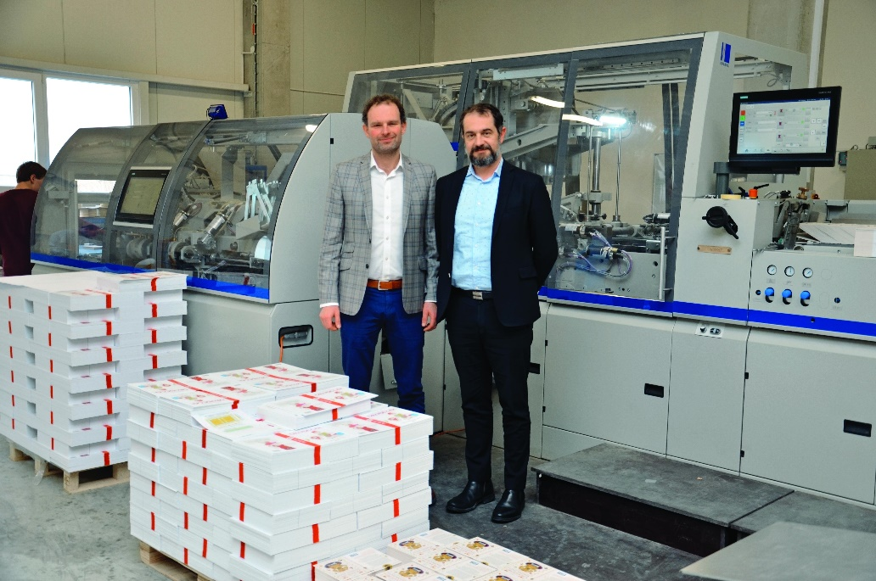
Company head Jaroslav Hradil (right) and Lubos Kunze (Managing Director of Muller Martini Czech Republic) in front of the new BF 513 bookline at Tisk Centrum.

“Today, there’s demand for print products that offer added value, are made from special materials and are long-lasting,” notes Jaroslav Hradil. Hradil, who helped to co-found the company in 1995, knows that quality is especially important for his company because it is not primarily planning to produce mass products, but rather high-quality special products with good margins – for example, for the art scene. “With our new, modern systems, we have a significant advantage over our competitors,” says the head of the company, which employs 80 people.

There were three reasons why Tisk Centrum chose the RF 700 and BF 513. As 80 percent of the company’s jobs have a print run of 3,000 to 5,000 copies, the Kolbus machines are ideally suited to its requirements. In addition, the high level of automation requires few staff. Furthermore, with Muller Martini, the company, located in the Moravian region, has a high level of protection for its investment because the systems can be expanded flexibly if market needs change.

