Media information

Date 23.03.2022
No. PI 2327
Number of characters 1'945
Contact Müller Martini AG
Untere Brühlstrasse 17, 4800 Zofingen/Switzerland
Phone +41 62 745 45 45
info@mullermartini.com, www.mullermartini.com

InfiniTrim trimming robot with five new, flexible delivery systems

Five new, flexible delivery systems on the InfiniTrim trimming robot from Muller Martini ensure an uninterrupted production process for (ultra-)short runs in softcover production.

A revolutionary drive, transport and cutting concept without any setup effort: there was great surprise in the graphic arts industry when Muller Martini presented the InfiniTrim as a world premiere at drupa 2016. The trimming robot, which has an output of 2,000 cycles per hour and is relied on by countless graphic arts companies around the world, shows its strengths in particular in the short-run segment and with book-of-1 products, especially in duet with the Vareo PRO perfect binder.

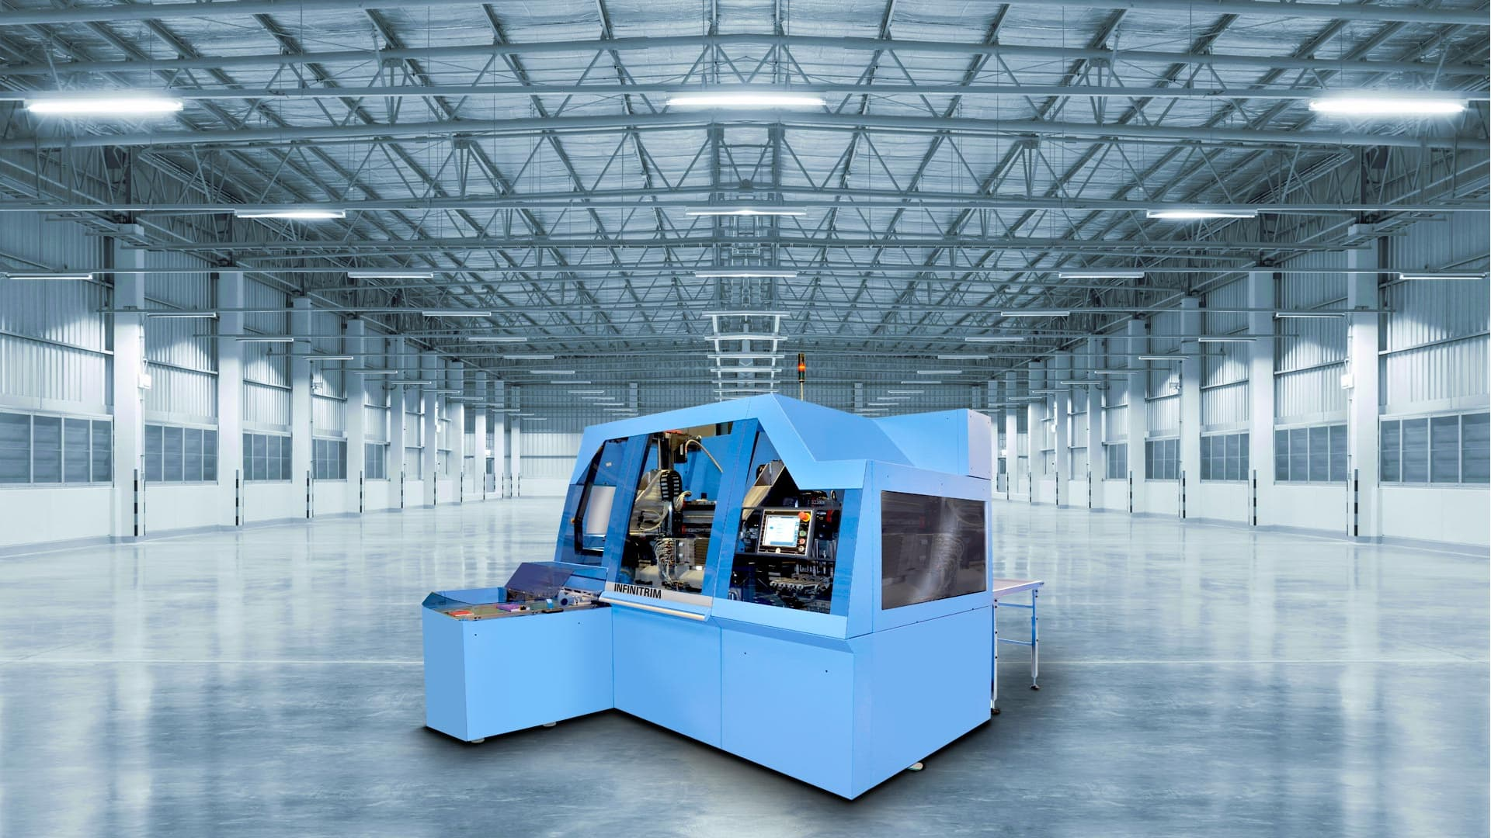
The InfiniTrim trimming robot from Muller Martini has five new, flexible delivery systems.

"The InfiniTrim is the best machine I've ever bought," says Andy Cork, founder and managing director of Printondemand-Worldwide.com in Cambridgeshire, England. "It allows us to make an automated transition from perfect binder to three-knife trimmer thanks to barcode recognition."

In the meantime, Muller Martini has expanded the range of possible delivery systems according to customer requirements:
Standard delivery
Delivery with collection box for NoRead books
Delivery with roller table to the side
Delivery with collection box for NoRead books and roller table for sorting
Stacker

The aim of these innovations is to avoid interrupting the production process wherever possible. To achieve this, the various delivery systems of the InfiniTrim with ejection and sorting functions offer a wide choice depending on requirements. In combination with a stacker, there were further cost-saving potentials.

