Media information

Date 17.03.2022
No. PI 2329
Number of characters 3352
Contact Müller Martini AG
Untere Brühlstrasse 17, 4800 Zofingen/Switzerland
Phone +41 62 745 45 45
info@mullermartini.com, www.mullermartini.com

Wograndl Printing Company: Prinova Saddle Stitcher as an Investment in the Future

The Wograndl printing company in Mattersburg, Austria, used the last two years intensively to renew its entire production technology. A Prinova from Muller Martini was installed in the saddle stitching area, enabling the company to achieve a higher level of productivity.

The printing company Wograndl currently serves 700 customers from a wide range of industries – from local artisans to industrial companies and the public sector. Competition is particularly fierce in eastern Austria – Vienna, Niederösterreich and Burgenland – which is also reflected in the prices that can be achieved on the market. "The challenge is to earn something even at this price level," says Managing Director Jochen Wograndl quite confidently.

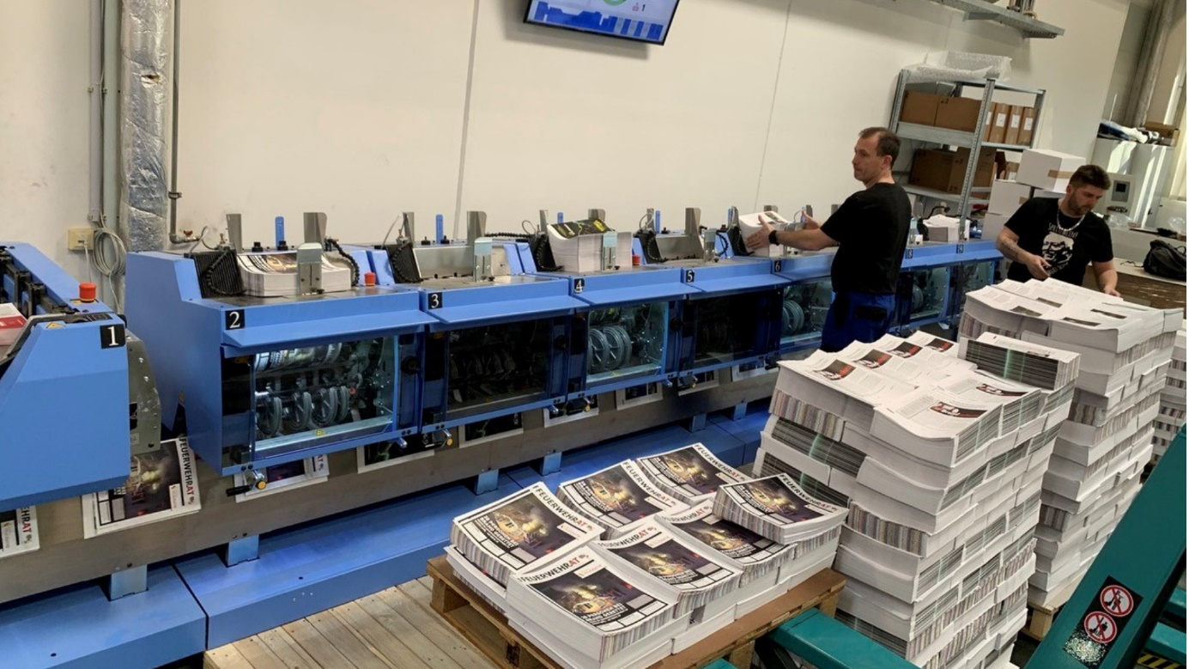
The Wograndl print shop opted for the saddle stitcher Prinova from Muller Martini because of its attractive price/performance ratio.

This also has to do with the fact that the company does not accept any compromises in a manufacturer's performance promise when making investments. "With every purchase, we expect to achieve maximum productivity on all jobs. We don't compromise on that," Jochen Wograndl emphasizes. And that was also the case with the Prinova saddle stitcher.

Attractive price/performance ratio
The print shop has redundant systems throughout production to offer its customers a high level of production reliability. To maintain this, an aging ST300 series saddle stitcher from Heidelberg had to be replaced. The procurement of spare parts in particular was often on shaky ground and also involved a great deal of time.

Due to the attractive price/performance ratio, Jochen Wograndl decided to invest in a new Prinova. It achieves a cycle rate of 9000 copies per hour and is configured with eight individual feeders and a cover feeder. "For us, the Prinova is an investment in the future to secure production in the long term, both technically and in terms of quality," says the Managing Director. Thanks to innovative individual feeders, he says, the saddle stitcher can be changed over in a very short time and is therefore ideal for short runs, but also predestined for medium runs.

In this context, Jochen Wograndl speaks of 10 to 15 minutes for a complete job changeover. Another technical highlight is the new ASIR PRO camera system. This recognizes and compares the signatures by means of 1D/2D code and/or image comparison. This is a feature that rules out confusion from the outset when processing different language versions, for example.

Competence in problem solving
However, a few teething problems had to be overcome before this could be achieved. "The fact that technical problems can occur during an installation was nothing new for us. The decisive factor is how a manufacturer deals with such a situation," emphasizes the managing director.

It took a while to locate the problems, he says, but then Muller Martini cleared up one problem after another according to a tight schedule. And now the Prinova is running exactly as Jochen Wograndl imagined: maximum productivity across all formats and grammages.

