Media information

Date 31.03.2023
No. PI 2380
Number of characters 2239
Contact Müller Müller Martini AG
Untere Brühlstrasse 17, 4800 Zofingen/Switzerland
Phone +41 62 745 45 45
info@mullermartini.com, www.mullermartini.com

Producing Perfect Books Fully Automatically

Tisk Centrum in Moravany u Brna has underpinned its leading position in the Czech book market with the commissioning of an FN 700 fold down press and a Ribbon inserting machine from Muller Martini.

The graphic arts company, which was founded in 1995 and employs 80 people, mainly prints and produces books – hardcovers as well as softcovers. For many years, Tisk Centrum has relied mainly on Muller Martini solutions: in perfect binding on a Pantera, in hardcover production on an RF 700 backgluing and backlining machine and a BF 513 bookline, in a Granit three-knife trimmer and in thread sewing on a system from another machine manufacturer.

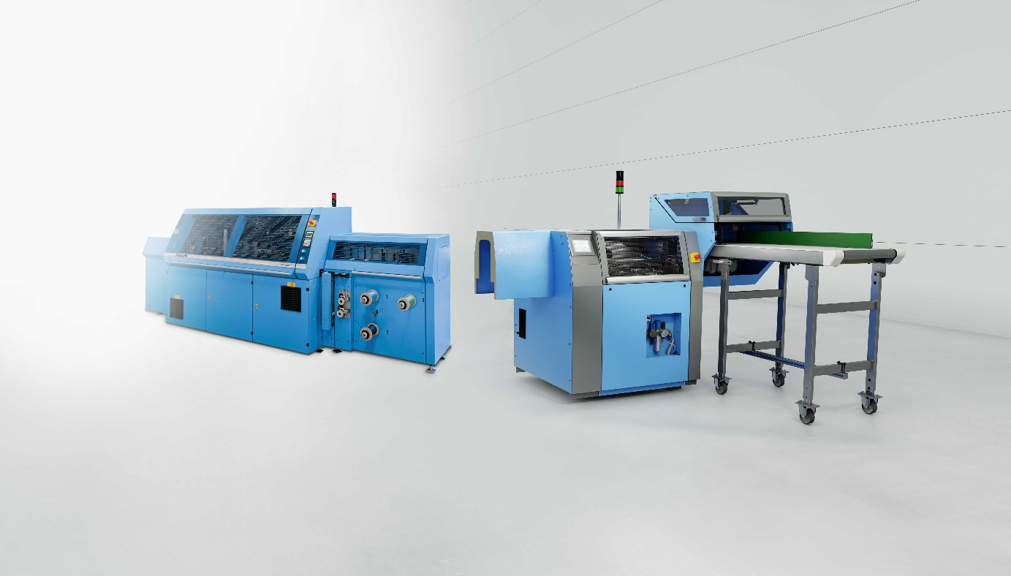
With the FN 700 fold down press and the Ribbon inserting machine from Muller Martini, Tisk Centrum is strengthening its leading position in the Czech book market.

However, the ambitions of company founder Jaroslav Hradil go beyond the production of high-quality, finished books and the use of the latest technology (the company recently added its third gold embossing machine). Tisk Centrum, which over the years has grown from a graphic studio for pure prepress work to a stately full-service operation with prepress, press and postpress, also wants to be a pioneer in terms of a workflow that is as fully automated as possible. The previous single hardcover presses and the Ribbon will therefore be linked by conveyor belts to form a complete inline bookline.

With the FN 700, which will be used after the RF 700, Tisk Centrum reduces the spine pitch caused by folding during thread sewing – with the Ribbon, it increases the value of a book. "In this way, we achieve two goals at once," says Jaroslav Hradil Jaroslav Hradil, "we produce more and improve our quality. Because it's not enough just to be number 1 in printing. We also have to use the latest technology in postpress. That's how we strengthen our position on the market."

The quality aspect is therefore particularly important because Tisk Centrum does not primarily have mass production in mind, but focuses on high-quality specialties with good margins. "Print products that offer added value, are made of special materials and are durable are in demand today," underlines Jaroslav Hradil.

