Press Release

Date 16.11.2017
No. PI 2123
Number of characters 2764
Contact Muller Martini AG
Untere Brühlstrasse 13, CH-4800 Zofingen/Switzerland
Tel. +41 (0)62 745 45 75, Fax +41 (0)62 751 55 50
info@mullermartini.com, www.mullermartini.com

A New Primera MC at Onlineprinters Provides
Greater Capacity and a Reliable Backup

The e-commerce company Onlineprinters, which is also known in Germany as diedruckerei.de, started out as a conventional printshop and specializes in the printing of standard print products. In order to ensure consistent product quality in the saddle stitching segment, the company has been using a Muller Martini Primera MC for a few months now.

The online printing plant was established in 2004 with the aim of selling individual print products to customers online at low cost. That is possible thanks to the collect-run procedure. A range of customer orders are produced together on one signature, which reduces the paper and time involved and is better for the environment.

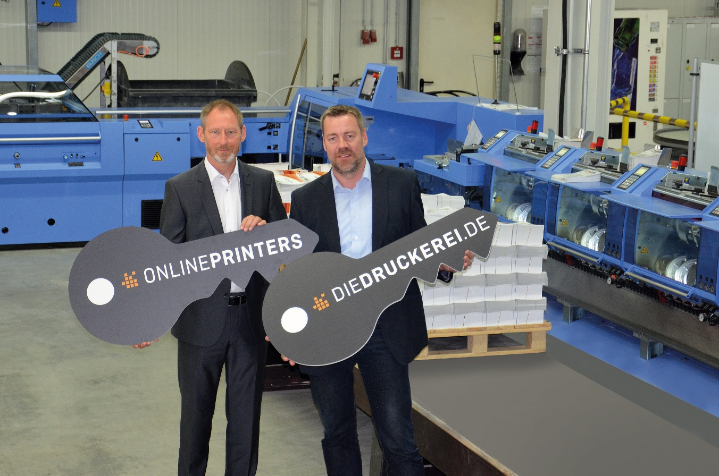
Operations Manager Armin Wondrak (right) and Frank Skorna (Area Sales Manager at Muller Martini Germany) in front of the new Primera MC at Onlineprinters.

Onlineprinters has over 1,500 products in its range, ranging from flyers and brochures through to large-scale trade fair displays. Onlineprinters is chiefly active in the business-to-business segment. “Our customers order exclusively online. The jobs are produced and finished in-house,” says Armin Wondrak, Operations Manager at the headquarters in Neustadt an der Aisch near Nuremberg. With 163 offset press units, the Onlineprinters group is the largest European printing plant for the 3b sheet size.

Its customers include many smaller printing plants that specialize in the production of particular formats. In order for them to continue offering their customers standard products such as flyers and brochures, they buy them in from Onlineprinters or supplement their range with products such as large-size printed materials like canvases and flags, which the online printing provider likewise produces.

By investing in a new Primera MC, Onlineprinters has increased its saddle stitching capacity and also has a reliable backup for its two existing saddle stitchers – a Muller Martini Bravo and a Heidelberg model.

The company decided on the Primera MC following an extensive evaluation by an experienced team of specialists. Armin Wondrak explains that the saddle stitcher impressed them in three key areas:
its proven, sound technology,
its excellent references, especially with regard to low downtime and high capacity utilization,
its unbeatable price-performance ratio.

The Primera MC really comes into its own at Onlineprinters. “We can now produce products even more efficiently and reliably. That’s a great advantage because we have to supply more and more products, such as brochures, on demand and with a short turnaround time,” says Wondrak. “We’re able to produce even faster thanks to the very short changeover and processing times.”

