Press Release

Date 13.02.2018
No. PI 2125
Number of characters 1730
Contact Muller Martini AG
Untere Brühlstrasse 13, CH-4800 Zofingen/Switzerland
Tel. +41 (0)62 745 45 75, Fax +41 (0)62 751 55 50
info@mullermartini.com, www.mullermartini.com

The Vareo Ensures High Quality

The customer is king at CEWE, which handles unique orders. The European market leader in the photo service segment relies on the Vareo perfect binder to achieve the high production quality that the market demands.

The over 50 million photo books that have been sold since their launch in 2005 are the flagship product of the company, which has four sites in Germany, its home market. Customers mainly design the 21st century albums on their computer and order online. The Vareo plays a key role in the production process. The Muller Martini perfect binder at the company’s site in Eschbach near Freiburg im Breisgau can handle an equivalent volume to the company’s two previous perfect binders put together. The CEWE managers were so impressed with the commissioning of the Vareo that they have followed it up with a perfect binder of the same type at all their sites in Germany.

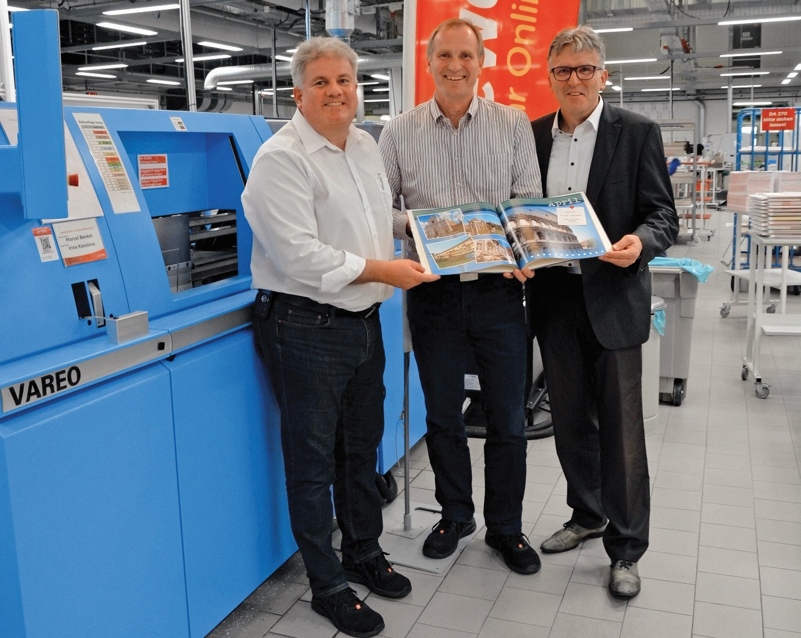
From left to right: Gerd Wild (Digital Printing Manager), Michael Bühl (Technical Manager) and Peter Stein (Area Sales Manager at Muller Martini Germany) in front of the new Vareo at CEWE in Eschbach.

It was critical to CEWE that the Vareo is not only capable of processing runs of one copy, which are in increasing demand, but also ensures enhanced product quality. The innovative Muller Martini perfect binder boasts a performance of 1,350 cycles per hour and clamps with unit-drive technology, enabling tailored processing of each product. It offers optimal overtravel speeds and longer cover nipping times. “The glue application monitoring and the automatic book thickness measuring system of the Vareo are an enormous help for us,” says Gerd Wild, Digital Printing Manager, naming two further advantages of the Vareo.

