Media information

Date 02.02.2023
No. PI 2365
Number of characters 3720
Contact Müller Martini AG
Untere Brühlstrasse 17, CH-4800 Zofingen/Switzerland
Phone +41 62 745 45 45, Fax +41 62 751 55 50
info@mullermartini.com, www.mullermartini.com

Hunkeler Innovationdays 2023

Muller Martini with World Premiere at the HID Booth

At the Hunkeler Innovationdays from February 27 to March 2 in Lucerne, Muller Martini will be presenting a world first with the highly automated Prinova Digital saddle stitcher. The Vareo PRO perfect binding line with numerous further developments will also be on show at the exhibition stand.

The industry event in Lucerne provides the perfect setting for Muller Martini to present two innovations for digital and hybrid production, and thus simultaneously expand its digital portfolio with a new system. The highly automated Prinova Digital saddle stitcher, which is being presented for the first time, impressively demonstrates that the Smart Factory is no longer just about softcover and hardcover production. Saddle-stitched magazines, brochures and catalogs are also increasingly being printed and produced digitally.

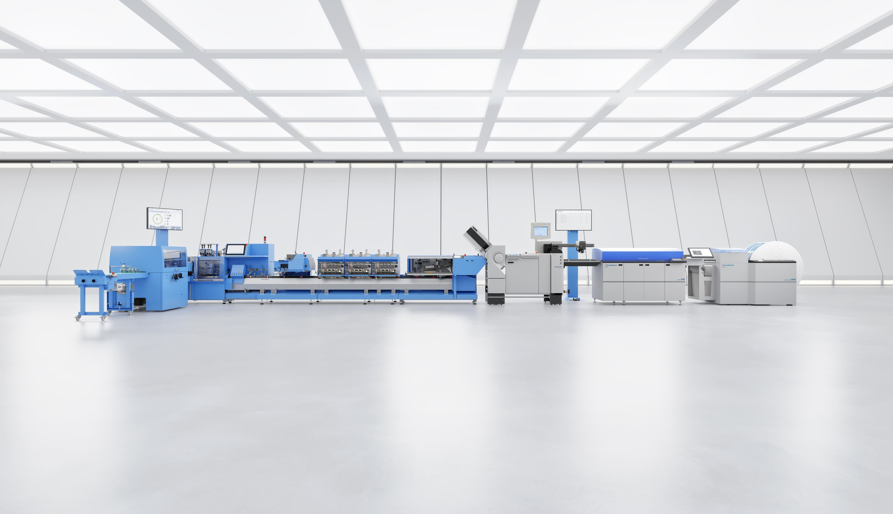
For digital and hybrid production: Muller Martini presents several technical innovations at the Hunkeler Innovationdays in Lucerne, including the Prinova Digital saddle stitcher as a world premiere.

Hybrid production: Prinova Digital
In order to produce short runs efficiently, cost-effectively and, as far as possible, without manual intervention, a completely automated workflow is also required here, from prepress to production of the end product. The hybrid saddle stitcher, which produces at 9,000 cycles per hour, is not only suitable as an entry-level model for digital saddle stitching, but also processes conventionally printed jobs confidently and reliably. The new saddle stitcher is also an optimum and cost-attractive solution for production down to run length 1 for smaller print shops.

New mixed mode for Vareo PRO
The Vareo PRO perfect binding line, which has been tried and tested hundreds of times on the market, will also shine at the trade show booth with numerous further developments. These focus on greater efficiency and a massive increase in productivity. The new mixed mode allows print shops to produce mixed softcover end products and hardcover book blocks in the same production run without changeovers. A new de-stacker solution optimizes the feeding of book blocks by process-safe separation of piles consisting of book blocks of soft and hardcover products. The system is completed with an innovative sorting solution downstream of the InfiniTrim cutting robot, which sorts finished products according to various criteria individually defined by the customer.

Real life jobs on the stand
Visitors to Hunkeler Innovationdays can see how this works in practice live at the Muller Martini stand. In addition to innovative production models, real-life jobs will also be on display. The Prinova Digital will not only produce seven digitally printed magazines in different formats and variants, but also a hybrid product in which offset printed signatures and a cover are fed in addition to the digital content. The Vareo PRO line will produce five different hard and soft cover jobs with changing formats and in very short runs, which will be intelligently sorted again at the end.

Connex and^{MM} Services
The benefits of the Connex workflow system - the backbone of digital finishing at Muller Martini - will also be demonstrated at the Hunkeler Innovationdays stand. In daily keynotes at the trade show, experts will explain all the innovations of a continuous, highly automated workflow and demonstrate the benefits of controlling and reporting a production with Connex.Info 4.0.

Another focal point at the Muller Martini stand will be the entire range of services offered by ^{MM}Services, with demos of the MPOWER solution portal as a special attraction.

