Media Information

Date 27.10.2022
No. PI 2361
Number of characters 3237
Contact Müller Martini AG
Untere Brühlstrasse 17, 4800 Zofingen/Switzerland
Phone +41 62 745 45 45
info@mullermartini.com, www.mullermartini.com

Printing United Expo in Las Vegas: "Just Like the Good Old Days"

The true smart factory environment presented by Muller Martini at the Printing United Expo at the Convention Center in Las Vegas – the Connex workflow system controlled and monitored the production of a live Presto II Digital VT saddle stitcher – met with great interest from visitors to the stand. "It was like the good old days. There was a lot of vibrant activity on all three days," said Andy Fetherman, President and CEO of Muller Martini North America, in an all-around positive summary of the first major live trade show in North America since the start of the corona pandemic.

The trade show visitors, who were able to gain an overview of Muller Martini's Finishing 4.0 strategy and extensive digital solutions portfolio through six different live presentations per day, did not only include large print service providers. "We were also able to welcome many medium-sized and smaller companies to our stand, for whom we also offer many productive and compatible solutions," says Andy Fetherman.

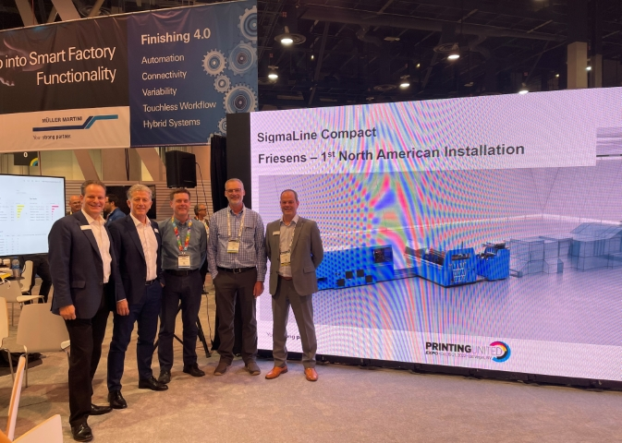The first SigmaLine Compact in North America will be up and running at Friesens in 2023. From left: Andy Fetherman, Bruno Muller (both Muller Martini), Andrew Fennell (Vice President of Finance Friesens), Steve Voth (Operations Manager Friesens), Steve Gardner (Muller Martini).

He was particularly pleased that many graphic arts companies traveled to Las Vegas in large groups and had other employees on the team in addition to their top-level decision makers. "This also allowed us to present our extensive portfolio in the areas of saddle stitching, softcover and hardcover applications to many machine operators."

Among the highlights of the Printing United Expo was the announcement by Bruno Müller, CEO of Muller Martini, of the launch of the SigmaLine Compact next year. With the introduction of the SigmaLine Compact as the latest innovation in digital print finishing, Muller Martini is setting another milestone in digital book block production. It is particularly impressive due to its minimal changeover times. For example, a change of folding schemes – from a four-page to a six-page signature – takes just a few seconds.

Shortly after Bruno Müller’s announcement, Andy Fetherman was visibly proud to promote in the Muller Martini booth the first North American user of the SigmaLine Compact. It is Friesens Corporation in Altona (province of Manitoba). Canada's largest hardcover producer already relies on numerous Muller Martini systems – including three Diamant MC book lines, a Ventura MC Digital book sewing machine, a Bolero perfect binder and an Alegro perfect binder among other Muller Martini finishing solutions.

