Media Information

Date 05/09/2023
No. PI 2390
Number of characters 3125
Contact Müller Martini AG
Untere Brühlstrasse 17, 4800 Zofingen/Switzerland
Telephone +41 62 745 45 45
info@mullermartini.com, www.mullermartini.com

Stable production – The reason why Schär is investing in a second Primera PRO

In light of the extremely stable operation of the Primera PRO installed four years ago, Schär Druckverarbeitung AG in Wikon, Switzerland, has decided to invest in a second saddle stitcher of the same type. The company is further upgrading its machinery just in time for its 35th anniversary.

"From four to three – that's the goal we've set," explains Yannick Bucher, Managing Director of Schär Druckverarbeitung AG. "The Primera PRO we just ordered is already replacing a 17-year-old Prima Plus, and the latest generation of saddle stitchers is so efficient that we plan to decommission another outdated model by the end of the year." In addition to the two Primera PROs, which will be producing in pairs at Schär from September, a 235 saddle stitcher from Müller Martini will still be in operation.
Efficiency is not the only reason for investing in the new saddle stitcher: another important factor behind the investment decision was easier training for new employees. "In the future, we will only have two saddle stitcher models in operation," explains Yannick Bucher. "This simplifies operating the machines for both existing and new employees and significantly streamlines the professional handling of orders."

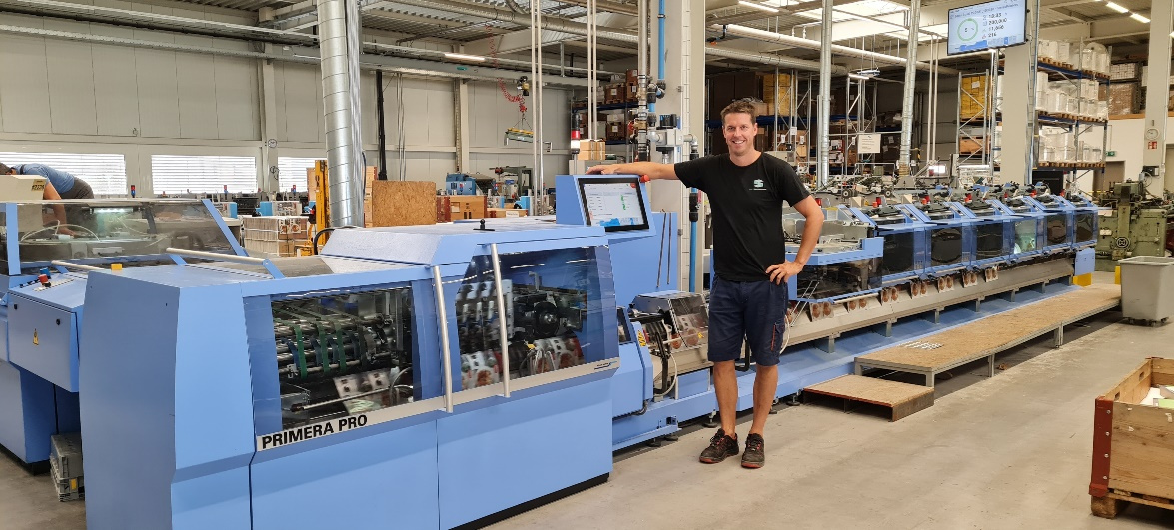
Yannick Bucher, Managing Director at Schär Druckverarbeitung AG, is very pleased with the performance of his Primera PRO installed four years ago and is looking forward to the second saddle stitcher of the same type, which is to be installed in September.

The Primera PRO features technical elements such as Motion Control technology and modern interaction with local control panels, providing short setup and conversion times. It also impresses with high format variability, making it very versatile at Schär. For the first time, the further developed SEMKO will be tested on the Primera PRO installed in September; it checks product thickness and, as a result, their level of completeness. The Perfetto PRO stacker, which is equipped with a new interaction, will also be used for the first time. "Our business environment is becoming increasingly fast-paced," Yannick Bucher points out. "Modern machinery allows us to respond to this development so that we can continue to serve our customers quickly and reliably."

Originally designed for large print runs, Schär now produces not only traditional brochures with editions beyond the million mark on the Primera PRO but also smaller jobs up to 1,000 copies. The fact that a much broader product range is now being processed than planned is largely thanks to the Primera PRO's outstanding variability and short setup times. Compared to the old saddle stitchers, also from Müller Martini, Yannick Bucher estimates the time saved during setup at 40 to 50 percent.

Impressive numbers and the latest technology – that's what the customers attending the 35th-anniversary celebrations of Schär Druckverarbeitung AG can expect. During the festivities in October, they will get the chance to see the Primera PRO saddle stitcher in live production as part of a company tour.

