Media information

Date 12.10.2023
No. PI 2391
Number of characters 2371
ContactMüller Martini AG
Untere Brühlstrasse 17, 4800 Zofingen/Switzerland
Phone +41 62 745 45 45
info@mullermartini.com, www.mullermartini.com

Muller Martini at PRINTING United Expo 2023: News from the Smart Factory

From October 18 to 20, Muller Martini will be presenting its latest equipment for the Smart Factory and highlights of its Connex Workflow System at the PRINTING United Expo 2023 in Atlanta, USA. At booth B1617, visitors will be able to experience the Prinova Digital saddle stitching system live for the first time in North America, as well as the proven Vareo PRO perfect binder combined with an integrated VBA end sheet tipper and InfiniTrim trimmer robot.

At the booth, visitors will be immersed in the exciting world of Smart Factory finishing. As the centerpiece of the exhibition, they will experience how the powerful Connex Workflow System reduces manual intervention, increases performance, reduces waste and provides real-time insight into production data. Andy Fetherman, President and CEO of Muller Martini in North America, is convinced: "For companies operating in the digital production environment, our Connex Workflow System provides a decisive competitive advantage."

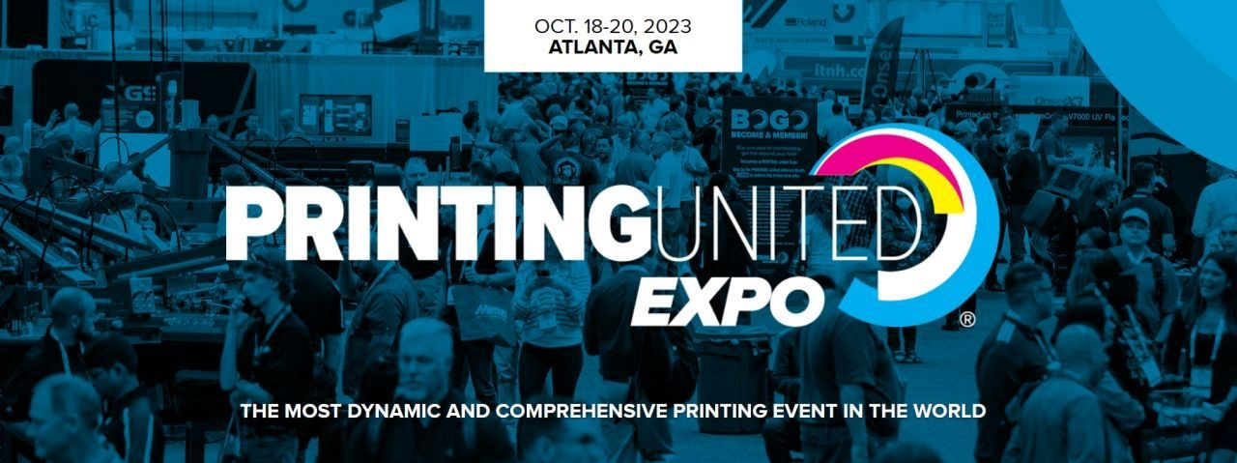
Muller Martini will be presenting the latest equipment for the Smart Factory at PRINTING United Expo 2023, which will be held in Atlanta between October 18 and 20.

For the first time, visitors to North America can take a live look at the new Prinova Digital saddle stitcher. It sets new standards in hybrid saddle stitching with the shortest set-up and changeover times and an intuitive operating concept. The stitcher adapts to the product thickness and controls the stitching wire length fully automatically from product to product. The Prinova Digital thus masters both digital and conventional jobs, offering print shops a high level of investment security.

The proven Vareo PRO perfect binder combined with the InfiniTrim trimmer robot will also be presented. It delivers first-class binding quality of individual softcover and gatefold brochures while maintaining a consistently high production output. The integrated VBA end sheet tipper also makes it possible to produce hardcover book blocks with end sheets and lining material in short runs inline. Muller Martini experts will be on hand at the exhibition stand to provide valuable insights into the functions and special features of these latest digital production systems and to guide visitors through practical application cases.

