Media-Information

Date 26.09.2023
Nr. PI 2398
Number of characters 4796
Contact Müller Martini AG
Untere Brühlstrasse 17, 4800 Zofingen/Schweiz
Telefon +41 62 745 45 45
info@mullermartini.com, www.mullermartini.com

Muller Martini Opens a New Chapter in Book Production

On 21 September, a new chapter in book production was opened at the Muller Martini Print Finishing Center (PFC). More than 120 visitors were able to experience live what level of automation is possible in book production today. The book production lines presented will sustainably increase productivity in print finishing.

"We are very pleased that over 120 guests from the DACH region and Eastern Europe accepted our invitation to the Print Finishing Center (PFC) in Zofingen. Watching the visitors, you could really sense that they are convinced that new opportunities and interesting business models will open up for the printing industry. We at Muller Martini are working flat out to develop innovative and future-oriented approaches and solutions for the market. Events like our Open House are needed to demonstrate the associated potential," assures Muller Martini CEO Bruno Müller. The absolute highlight was the presentation of a new compact book production line designed for applications that are printed on web digital printing systems. From the combination of the SigmaLine Compact, the new Antaro Digital perfect binder and the InfiniTrim three-knife trimmer, digital book production can now be raised to a new level of productivity.
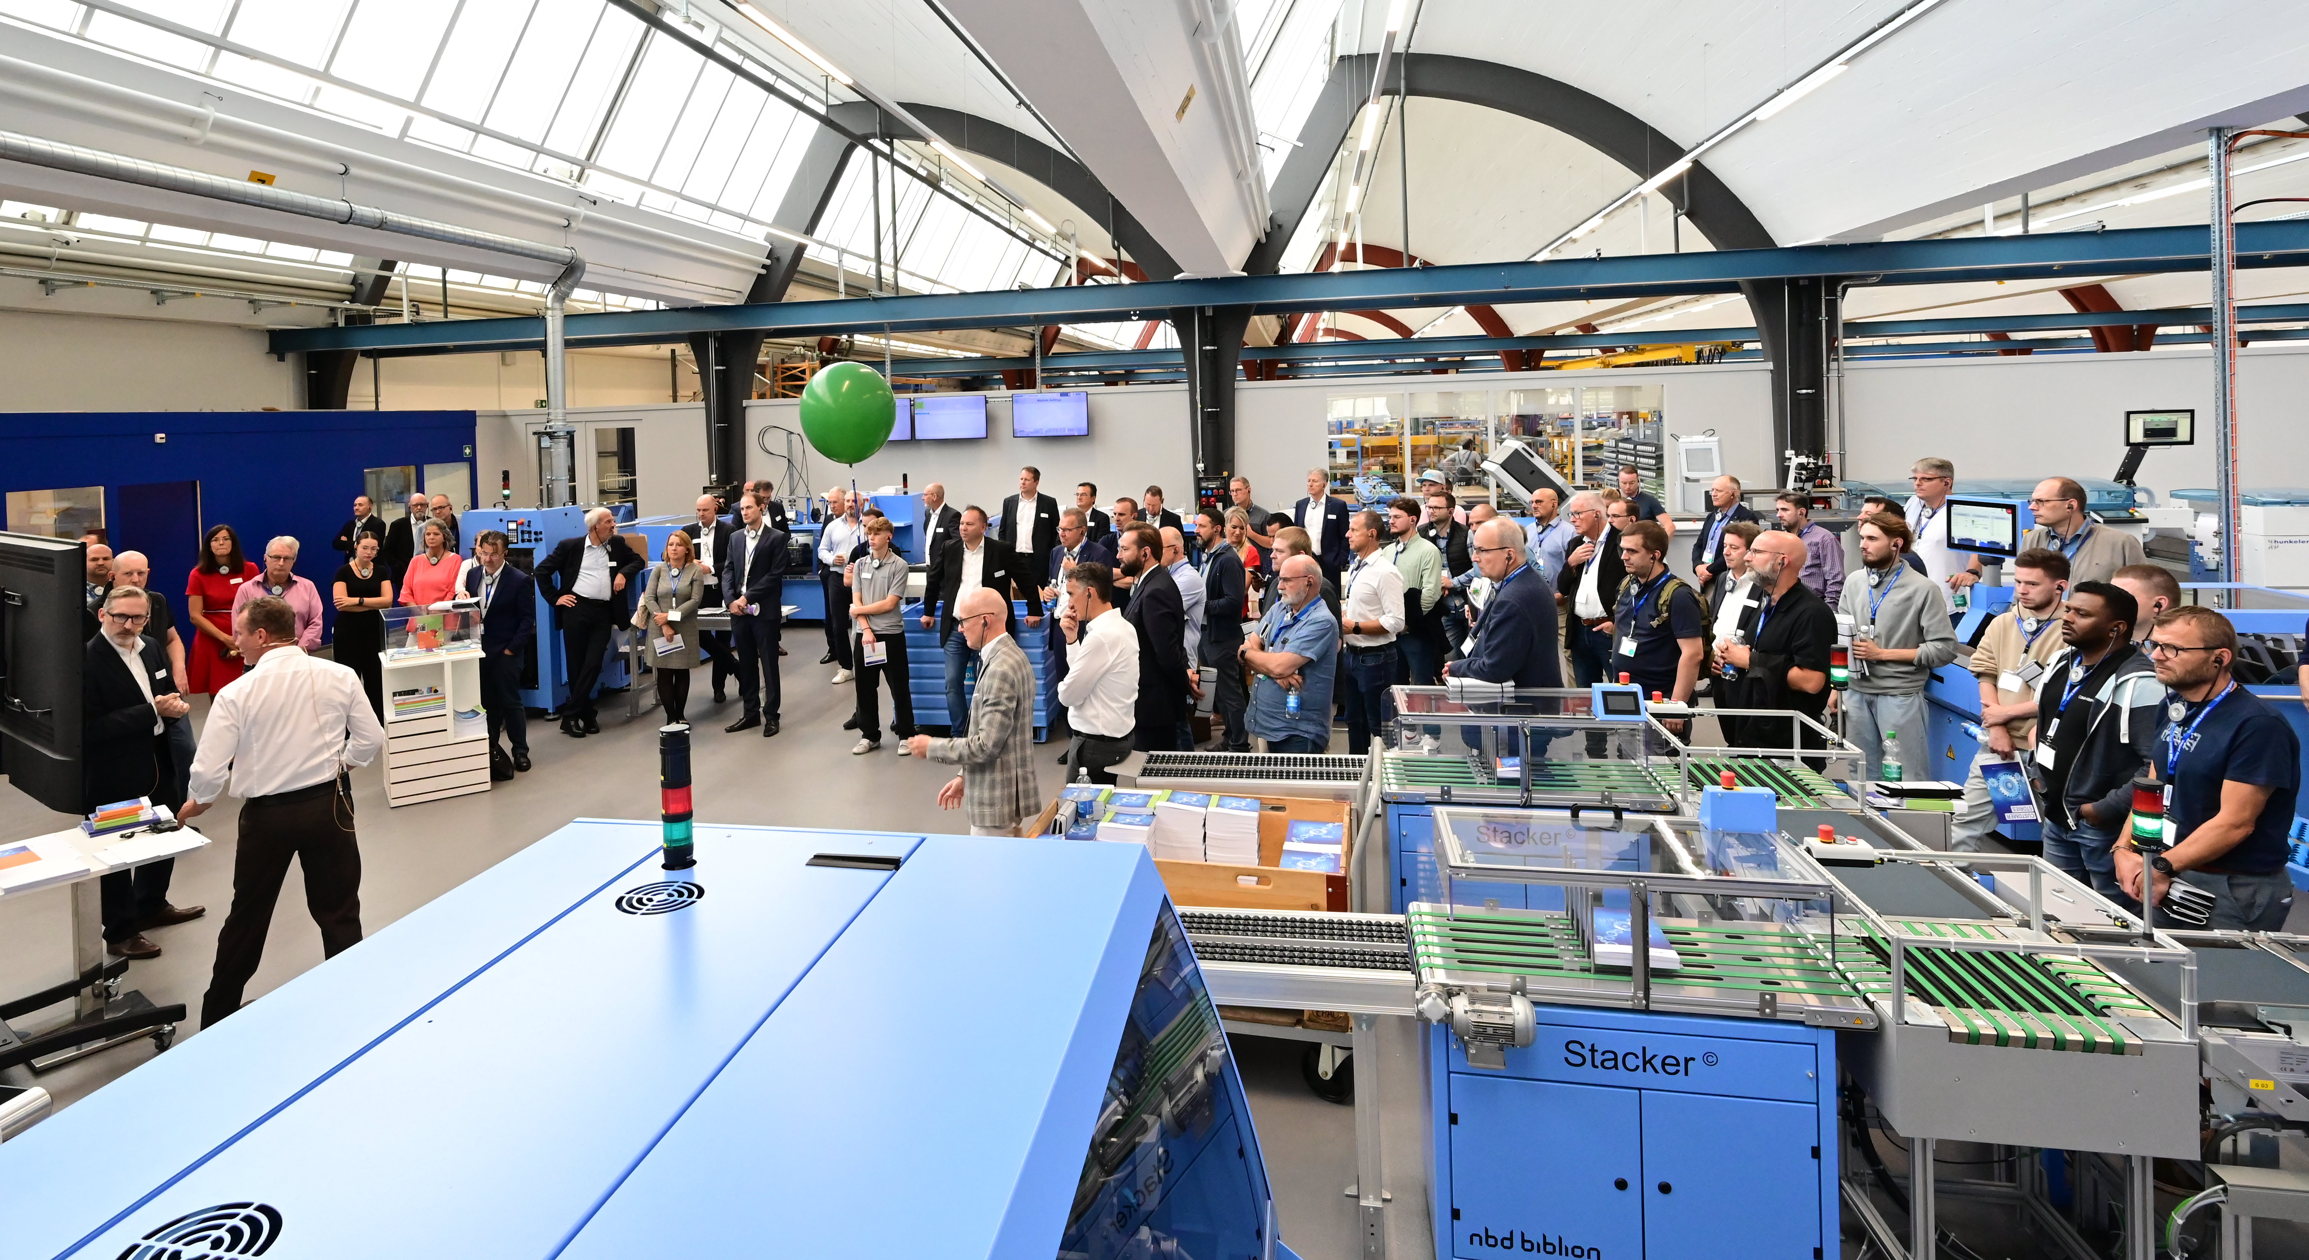
SigmaLine Compact/Antaro Digital: sustainable in every respect
The facts are impressive. Output is 2 000 copies per hour with a thickness variance of 20 mm from book to book – and without any loss of speed. This corresponds to a threefold increase in output compared to previous solutions. The issue of personnel is an ongoing one – both in terms of availability and costs. Only two people are needed to operate the complete production line – a machine operator and a helper. The space required for the entire process chain from folding to gluing to cutting is just 170 m² – in the past, a space requirement of well over 300 m² had to be estimated for this. The continuous barcode-based production enables a completely contact-free changeover. This happens de facto on-the-fly and offers the flexibility that is required especially for short runs or book-of-one production. "Changing folding schemes – for example from triple to quadruple-up – takes less than 10 seconds," assured Ingolf Fritzsche, Product Manager Digital Solutions at Muller Martini.
The first book is ready for sale
As part of the product presentation, 50 jobs, which varied in terms of run length, format and
thickness, were produced live without manual intervention. Muller Martini thus once again demonstrated how flexibly and efficiently softcover brochures, hardcover book blocks or layflat brochures can be produced. The digital mastermind of the bookline is the Connex workflow, which prepares the data in the appropriate form for production. The solution also has a lot to offer in terms of sustainability and saves waste and energy. As a rule, the first book can already be sold. "In the development of the Antaro perfect binder, we have incorporated all the experience gained so far from previous product generations as well as new ideas," emphasised Roland Reddmann, Product Manager Perfect Binding Systems. The format-variable and efficient three-knife trimmer InfiniTrim has already proven itself in practice in other constellations. With the book production line, Muller Martini has recognised the current demands of the market and created an innovative solution. This was also confirmed several times by visitors to the Open House:
"Above all, the new Antaro perfect binder is very interesting for us as a bookbindery. It optimally combines the requirements of both the analogue and digital worlds of print finishing. Muller Martini has thus created a symbiosis of both worlds."
Christian Burkhardt, CEO, BuBu AG, Switzerland
"The Antaro can be a step for us to bring the entire perfect binding process chain to a completely new level and a promising solution on the way to the Smart Factory. Furthermore, with the Connex workflow, Muller Martini has a lot of know-how on how to set up fully automated production in practice via end-to-end barcode control."
Ralf Schraud, Online Printers Produktions GmbH, Germany
"For me, the productivity, variability and compactness of the complete bookline are impressive. In combination with an inkjet web press, you get a complete, high-performance digital print shop virtually out of the box. The trend in print production is towards small but individualised jobs. With this system, the requirements that go hand in hand with this – especially for brochure and book production - can be optimally implemented."
Martin Wlacil, Managing Director, Print Alliance GmbH, Austria

New edition on Tuesday
On Tuesday, September 26, the next customers were welcomed to the Print Finishing Center in Zofingen. The second customer event for visitors from the Western Europe sales region also offered an equally impressive program. They were informed about the latest Muller Martini innovations on a tour of the company and during various machine demonstrations in the Print Finishing Center. The program ended with the highlight: the presentation of the world firsts SigmaLine Compact and Antaro Digital. And the customers from the Western Europe region were also very enthusiastic!

