Media information

Date 27.02.2023

No. PI 2367

Number of characters 5765

Contact Müller Martini AG

Untere Brühlstrasse 17, 4800 Zofingen/Switzerland

Phone +41 62 745 45 45

info@mullermartini.com, www.mullermartini.com

Turning Three into Five – Finishing 4.0 at its Best

At the [Hunkeler Innovationdays in Lucerne](https://www.innovationdays.com), Muller Martini will be demonstrating for the first time the End sheet feeder/Vareo PRO/InfiniTrim line, which has been supplemented with a De-Stacker and sorting solution. The two new systems at the beginning and end of the line ensure an increase in efficiency in softcover and hardcover production of very short runs and optimize logistics.

There was great astonishment among experts when Muller Martini presented the 1350-cycle Vareo at the HID 2015, a perfect binder predestined for digital and offset printing, whose three clamps each have their own servo drive – so that each processing step can be individually adapted to the product. One year later, Muller Martini once again caused a sensation and presented the InfiniTrim, a new 2000-cycle trimming robot with a revolutionary drive, transport and trimming concept, as its second world premiere within 15 months at drupa 2016. Since then, the Vareo/InfiniTrim dream team has been considered unbeatable for the production of softcover short runs down to book-of-one.

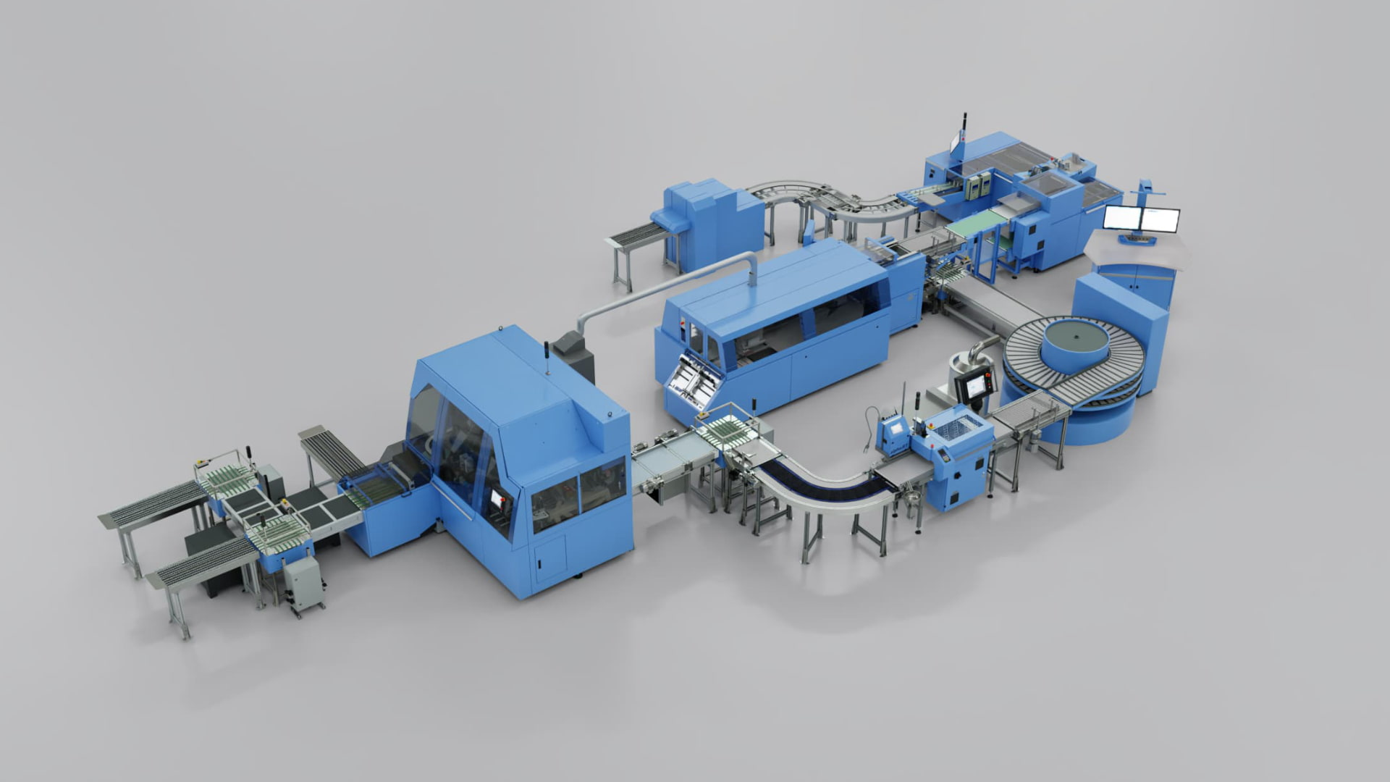

*De-Stacker/End sheet feeder/Vareo PRO/InfiniTrim/sorting solution: automating short-run softcover and hardcover production even further.*

Three more years later, the duo became a trio when Muller Martini showed the Endsheet feeder/Vareo/InfiniTrim solution for industrial production of hardcover book blocks for Book-of-1 to a wide audience at HID 2019. This is the first time that a highly automated Endsheet feeder has also been used in a lower performance class and ensures that book blocks with end sheets and mull stripe can be produced inline in top quality even in very short runs.

New with De-Stacker and sorting solution

Now the trio has become a quintet. At this year's HID, Muller Martini will be presenting an expanded Endsheet feeder/Vareo PRO/InfiniTrim line with a De-Stacker solution for higher efficiency when destacking book blocks at the beginning and an intelligent sorting solution for flexible, fully automated sorting of books at the end, coordinated to individual customer requirements.

The De-Stacker placed at the entrance to the line separates the book blocks, which are usually digitally printed, folded and pre-glued, from the top of the pile. This results in high process reliability and thus high efficiency. Blocks with variable thicknesses (controlled via barcode) as well as with constant thicknesses can be reliably separated.

At the infeed of the Endsheet feeder, the barcode on each individual book block is scanned. In addition to the job ID and various format data, information is stored as to whether the book block is a softcover or a hardcover. This means that all units in the line, right through to sorting, know exactly what they have to do with the respective book block. Both softcover and hardcover book blocks can be within the same pile and be mixed in terms of sequence.

In the case of soft covers, the Endsheet feeder only transports through, and in the Vareo PRO, the cover is glued on when a positive match is made. If a hardcover block is detected at the infeed of the Endsheet feeder, side gluing and endpapers are applied accordingly, and in the Vareo PRO the application of a folding strip takes place. A scan and print unit downstream of the Vareo PRO automatically prints a barcode on the mull stripe for hardcover book blocks so that the book can be further identified.

This patented mixed mode not only saves on sorting work in advance, but also ensures that delivery times are kept to a minimum. Because if problems occur in one of the subsequent process steps, the already completed production of softcover brochures and hardcover book blocks has gained time to be able to react in time if necessary.

Fully automated sorting of the mixed orders

The new sorting solution integrated into the Connex workflow system from Muller Martini at the end of the line comes into its own in a Smart Factory, particularly when the book blocks – down to edition 1 – are trimmed from several Vareo PRO perfect binders in a single InfiniTrim trimming robot to create finished end products. Whether separation of hardcover and softcover jobs, different end customers, products that still need to be foiled, or high urgency: the new intelligent transport control system ensures the desired sorting of the colorful mix of jobs leaving the cutting robot in a fully automated process. "With this new logistics application, we are offering our customers another important building block for automating production even further – this is Finishing 4.0 at its best," says Ronald Reddmann, Product Manager Perfect Binding Systems at Muller Martini.

New VPN-Flex nozzle: up to 30 percent less adhesive loss and up to 20 percent higher productivity

The Vareo PRO is also undergoing a technological upgrade. It features a completely new VPN-Flex nozzle system developed together with Robatech for variable thickness production. No matter what the thickness of a product: Excess PUR adhesive is no longer squeezed out of the nozzle, nor does it have to be wiped off, because these situations do not even arise with the new system.

The new technology thus ensures significantly more efficient use of the adhesive with up to 30 percent less glue loss and, conversely, up to 20 percent higher productivity, as continuous production is possible. In addition, the new system is simpler in design, especially in the area of the application head, and can be easily maintained even by a semi-skilled machine operator.

The LAK glue application control system has also been revised. With both new hardware and software components and new algorithms, it now enables even more precise evaluation of the glue application on the block back.