Media information

Date 11.09.2023
No. PI 2389
Number of characters 2749
Contact Müller Martini AG
Untere Brühlstrasse 17, 4800 Zofingen/Switzerland
Phone +41 62 745 45 45
info@mullermartini.com, www.mullermartini.com

Connex, the key to end-to-end automation

A comprehensive investment package has ensured that Emanuel Offset Printing plays a leading role in the Israeli printing market. Connex technology from Muller Martini has taken the networking of the entire production process to a whole new level, and the Primera PRO saddle stitcher has further reinforced the company's competitiveness.

"In recent years unstoppable technological progress has transformed the graphic arts industry at an unprecedented pace. Companies that are able to keep up with this pace will master these challenges," assures Emanuel Offset Printing's technical manager, Anav Liron. He is resolutely pursuing this approach to become the leading factory in the Middle East regarding technology and efficiency and launched an "top of the art" investment package that includes a Heidelberg Speedmaster XL with InPress Control, a Heidelberg SPH folding machine, an analytics software from Kodak, and the Primera PRO saddle stitcher with integrated ASIR cameras and Connex from Muller Martini.

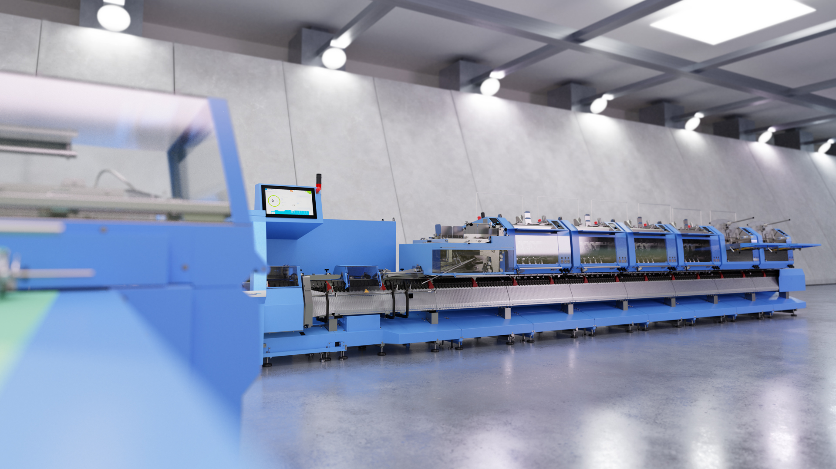
With the Primera PRO saddle stitcher, Muller Martini also focuses on automation with motion control technology to reduce make-ready times to an absolute minimum.

One Workflow for all process steps
With the Connex workflow modules from Muller Martini, the company will fully automate the entire workflow - from the MIS system to digital proof and print-finishing. In addition to end-to-end automation, the system delivers real-time monitoring of the entire production technology and comprehensive data analysis of each individual machine integrated into the Connex workflow. "The transparency attained with Connex over the entire workflow helps us to achieve a higher degree of utilisation and hence greater efficiency," says Anav Liron, summing up his expectations of Connex. In Connex, a digital order bag is used so that the individual operators no longer have to concern themselves with the delivery of the order data. Job data can be modified directly in the MIS and are available at the machine up until the last second.
With the Primera PRO saddle stitcher, the company is further expanding its capacity in the saddle stitcher sector. This is incidentally the second installation of a Primera PRO within a year in Israel. Companies have come to realise that the saddle stitcher is an optimal solution for the entire job spectrum - from short runs to long runs. Here, too, Muller Martini relies on automation with motion control technology to reduce make-ready times to an absolute minimum. Another highlight is the ASIR PRO camera system, which ensures that individual signatures are not mixed up without checking. This ensures safety on both sides - for the customer as well as for the supplier.

