Press Release

Date 06.03.2018
No. PI 2135
Number of characters 3730
Contact Muller Martini AG
Untere Brühlstrasse 13, CH-4800 Zofingen/Switzerland
Tel. +41 (0)62 745 45 75, Fax +41 (0)62 751 55 50
info@mullermartini.com, www.mullermartini.com

Open House Event
at the Schiffmann Bookbindery in Rösrath Attracts Numerous Bookbinders

Some 70 bookbinders from across Germany took up the invitation of Muller Martini and Großbuchbinderei Schiffmann GmbH & Co. KG to experience the numerous advantages of the Alegro perfect binder for themselves at the Schiffmann bookbindery’s site in Rösrath near Cologne.

“The large number of visitors exceeded our expectations,” says Bernd Sauer, Managing Director of Muller Martini Germany, who was delighted by the success of the open house event. According to Bernd Sauter, the numerous bookbinders were not only impressed by the demos at the Alegro but also took the opportunity to have an informative discussion with Gerhard Wittemann, owner and Managing Director of the Schiffmann bookbindery, and the Muller Martini perfect binding experts. Two live demos were performed alternately at the open house event at Schiffmann. The first job was an A5 notebook produced using the primer-two-shot method (cold glue and hotmelt), while the second job was an A4 brochure produced using the PUR method. The bookbinding experts were impressed not only by the high quality of the products but also by the short setup times of the Alegro.
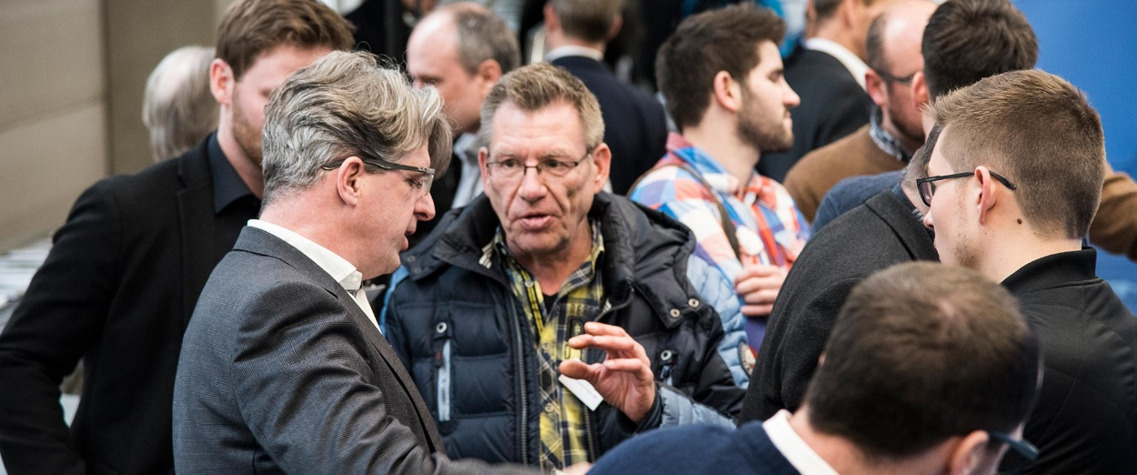
The live demos at the Schiffmann bookbindery in Rösrath met with great interest among the many bookbinding experts from across Germany.
Before and after the demos, the visitors to the open house took advantage of the opportunity to engage in lively conversation about “flexible perfect binding production”. The discussion revolved not only around the Alegro, but also the peripheral systems (especially the Orbit three-knife trimmer) and the various gluing methods. Ralph Zängerle, Regional Sales Director at Muller Martini Print Finishing Systems AG, gave a presentation on the advantages of Muller Martini’s perfect binder technology in general and of the Alegro in particular. Gerhard Wittemann answered numerous questions about daily production using his new softcover system. Ralph Tomm, Head of Procurement at the diary and notebook producer Geiger-Notes AG, one of Schiffmann’s largest customers, emphasized the shorter response times and higher productivity following commissioning of the Alegro. Increased flexibility throughout the production process was made possible in particular by the primer-two-shot gluing method, which – unlike the earlier, time-consuming drying method – enables immediate feeding of the products to the three-knife trimmer.

For 23 years, a Muller Martini Trendbinder purchased in 1994 was in reliable daily operation at the Schiffmann bookbindery together with an Orbit three-knife trimmer, a splitting saw and a CB 18 book stacker, which were acquired in 2009. To increase the efficiency and flexibility of the whole perfect binding line, while continuing to use the three peripheral devices, last summer Schiffmann replaced the Muller Martini “oldie”, which had produced well over 100 million books in its 23 years of operation, by an Alegro with a 27-station gathering machine. According to Gerhard Wittemann, the results have been highly impressive.

The Schiffmann bookbindery now has one to two fewer shifts each week, resulting in a ten to 20 percent production increase and a significant reduction in (expensive) overtime, Saturday work and the use of temporary workers.

Thanks to servo technology and the Book Data Center, whose data are used by the entire line, changeover times within the same product group have been reduced to 15-20 minutes (compared to 45-60 minutes previously).

The VPN nozzle means that the machine operators need just 15 minutes before the shift starts to prepare the adhesive instead of 45 minutes. That enables some 100 hours to be saved each year.

Since glue consumption is significantly lower thanks to the PUR nozzle and adhesive application monitoring, the Schiffmann bookbindery uses 500 kilograms less adhesive yearly. Moreover, no cleaning is required.

That considerable increase in productivity and flexibility is of particular importance to the Schiffmann bookbindery because it specializes in diaries, which are often produced in runs of 100 copies. With its short changeover times, the Alegro comes into its own for such jobs. That is especially the case if a long run needs to be interrupted by a small job with a quick turnaround time – a common occurrence at the Schiffmann bookbindery.

