Press Release

Date 14.11.2019
No. PI 2224
Number of characters 1923
Contact Muller Martini AG
Untere Brühlstrasse 17, CH-4800 Zofingen/Switzerland
Tel. +41 (0)62 745 45 75, Fax +41 (0)62 751 55 50
info@mullermartini.com, www.mullermartini.com

Wydawnictwo Jedność: New Perfect Binder, New Gluing Process

Book specialist Wydawnictwo Jedność, located in the Polish city of Kielce, killed two birds with one stone with its new Muller Martini Kolbus-brand KM 610.A perfect binder, which it plans to commission at the end of 2019/beginning of 2020.

First, the company – which was founded in 1917, closed by the Communists in 1947 and restarted as a traditional graphic company in 1990 – increased the efficiency of its softcover production. Second, the new perfect binder, which has a 20-station ZU 805 gathering machine, a 153.M three-knife trimmer and a KL 501 book stacker, also allows the company to prepare book blocks for hardcover production on a Muller Martini Diamant MC 60 bookline.

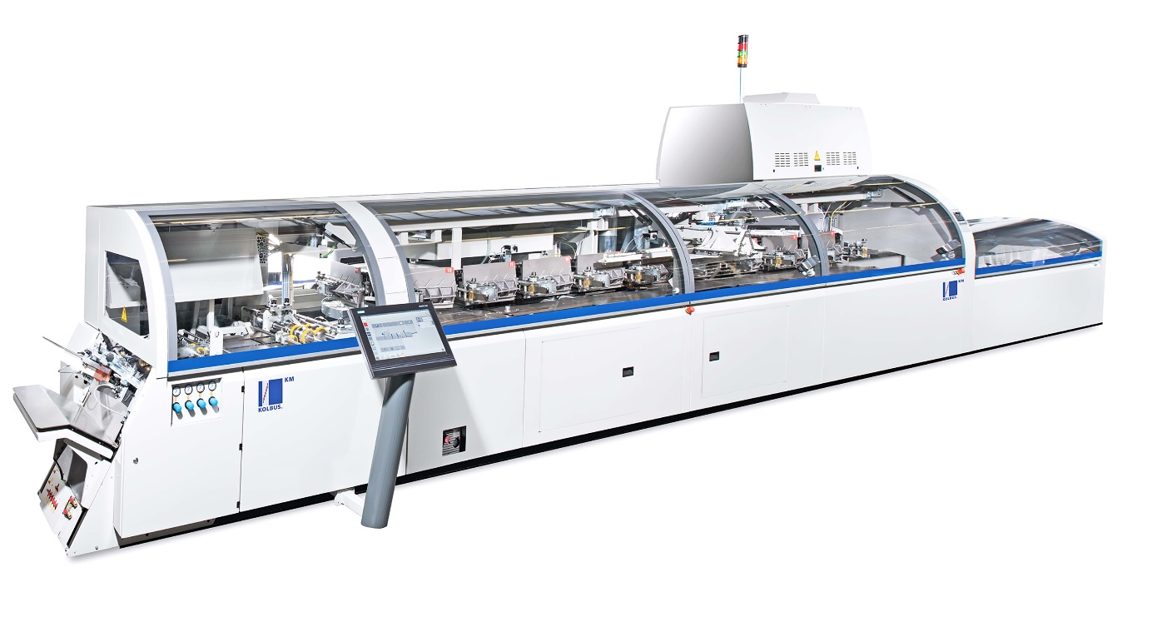
With the new KM 610.A, Wydawnictwo Jedność can now use the two-shot gluing process as well.

Compared to its previous model, a Muller Martini Acoro A5 that has been retired after 11 years and more than 70 million books produced, the new softcover line is a technical innovation, especially when it comes to gluing, according to Director Leszek Skorupa. “With the new KM 610.A, we can now use the two-shot gluing process as well. First we apply cold emulsion and then hot melt or PUR, which results in a thinner layer of glue and thus better layflat behavior of the books.” In the softcover segment, books have great size variability as well as a broad range of print runs from 1,000 to 80,000 copies, with an average of 5,000 per title.

The director of Wydawnictwo Jedność, which employs around 100 people and also has an EMP 513 casing-in machine and two DA 270 casemakers from Kolbus, is confident that the book market will remain stable over the coming years. “But we need to satisfy our customers by providing high quality and – especially in the short-run segment – fast delivery times. That’s why we continuously invest in modern solutions from well-known machine manufacturers.”

