Press Release

Date 2/6/2020
No. PI 2237
Number of characters 3351
Contact Muller Martini AG
Untere Brühlstrasse 17, 4800 Zofingen
Tel. +41 (0)62 745 45 45
www.mullermartini.com

Connect to a Smart Factory

With Finishing 4.0 and the Connex workflow system, Muller Martini is making smart factories a reality for customers around the world. The company will be presenting concrete business cases and inspiring examples at drupa 2020 in Düsseldorf.

The smart factory is already a reality in the graphic arts industry. The numerous customer projects that have been implemented demonstrate the enormous potential of a networked printer. The biggest drivers here are the new business models. The desire for personalization, the photobook boom, applications such as web-to-print and print-on-demand require networked production processes.

Adjusting the business process
With the smart factory, production processes, the flow of materials and the exchange of data are optimally integrated. Unnecessary steps are eliminated, sources of errors are avoided and everything that can reasonably be automated is. There is no longer a focus on individual production islands, but rather on the optimization of entire business processes. As a result, even ultra-short runs can be produced cost-effectively.

Getting to know the direct benefits
This sort of switch requires learning and new ways of thinking because it changes processes in nearly every area of the company. The most important thing is for the company to know its strengths and know how it wants to develop further. The experience of Muller Martini's specialists with a number of projects has shown that idealistic approaches should be avoided and instead only those solutions that offer direct benefits should be implemented.

A comprehensive solution from Muller Martini
Muller Martini supports customers in these projects with a high level of advisory expertise and sophisticated comprehensive solutions. High-precision machine design ensures seamless collaboration as does the Connex workflow system with its numerous features. In order to support customers with the complex requirements of a smart factory project, Muller Martini provides a comprehensive workflow solution with Connex. From digital page assembly to controlling the printing press, production tracking, automatic pre-adjustments on the basis of digital job sheets through to production control, it is the only company to offer an approach that covers all aspects of this sort of project.

“Avoid all barriers”
Book production specialist Livonia Print in Riga, Latvia is preparing itself for the future of hardcover book production, thread sewing, perfect binding and saddle stitching with no less than five digital print finishing systems from Muller Martini. The company’s new and existing machines are networked via the Connex workflow system, which allows for a touchless workflow. “We see this as an important step toward our goal of total integration,” says CEO Trond Erik Isaksen. “Our business model won't work without the touchless workflow solution. The removal of all barriers between our conventional and digital production is a top priority. Using individual machines for production without them being connected is outdated. Connex also makes it easier to monitor production and set delivery times. That’s why I see no future for our industry without ‘Connextivity’.”

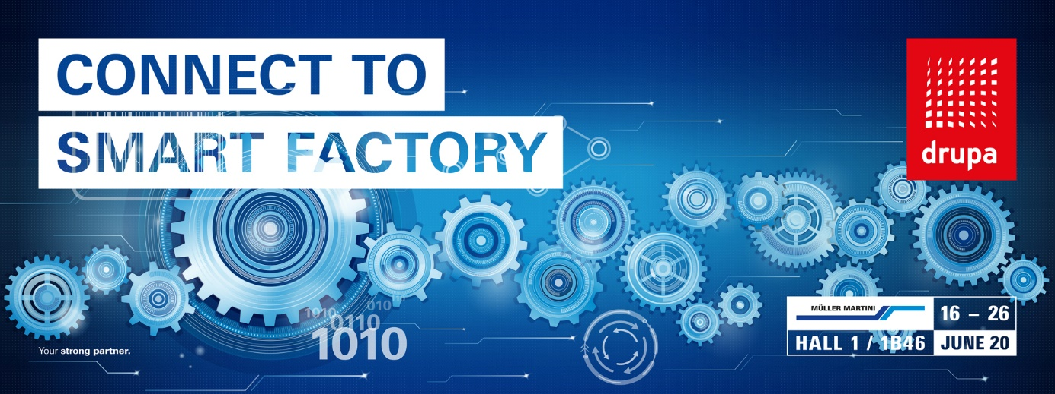

Muller Martini supports customers in smart factory projects with a high level of advisory expertise and sophisticated comprehensive solutions.

