Press Release

Date 03.10.2017
No. PI 2108
Number of characters 2120
Contact Muller Martini AG
Untere Brühlstrasse 13, CH-4800 Zofingen/Switzerland
Tel. +41 (0)62 745 45 75, Fax +41 (0)62 751 55 50
info@mullermartini.com, www.mullermartini.com

Big Leap Ahead with the Pantera

By investing in a Pantera perfect binder, Grafica Metelliana SpA in southern Italy has streamlined its softcover work processes and positioned itself for further growth.

The company, which is located near Salerno, was previously reliant on cooperation with an external bookbindery as part of its softcover workflow. The commissioning of a Muller Martini Pantera, the first perfect binder in the company’s 26-year history, has enabled Metelliana to bring print finishing fully in-house and reduce the workflow to a few meters and hours. The investment has positioned the full-service graphic arts business for further growth.

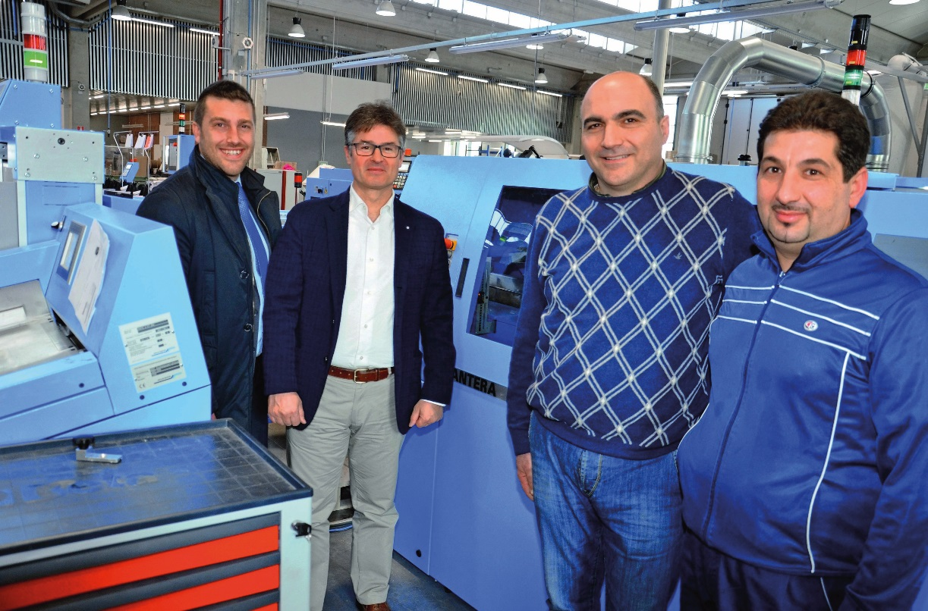
From right to left: Massimo d’Amico (machine operator), Filippo Marcellino (Works Manager), Fabio Casale and Fabrizio Golisciani (both from Muller Martini Italy) in front of the new Pantera perfect binder at Metelliana.

However, the Pantera not only has logistical advantages for the company, which until now was only able to perform saddle stitching in-house for the predominantly offset printed products in the print finishing segment. “Since we’ve switched to doing perfect binding ourselves, the complete value chain has been brought in-house and we also have significantly better deadline management and quality control,” says CEO and co-owner Gerardo di Agostino. “Thanks to the quicker changeovers, we can process the higher number of jobs extremely quickly.”

Grafica Metelliana thought hard about its decision to invest in a Pantera, with a 16-station 3692 gathering machine, a Granit three-knife trimmer and a Uno book stacker. That extensive evaluation is now really paying off. The short setup and changeover times and user-friendliness of the machine make the production process much easier for the machine operators. The company can impress customers with PUR binding – a first in southern Italy – and is now also able to offer thread-sewn products thanks to a Ventura MC 160, which has likewise been newly installed.

More information will be available on our website below in German and English (switch languages) after the publication date given above.

