Press Release

Date 31.10.2017
No. PI 2111
Number of characters 1885
Contact Muller Martini AG
Untere Brühlstrasse 13, CH-4800 Zofingen/Switzerland
Tel. +41 (0)62 745 45 75, Fax +41 (0)62 751 55 50
info@mullermartini.com, www.mullermartini.com

An Even More Dynamic Workflow

A new Primera MC saddle stitcher is enhancing the much faster workflow at Strands Grafiska in the Swedish municipality of Lindesberg.

The increase in productivity of the work process starts with the printing plates, which, using CTP technology, have four times more exposures per hour than a few years ago, and continues with an efficient eight-color sheet-fed offset press. Wire-stitching using the newly installed Primera MC with Motion Control rounds off the productivity gains. Thanks to the above steps, Strands has doubled its annual output to some 25 million copies, can now produce all jobs in-house and is also cutting costs thanks to a reduction in expensive night and weekend shifts.
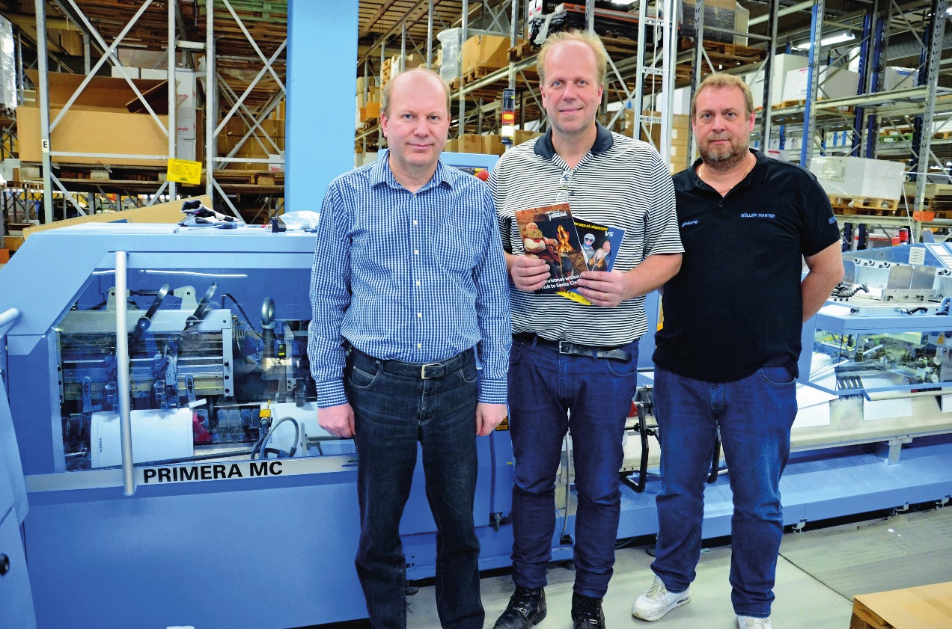
From left to right: Thomas Strand, Mikael Strand, and Johnny Mattson (technician at Muller Martini Nordic) in front of the new Primera MC.

“I worked out that the investment in the Primera MC would pay off since the make-ready times are halved compared to those with our 16-year-old saddle stitcher,” says co-owner Mikael Strand. The purchase of a new Muller Martini system with a folder feeder, three vertical pile feeders, two flat pile feeders, inkjet addressing in the chain and a Perfetto compensating stacker is not only good for the company’s bottom line, but also facilitates its work processes thanks to its seamless workflow.

Strands Grafiska produces a wide range of magazines and periodicals in run sizes of between 100 and 170,000 copies, with increasing use of digital printing and enhanced quality. Incredibly, alongside all the state-of-the-art facilities, the plant is also home to an “oldtimer”. The legendary B1 block and brochure stitching machine from Muller Martini’s early years still works perfectly after many decades at the company in southern Sweden and is chiefly used to produce over-sized wire-stitched brochures and carbon-copy blocks.

