Press Release

Date: 26.09.2018
No. PI 2146
Number of characters 2999
Contact Muller Martini AG
Untere Brühlstrasse 13, CH-4800 Zofingen/Switzerland
Tel. +41 (0)62 745 45 75, Fax +41 (0)62 751 55 50
info@mullermartini.com, www.mullermartini.com

The New Vareo Fills Order Books

Following the installation of a Muller Martini Vareo perfect binder at the beginning of this year, Tandym Print, located in Cape Town, South Africa, has seen a noticeable increase in digital print orders.

Traditional print products and package printing for the food industry still make up the lion’s share of Tandym Print’s printing volume. But because the innovative company has lately been trying to make a name for itself in the areas of print on demand, web to print and variable data printing (VDP) as well, digital printing has become more important – and it also represents a challenge in the area of print finishing for the company, which employs 152 people.
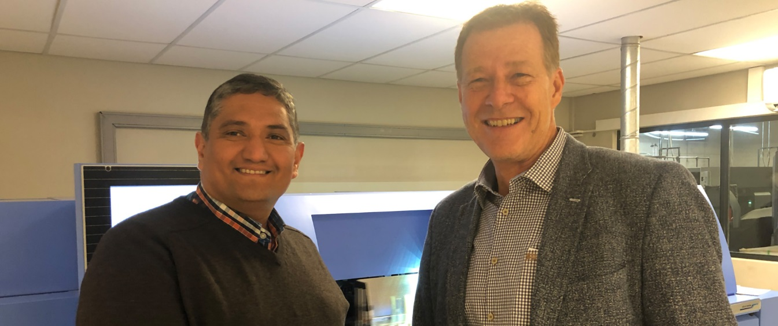
Jerome Morkel (left): “The Vareo is the ideal solution for run-of-one products for us.” Right: Jules Dietz, Muller Martini Sales Manager.

“Our increasingly younger customers are submitting orders with smaller and smaller print runs on a more frequent basis,” says Managing Director Jerome Morkel. “We need to respond to changes in the market and to our customer structure with a seamless and integrated workflow and few manual interventions during the production process.”

For this reason, Tandym Print has been producing its digital and some of its offset-printed softcover products on a new Vareo for the past few months. This is because the Muller Martini perfect binder, which runs at 1,350 cycles per hour and whose three clamps have their own servo motor and are operated individually, displays its strengths not only on ultra-short runs but also on medium print runs as well. So it is the ideal fit for the order structure at Tandym Print, which produces between one and 1,000 copies per job in the digital area – with an average run of 150 to 200.

The company, which uses five sheet-fed presses (four offset and one digital) and has worked with Muller Martini since its founding in 1994 – using an Acoro A5 perfect binder and two BravoPlus saddle stitchers in addition to the Vareo – did look at alternatives. “But the Vareo won us over not only because of its incredible user-friendliness and binding quality but also because it is the ideal solution for us for run-of-one products,” says Jerome Morkel. The books, annual reports and marketing print materials, ranging in size from A4 to A5, which are bound on the Vareo, are still cut offline. “However, during the second phase, we will invest in an inline three-knife trimmer in order to reduce processing times further and increase productivity,” says Jerome Morkel, the managing director responsible for strategic positioning and the development of new business segments.

A look at the company’s order books shows that Tandym Print made the right investment decision. Since the Vareo went into operation, sales figures in the digital printing segment have risen considerably. Jerome Morkel is confident that this trend will continue: “After all, inkjet technology and inline print finishing will also have an impact on the commercial market.”

