Press Release

Date 05.03.2019
No. PI 2180
Number of characters 2917
Contact Muller Martini AG
Untere Brühlstrasse 13, 4800 Zofingen, Switzerland
Tel. +41 (0)62 745 45 75, Fax +41 (0)62 751 55 50
info@mullermartini.com, www.mullermartini.com

Nahdet Misr: the New KM 610.A Featuring
Two-Shot Technology as the Key to Continuing Success

Nahdet Misr in Cairo is the first publishing house in Egypt to invest in a Muller Martini KM 610.A perfect binder under the Kolbus brand featuring 32 clamps for excellent two-shot technology to ensure its continuing success – the company enjoys annual growth of over 20 percent.

With 1,500 employees, Nahdet Misr – which celebrated its 80th anniversary in 2018 – is the largest private publishing business in Egypt, and one of the largest in the Middle East as a whole. It produces some 100 million books each year, including school text books and books in the fields of literature, science, Arab and Islamic culture for adults, comics, art books, and encyclopedias. Nahdet Misr installed four Kolbus perfect binders in 1999, 2009, 2016, and 2018. With a ninth web offset printing press being commissioned in a new building (in addition, Nahdet Misr has three sheet-fed offset presses), the company has opted for a fifth softcover line from Rahden, namely a KM 610.A.
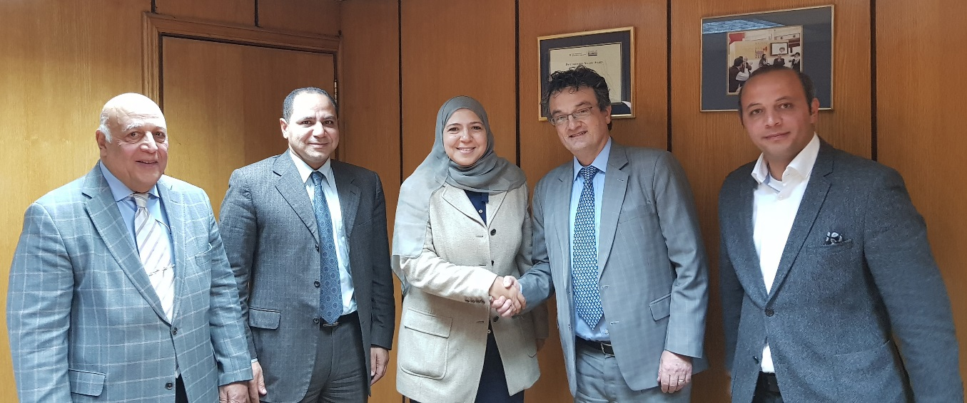
From left to right: Eng. Fathi El-Kheiashy (CEO of Texti Company, the local Muller Martini agency), Dr. Ahmed Ibrahim (Member of the Board of Nahdet Misr), Dr. Dalia Ibrahim (CEO of Nahdet Misr), Enrico Farinacci (Regional Sales Director at Muller Martini), and Eng. Sherif El-Kheiashy (Vice President of Texti Company).

Its two-shot technology with cold glue and hotmelt will enable Nahdet Misr to produce books that have significantly better layflat properties and greatly enhanced durability.

“We have a long-standing partnership with Kolbus,” says CEO Dr. Dalia Ibrahim. “And we're now looking forward to successful cooperation with Muller Martini, since long-term partnerships are part of our company philosophy.” Nahdet Misr is confident that the KM 610.A will not only ensure continued excellent quality but will also keep production waste to an absolute minimum “to help protect the environment,” explains Dr. Dalia Ibrahim.

In addition, the new perfect binder is highly flexible, making it ideally suited to Nahdet Misr’s needs, since the company has softcover runs of between 500 and 1 million copies, with an average run size of 50,000 copies per title. However, the KM 610.A will be used from this May onwards not only to produce softcover books but also to produce book blocks in the hardcover segment. The Cairo-based company is considering integrating the various perfect binder lines into a complete system using Connex.

The fact that the new line can be used for both book segments will help ensure Nahdet Misr’s continuing success. “We enjoy annual growth of over 20 percent,” says Dr. Ahmed Ibrahim, Member of the Board of Directors. “There is high demand on the Arab market, and in particular the Egyptian market, not only for larger volumes but also for higher-quality books that can be produced efficiently using high-performance systems.”

