Media Release

Date 30.11.2022
No. PI 2370
Number of characters 1981
Contact Muller Martini AG
Untere Brühlstrasse 17, CH-4800 Zofingen/Switzerland
Tel. +41 (0)62 745 45 75, Fax +41 (0)62 751 55 50
info@mullermartini.com, www.mullermartini.com

IGAS in Tokyo: Visitors Appreciated Muller Martini's Trade Show Concept

Takashi Gotanda, Managing Director of Muller Martini Japan, draws a positive balance of the five-day IGAS in Tokyo. "The number of visitors did drop by around 30 percent compared to the last trade fair in 2018. Nevertheless, it was important that we were able to meet again after the four-year break caused by the pandemic. This will definitely give a new boost to the graphic arts industry in Japan."

Muller Martini Japan's special Smart Factory exhibition concept – an interplay between the exhibition stand and the showroom, which is around 30 kilometers away and equipped with cameras – met with great interest among visitors. They were able to follow live on large screens an alternating production of A4 and B5 jobs on Primera PRO saddle stitchers linked to the Connex LineControl workflow system. They also saw the JMF feedback and thus all production-relevant data on a second large screen.

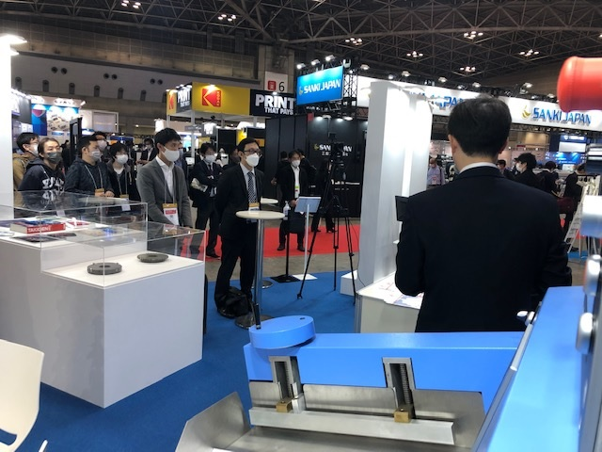
At IGAS in Tokyo, many customers were impressed by the advanced technology of the Connex workflow system.

"With this new form of presentation, we not only underlined the high production output, fast changeover and quality controls of our machines, but we also demonstrated data transfer," emphasizes Takashi Gotanda. "Many customers were impressed by the advanced Connex technology. The fact that we created the JDF using an iPad rather than a PC and sent it to the showroom was something customers found easy to understand."

The screens also ran other presentations on all five days of the show. For example, it was shown how data for book production can be easily transferred from the Book Data Center (BDC), which was located on the stand, to the Commander of the Alegro perfect binder, and what attractive end products Muller Martini's finishing systems produce. In addition, trade show visitors saw videos of Muller Martini's Japanese Smart Factory customer I-word as well as the Alegro and Primera PRO.

