Media Information

Datum 20.10.2022
Nr. PI 2358
Anzahl Zeichen 3315
Kontakt Müller Martini AG
Untere Brühlstrasse 17, 4800 Zofingen/Schweiz
Telefon +41 62 745 45 45
info@mullermartini.com, www.mullermartini.com

The New SigmaLine Compact: Finishing 4.0 Meets Sustainability

The SigmaLine family is being expanded: on the opening day of the Printing United Expo taking place at the Convention Center in Las Vegas, Bruno Müller, CEO of Muller Martini, announced the launch of the new SigmaLine Compact for the coming year. It enables digital printers to produce more end-products in a smaller space, with fewer staff and a lower waste rate. With the SigmaLine Compact, Finishing 4.0 meets sustainability in the production of books, brochures and magazines.

With the introduction of the new SigmaLine Compact as the latest innovation in digital print finishing, Muller Martini is setting another milestone in digital book block production. The expansion of the SigmaLine family is particularly impressive due to its minimal changeover times. For example, changing folding schemes – from four-up to six-up – takes just a few seconds.

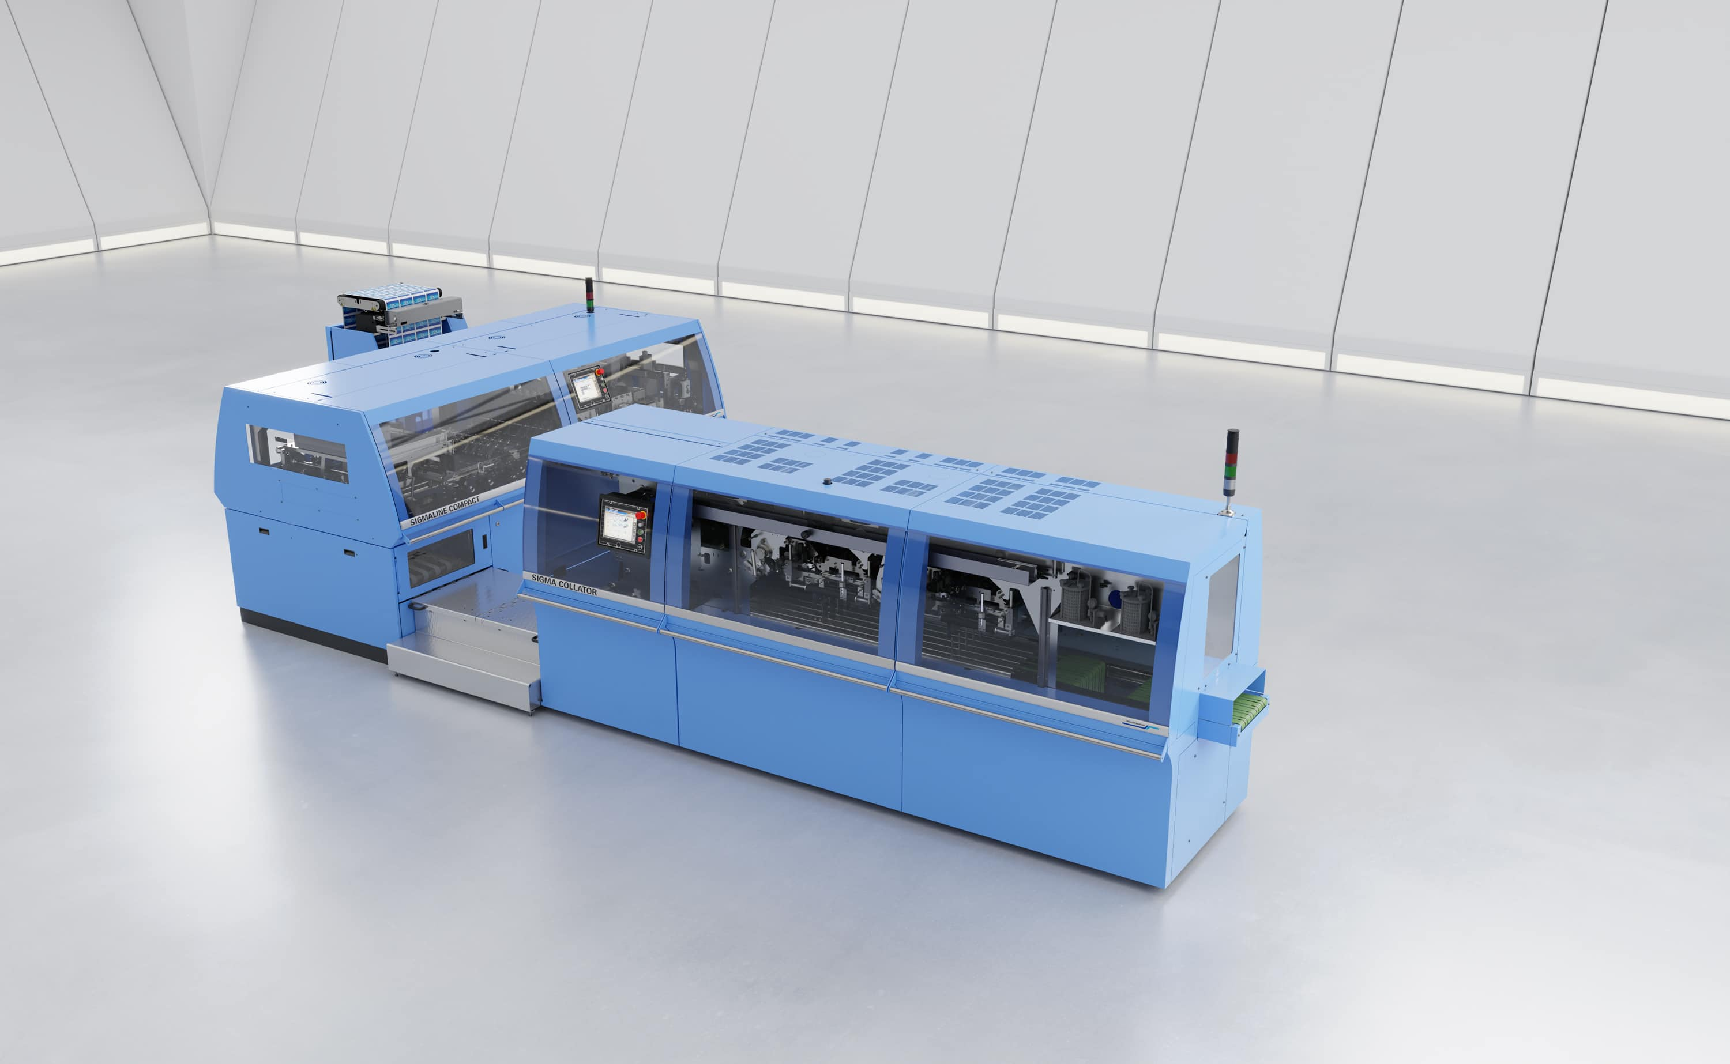
The new SigmaLine Compact covers all finishing options: softcover, hardcover, thread sewing and saddle stitching. In conjunction with the Connex workflow system, it takes finishing 4.0 to a new level.

The SigmaLine Compact, which requires a production area of just 40 m², not only sets new standards in terms of ease of operation and lower maintenance, but it also increases productivity and significantly reduces setup and changeover time. The fact that there is less than 10 m of waste generated when the folding scheme is changed is a weighty argument, especially in view of the current high material and energy prices.

Designed to handle digitally printed rolls up to 22.5 inches wide, the SigmaLine Compact is the perfect solution for any digital printer producing semi-finished products for softcover, hardcover, thread-sewn and saddle-stitched print products in his Smart Factory. By covering all print finishing options, it sets new standards in terms of flexibility and takes the topic of Finishing 4.0 to a new level in conjunction with Connex. This is because this workflow system from Muller Martini ensures a completely automated production flow without manual intervention from prepress to the end-product. In other words: thanks to the SigmaLine Compact, which Muller Martini plans to launch on the market next year, digital printers can produce more books and brochures per shift with fewer staff. This gives them a significant economic advantage.

The highlight of the SigmaLine Compact, which complements the proven SigmaLine lll with web widths of up to 42 inches, is the folding process. While all known digital folders work with a sword, former or plow fold unit, the SigmaLine Compact uses Muller Martini's patented air knife technology to process the signatures. "We have continuously improved air fold technology in recent years and use the same technology in the 22.5-inch line as in the high-speed area," says Ingolf Fritzsche. The Product Manager Digital Solutions at Muller Martini has maintained close contact with partners in the digital printing industry for years and is convinced "that companies operating in the digital sector have been waiting for this new solution."

Read in this blog on the Muller Martini website, how the SigmaLine, presented as a world premiere at drupa 2004, has been steadily developed into a multifunctional digital book block solution.

