Media Information

Date 23.11.2022
No. PI 2360
Number of characters 4778
Contact Müller Martini AG
Untere Brühlstrasse 17, 4800 Zofingen/Switzerland
Phone +41 62 745 45 45
info@mullermartini.com, www.mullermartini.com

Lean Production Meets Photobook

With its investment in a Diamant MC Digital Photobook bookline from Muller Martini, ORWO in Bitterfeld-Wolfen in the German state of Saxony-Anhalt is on the one hand ensuring full integration of all processes in photo book production. On the other hand, the company will become more flexible with regard to customer needs in terms of formats and spine width of its extensive product range.

"Hands off the product" – according to Björn Schwarzbach, this thought from the automotive world was a key consideration behind why the traditional company, which was founded more than 100 years ago and has been operating as ORWO Net since 2002, decided to switch from a BF 512 to a Diamant MC Digital Photobook. The clear aim is to produce more books even more efficiently in less time in the future.

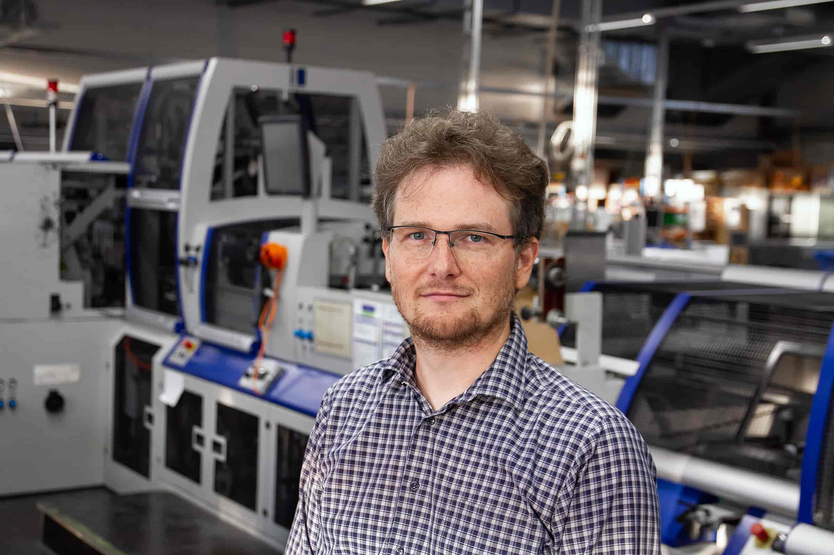
Björn Schwarzbach (in front of the current ORWO Net bookline BF 512): "Photography has a great future."

"Our Kolbus bookline is getting a bit long in the tooth," says the managing director. "It's still running fine because, for one thing, we're known for the fact that our maintenance teams take excellent care of the machinery and, for another, we have a service contract with Muller Martini. But the BF 512 is limited in terms of formats and spine widths, and many settings have to be made manually."

Three aspects that are particularly crucial for the production flow of photo books. Because for very short runs down to Book-of-1, a barcode-controlled, automated touchless workflow from a single source is required, as well as efficient batch production – and that's what the Diamant MC Digital Photobook stands for. "With the diversity of customers we serve throughout Europe, even more flexibility will be required in the future," says Björn Schwarzbach.

Transforming virtual image data into beautiful haptic products
As one of the largest photofinishing and printing companies in Germany, ORWO produces nearly one million photo books a year with its staff of around 340 employees, usually working 24/5, but in some departments also 24/7 in the run-up to Christmas. In addition, ORWO offers its customers, who are mainly from the DACH region (Germany/Austria/Switzerland) but also from all over Europe, numerous other individualized products such as calendars, digital and analog prints, posters, wall pictures, cards and innovative print products for the gift and decoration sector.

Björn Schwarzbach is convinced that "photography continues to have a great future. Especially in the mobile transformation, there are great opportunities and sales potential – in the transformation of virtual image data into beautiful haptic products that capture emotions and make them everlasting."

B2B and B2C
ORWO, which prints digitally and images on real photo paper, is on the one hand a white-label full-service partner and on the other hand, also an e-commerce company with direct sales. In other words: The company produces for major customers such as drugstore chains and well-known retail brands under their flag and supplies their end customers directly. ORWO also realizes direct customer business through its own brands PixelNet, Foto Quelle, Photo Dose, myFOTO and ORWO.

"We are therefore involved in both B2B and B2C business and are represented in-house in both areas by all experts – from producers to software developers to customer service representatives," emphasizes Björn Schwarzbach. Thanks to state-of-the-art API interfaces and the most extensive product portfolio in the white label business, the company can connect any partner within a very short time and produce for them.

During the evaluation phase of the new book line, the managing director personally convinced himself of the advantages of the Diamant MC Digital Photobook during a customer visit, which will most likely start operations in Bitterfeld-Wolfen in the third quarter of 2023.

For frictionless book production without additional manual work
The Diamant MC Digital Photobook enables sequential changeovers and batch production down to single books, as well as 1:1 matching and matching via a reference list. It has a variable-format single-cover feeder as well as block and cover ejection. This allows them to feed different formats to the Diamant MC Digital Photobook without interruption in the automatically controlled production flow.

Changeovers run sequentially and efficiently. The block and cover ejection system enables book blocks and covers to be ejected fully automatically if required – after comparing the incoming products with a reference list in the job ticket, which comes via the Connex workflow system developed by Muller Martini. This means that production can continue without interruption.

Read more about Muller Martini's digital booklines in this blog.

