ExpoPrint in São Paulo: Muller Martini draws a successful balance sheet

The five-day ExpoPrint in the Brazilian metropolis of São Paulo was a great success for Muller Martini, with the same number of visitors to the stand as four years ago.

Unlike many other trade shows, ExpoPrint was not affected by the corona pandemic and went ahead as scheduled every four years. However, the total exhibition space was reduced to less than half compared to 2018 and the number of exhibitors from over 300 to 164, but the drop in visitors was not as marked: 40,000 compared to 50,000 four years ago.

Only a few exhibitors showed machines. Muller Martini Brazil dispensed with live demos and presented running machines on a large screen at its attractive stand. These met with great interest from trade show visitors from eight different countries (Brazil, Argentina, Chile, Uruguay, Paraguay, Bolivia, Colombia, Mexico), who were fortunately in the same range as in 2018.

"For Muller Martini, the show was a great success," says Hector Castro, Regional Director Latin America. "We generated more leads – including contacts with potential new customers – for machines than four years ago and successfully closed a machine sale with a DA 270 casemaker, a product of Kolbus, a company we represent."

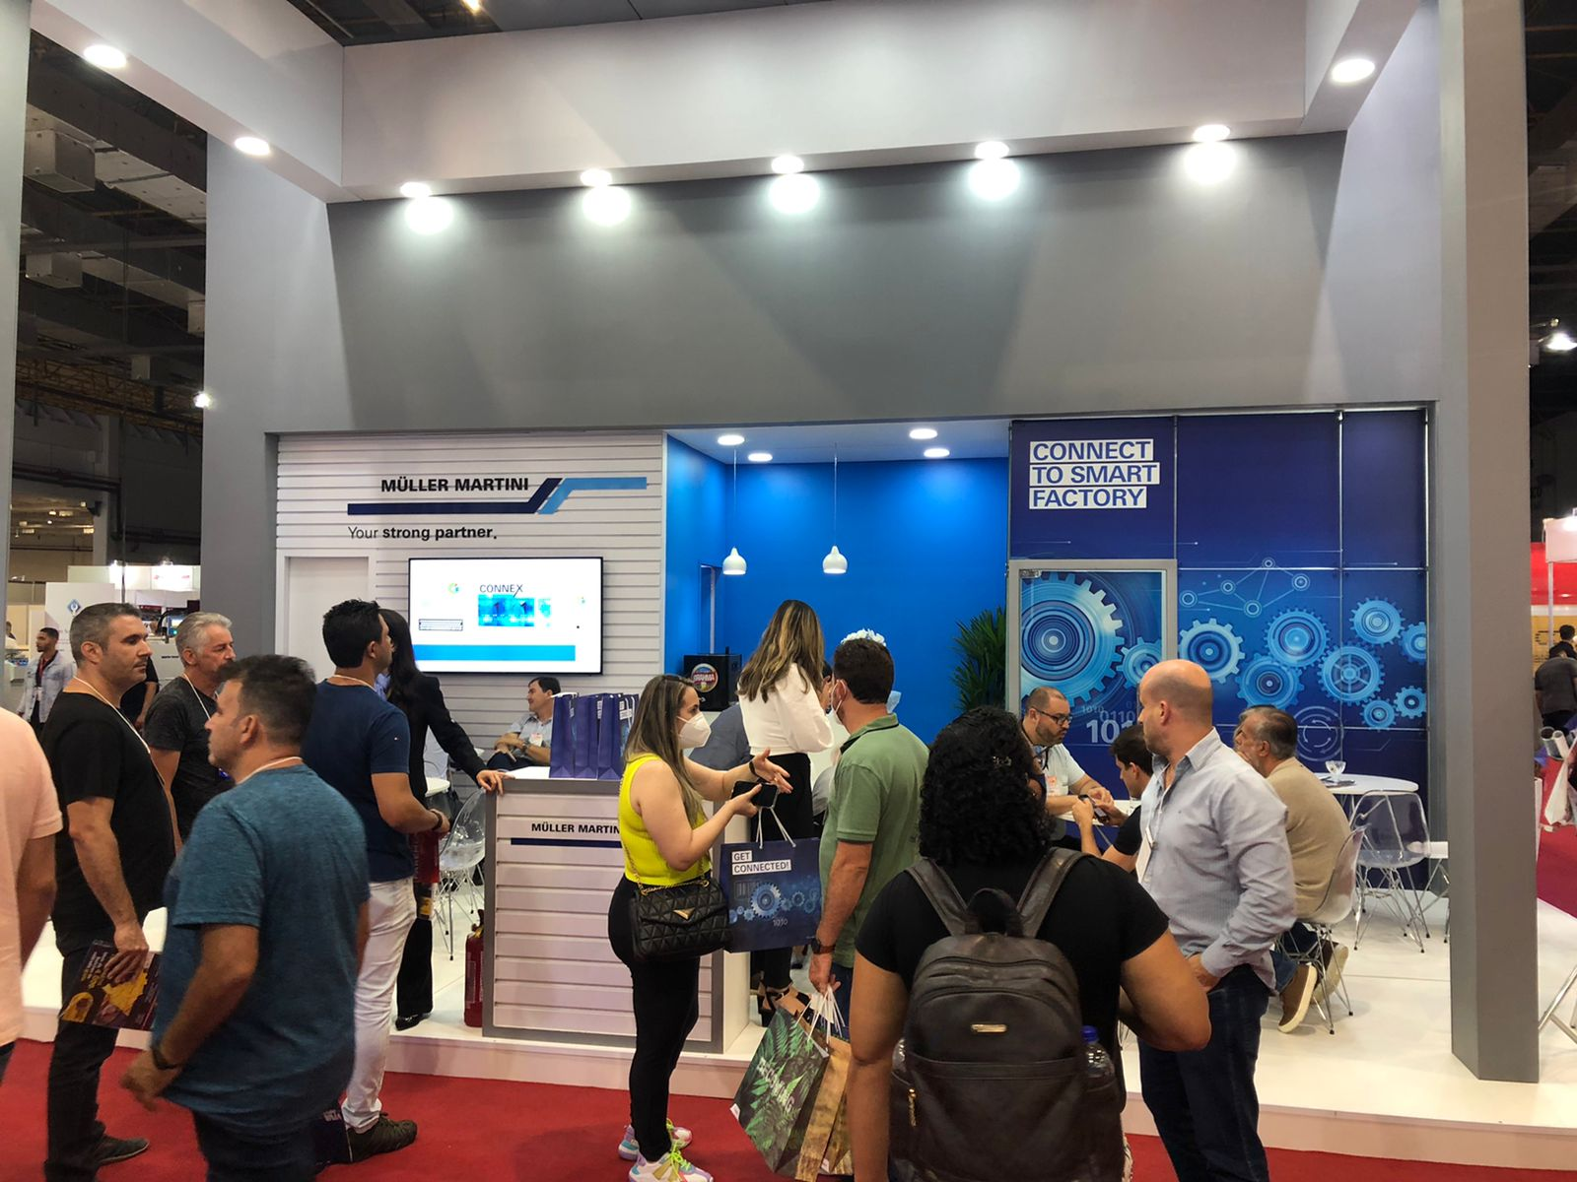
The Muller Martini stand at ExpoPrint attracted a great deal of interest from visitors from eight different countries.

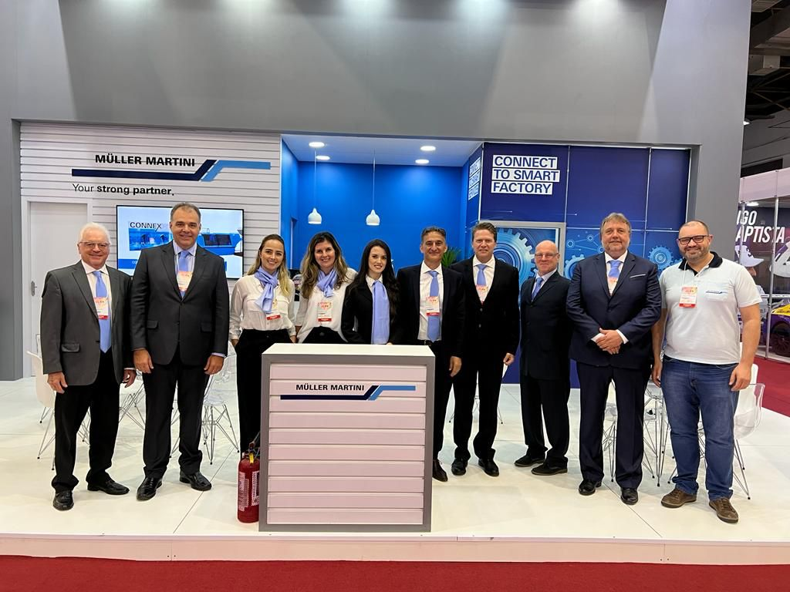
The Muller Martini stand team at ExpoPrint in São Paulo.

