Press Release

Date 22.11.2018
No. PI 2163
Number of characters 2105
Contact Muller Martini AG
Untere Brühlstrasse 13, CH-4800 Zofingen/Switzerland
Tel. +41 (0)62 745 45 75, Fax +41 (0)62 751 55 50
info@mullermartini.com, www.mullermartini.com

More Productive and Higher Quality

Spain’s Gómez Aparicio Grupo Gráfico has been able to produce softcover products much faster since the installation of an Alegro perfect binder, allowing it to better meet its customers’ quality requirements.

Located in Casarrubuelos, near Madrid, the company produces Bibles for customers around the world as well as textbooks for regions across Spain. The many different languages that are printed and the fall in run sizes have resulted in increased changeovers, which the Alegro is capable of handling more quickly than the aging previous machine. The new softcover production has also resulted in higher quality, which is already visible to the naked eye. With the Alegro, Gómez Aparicio is also better equipped to meet its other objectives – providing shorter delivery times and innovative solutions.

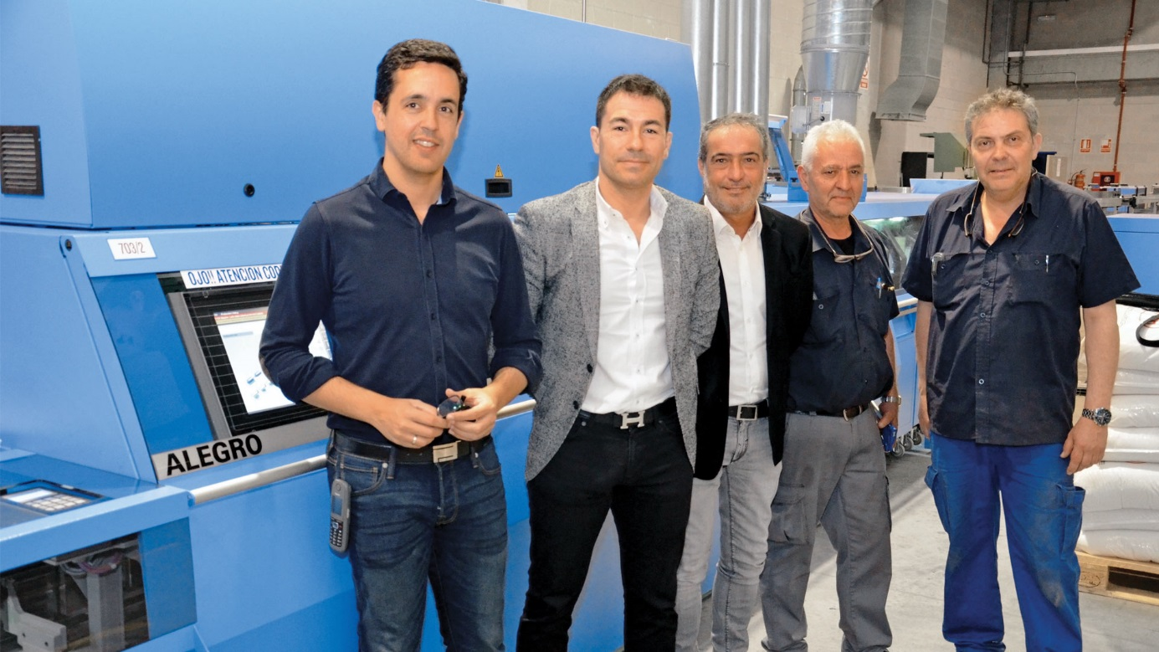
From left to right: Enrique Diaz (Works Manager), Luis Francisco Hedo Gómez (CEO), Carlos Barnes (Sales Manager at Muller Martini Ibérica), Eduardo Pérez (Maintenance Manager), and Lisardo Fins (Workshop Manager) in front of the new Alegro perfect binder at Gómez Aparicio.

Besides the shorter make-ready times, the higher quality of end products and synergy effects for the machine operators of other Muller Martini models, the new Alegro has had another positive impact for Gómez Aparicio, which employs around 50 people. “Thanks to the significantly higher productivity, we’re easily able to save one to two shifts,” says Managing Director Luis Francisco Hedo Gómez.

The market leader in digital printing in Spain wants to use the Alegro line with a 3694 gathering machine (with 15 stations), an endsheet feeder, criss-cross delivery, an Orbit three-knife trimmer, an Easy Fly front trimmer, and a CB 18 book stacker for digital production, too. So it is currently evaluating a solution to use the Alegro to bind books consisting of single sheets from the two Canon digital printing presses. Digital printing has become successful because of the increase in on-demand printing of thick books with short runs due to the amount of warehouse space such books require.

