Press Release

Date 18.03.2019
No. PI 2194
Number of characters 1427
Contact Muller Martini AG
Untere Brühlstrasse 13, 4800 Zofingen, Switzerland
Tel. +41 (0)62 745 45 75, Fax +41 (0)62 751 55 50
info@mullermartini.com, www.mullermartini.com

Expográfica in Mexico City – the Vareo Perfect Binder Attracts Great Interest

The Vareo perfect binder was the center of attention among visitors from eight different countries to the Muller Martini at the four-day Expográfica in Mexico City.

The event was the first occasion that the Vareo was showcased live at a Mexican trade fair. It is designed for digital and offset printing and each of its three clamps are equipped with their own servo motor and driven individually. Accordingly, it met with great interest among the over 400 visitors to the booth from Mexico, as well as the neighboring countries of Costa Rica, Guatemala, Honduras, Colombia, Panama, El Salvador and Ecuador.
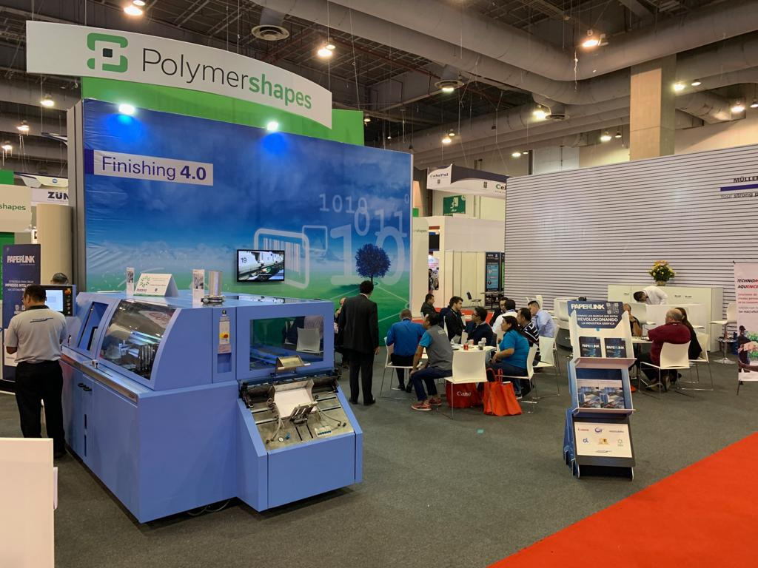
The Vareo perfect binder drew large numbers of visitors to the Muller Martini booth at Expográfica in Mexico City.

Muller Martini’s live demos showed that the Vareo – an all-rounder which boasts an excellent price-performance ratio – comes into its own not only in digital printing for ultra-short runs right down to one copy per job, but also for medium runs, regardless of whether the brochures are produced using offset or digital printing.

Hector Castro, Muller Martini Managing Director for the Latin America region, had two reasons to celebrate – as well as being delighted by how well-attended the booth was, he also had the opportunity to toast Muller Martini Mexico’s 20th birthday at the trade fair together with customers and staff.

