Media Information

Date 26.05.2023
Nr. PI 2386
Character 2236
Contact Müller Martini AG
Untere Brühlstrasse 17, 4800 Zofingen/Schweiz
Phone +41 62 745 45 45
info@mullermartini.com, www.mullermartini.com

After perfect binding, CPB also modernizes hardcover production

One year after purchasing an Alegro perfect binding line, Casa Publicadora Brasileira (CPB), based in Tatuí in the state of São Paulo, is also investing in two new hardcover systems from Muller Martini.

The company, which belongs to the Seventh-day Adventist Church and is one of the technological leaders in graphic arts in Brazil, has relied on Muller Martini finishing solutions for many years. The most recent investments were a Primera MC saddle stitcher, a Vareo perfect binder with InfiniTrim three-knife trimmer and, a year ago, an Alegro perfect binder, which is currently being installed.

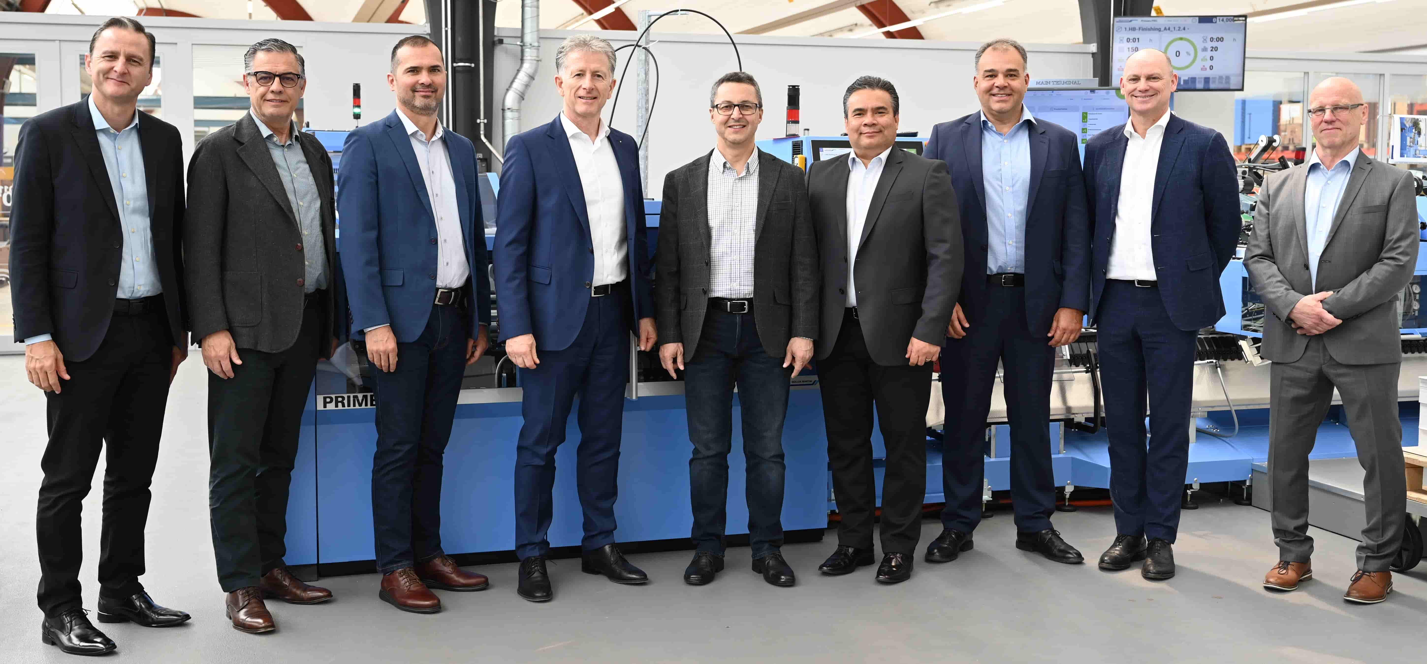
At the Print Finishing Center in Zofingen, Seventh-day Adventist Church, CPB, and Muller Martini toasted the sale of a Diamant MC 60 bookline and RF 700 spine gluing and folding machine.

In addition to saddle stitching and perfect binding, the company, which covers the entire graphic production chain from prepress to press and postpress and, as a long-standing partner of Muller Martini, also keeps its doors open at all times for other Brazilian customers, is also involved in the hardcover segment. In order to be at the cutting edge of technology there as well, CPB is investing in a Diamant MC 60 bookline and an RF 700 backgluing and backlining machine as a replacement for a BF 530 book line. Both systems will be installed in the coming year.

The RF 700, which can be configured as a 30- or 70-cycle/minute line, is the most universal gluing solution for thread-sewn book blocks: gluing on endpapers, gluing off and rebating – all processes take place in a single machine. The CoPilot system also enables efficient operation and the fastest make-ready times.

The Seventh-day Adventist Church Latin America – represented by Stanley Arco (President), Marlon Lopes (CFO) and Edward Heidinger (Secretary) – and CPB – represented by Edson Medeiros (President) and Uilson Garcia (CFO) – took advantage of the recent investment decision to visit Muller Martini headquarters in Zofingen and meet with Bruno Muller, CEO of Muller Martini.

Learn more about the benefits of the RF 700 backgluing and backlining machine in this blog on the Muller Martini website and in this video.

