Media Information

Date 2/25/2024
No. PI 2421
Number of characters 4209
Contact Müller Martini AG
Untere Brühlstrasse 17, CH-4800 Zofingen/Switzerland
Phone +41 62 745 45 45
info@mullermartini.com, www.mullermartini.com

Finishing Focus Day at Müller Martini

A Focus on New Solutions at Müller Martini

More visitors than expected and many interesting conversations: On February 22, Müller Martini invited German customers to a Finishing Focus Day at its Print Finishing Center in Zofingen. More than 50 people were enthusiastic about Müller Martini’s latest innovations.

Visitors were treated to a packed program at the Müller Martini headquarters in Zofingen. The factory tour through the assembly halls and training facility started things off, followed by machine demonstrations on the Prinova Digital and Primera PRO saddle stitchers. The Vareo PRO and Alegro perfect binders also showed off their advantages in live production. Moreover, there were detailed explanations of the possibilities offered by the Connex workflow system with its various modules and the MPOWER customer portal. “The focus day offered me a great opportunity to get to know machines such as the Primera PRO, with which I was not previously very familiar,” said Jens Diegelmann, Technical Manager at Xerox GmbH. “The information about the Connex workflow system was especially exciting for our operation – our employees could use a training in order to exploit its advantages in our operation in the future.”

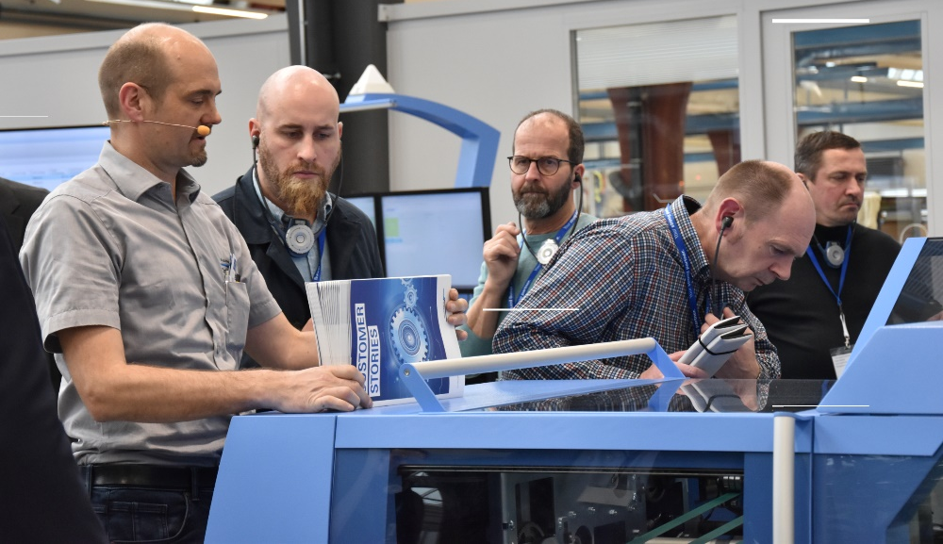
Successful customer event: At the Finishing Focus Day, German customers experienced the latest production systems that Müller Martini offers for the digital and conventional print markets.

The highlight of the event was the presentation of the new compact book block production line, which consists of SigmaLine Compact, the Antaro Digital perfect binder, and the InfiniTrim cutting robot. The audience was impressed by the details. The output of this highly automated line is 2,000 copies per hour with a thickness variance of 20 mm from book to book – without any loss of speed. This corresponds to a tripling of output as compared to previous solutions. Continuous barcode-based production enables completely touch-free conversion. This happens de facto on the fly and offers the flexibility that small runs or book of one production require. “It is a very exciting solution,” confirms Jens Diegelmann. “For our goal is to realize continuous, fully automated production from printing to the end product.”

Availability and operating personnel costs were also an object of the demonstration, for only two people are required to operate the entire production line – a machine operator and an assistant. The space required for the entire process chain, from folding to gluing to cutting, is just 170 sq m – whereas once upon a time, you would have needed much more than 300 sq m for all this.

“Müller Martini proves that as a partner to the print industry, it has understood the transformation that is taking place in the entire graphic industry and serves as an innovative partner to printing plants and bookbinders despite the massively changed conditions,” says Tobias Kaase, summarizing his impressions of the focus day. “The path for all developments is heading increasingly toward small runs, machines that can be changed over quickly, and hybrid production – which reflects what we’re already doing.” The Managing Director of mediaprint solutions GmbH will soon be adding an endsheet feeder and an automatic book feeder to his smart factory, which consists of a Vareo PRO perfect binder and an InfiniTrim.

Always with a finger on the pulse of the times, Müller Martini invited Tobias Kaase to give a lecture on the topic of future-oriented production with artificial intelligence. He reported how his company has undergone a digital transformation in recent years and what experiences he has had with the establishment of a smart factory with regard to infrastructure, organization, and personnel. His conclusion: “Artificial intelligence is a wonderful tool, but so that it can be used successfully, people, in particular, employees, are needed who can apply it sensibly.”

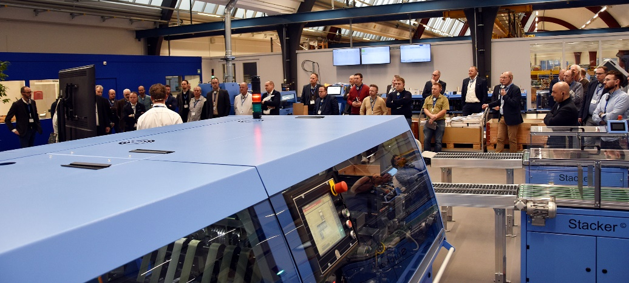
Visitors to the Finishing Focus Day, which was held at Müller Martini in Zofingen, Switzerland in February 2024, were enthusiastic about the highlight: the SigmaLine Compact book block production line with Antaro Digital perfect binder and the InfiniTrim cutting robot.

