Media information

Date 20.04.2021
No. PI 2298
Number of characters 2954
ContactMüller Martini AG
Untere Brühlstrasse 17, 4800 Zofingen/Switzerland
Phone +41 62 745 45 45
info@mullermartini.com, www.mullermartini.com

Muller Martini at virtual.drupa

"We will show you our renewed portfolio"

Muller Martini has kicked off virtual.drupa with the presentation of its renewed machine portfolio and will be offering you interesting information on the subject of digital transformation in the graphic arts industry in the web session on April 23 at 8:40 a.m.

"At virtual.drupa, we will be showing you our comprehensively renewed portfolio in a streamlined form with the consistent expansion of our Finishing 4.0 solutions," enthuses Bruno Müller, CEO of Muller Martini, on the opening day of the online event. "We can thus offer you maximum efficiency and flexibility in the production of print products - from large print runs to individualized single copies." Visitors will be able to get a detailed overview of the machines launched on the market last year in the Muller Martini exhibition area.
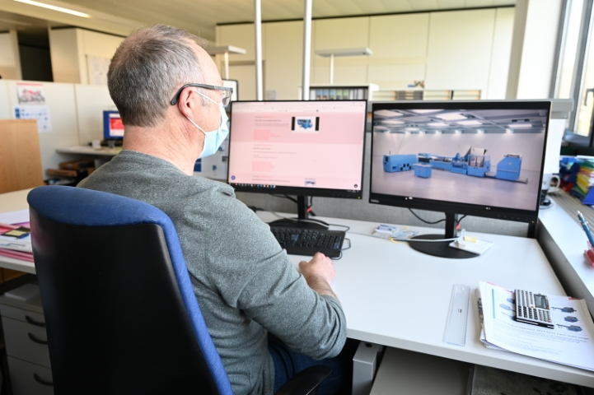

Stop by the online showroom
The trade show's new online format offers an efficient alternative for easily and conveniently gaining an impression of new products and trends, despite the pandemic-related travel restrictions. In addition to the information on the virtual.drupa platform, visitors to Muller Martini have the opportunity to visit the online showroom, which is permanently available. Its range has been expanded and now also includes the SigmaLine III digital book block line, the Diamant MC book line, the Alegro and Publica PRO perfect binders, and the Ventura MC book sewing machine with the VFN 700 spine nipping press.

Digital transformation web session
On Friday, April 23, 8:40 a.m., we also invite you to our web session "Müller Martini: Your strong partner - driving the digital transformation in print finishing". Speakers Volker Leonhardt, Group Management and Head of Global Sales, and Georg Riva, Head of Sales, will explain why there is no out-of-the-box solution for a smart factory. Rather, it requires a workflow that is perfectly tailored to individual needs in order to realize a digital transformation.

Muller Martini not only has the products, business and workflow solutions for this process, but also supports its customers with experience from numerous projects that have already been implemented. In the webinar, the experts will highlight some of the solutions that Muller Martini offers and show exciting case studies from recently implemented projects.
You are welcome to register to participate in the web session here.

"In addition to the virtual presence, however, we are looking forward to the personal contact with our customers that we hope will soon be possible again," says Bruno Müller. "Because just as the physical presence of printed products has advantages over digital content, the virtual presence does not replace the impression of a real and successful machine presentation."

First of all, however, Muller Martini is looking forward to your visit to virtual.drupa. Click here for comprehensive information in our exhibition area.

