Press Release

Date: 9/14/2017
No. PI 2114
Number of characters 4499
Contact Muller Martini AG
Untere Brühlstrasse 13, CH-4800 Zofingen/Switzerland
Tel. +41 (0)62 745 45 75, Fax +41 (0)62 751 55 50
info@mullermartini.com, www.mullermartini.com

Muller Martini’s Finishing 4.0 Solution
Wins the 2017 Swiss Industry 4.0 Award

Muller Martini, the innovative, Zofingen-based machine manufacturer, had the great honor of being presented with the 2017 Swiss Industry 4.0 Award for its Finishing 4.0 book production line for runs of one copy at the Swiss Industry 4.0 Conference at the TRAFO Culture and Congress Center in Baden.

With its forward-looking Finishing 4.0 strategy, which draws on Industry 4.0, Muller Martini ensures all its systems meet the requirements of the increasing customization and personalization of print products and the production of ultra-short runs. The book production system that won the 2017 Swiss Industry 4.0 Award boasts a seamless, touchless workflow, i.e. books can be produced in runs of one copy without manual interventions and setup time.

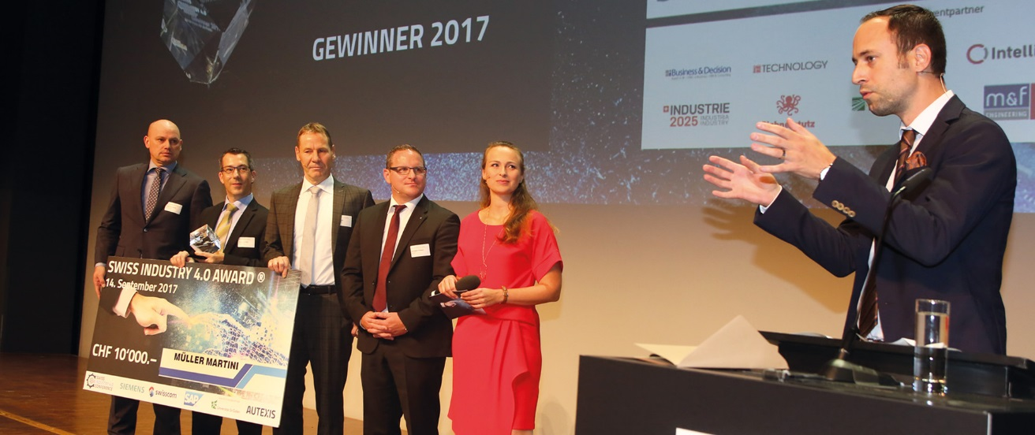
From left to right: the three representatives of Muller Martini Volker Leonhardt, Markus Bracher and Roland Kost together with Philippe Ramseier (representative of the co-operation partners), Nina Havel (moderator) and Christian Wasserfallen (member of the Swiss parliament), who hold the laudation.

The Connex workflow system that was developed by Muller Martini connects all work steps. First it reads the book data from the PDF. The size and job data are prepared for the digital printing press. The individual book is printed onto a web and processed into a book block. The book block and the cover are glued together in the Vareo perfect binder and then trimmed to the final size in the InfiniTrim three-knife trimmer. The size, thickness and content of each book can differ, and all settings are performed fully automatically. “The workflow system combines all process steps, from online ordering and printing through to bookbinding and immediate delivery of the book,” says Roland Kost, Head of Technology at Muller Martini Print Finishing Systems AG, emphasizing the considerable benefits of Connex.

Runs of one copy, which are especially associated with photo books, pose major production challenges. “Today a printing plant has to be able to process up to 10,000 jobs per day,” notes Volker Leonhardt, Head of Marketing and Sales at Muller Martini Print Finishing Systems AG. “However, that’s only possible with a seamless and touchless workflow solution like Connex that controls the whole process.” Muller Martini designed the Vareo perfect binder and InfiniTrim three-knife trimmer to enable the production of runs of one copy – the entirely new, highly automated systems boast revolutionary technology.

That has numerous logistical advantages. Book producers can eliminate their stock and no longer need to print minimum runs. That is a key advantage given that an extensive part of the books printed worldwide are never delivered and are fed into the recycling system directly from the warehouse. As a result, on-demand production also protects natural resources.

********************

About Muller Martini
Muller Martini, a family business that was founded in 1946, has its headquarters in the city of Zofingen (in the Swiss canton of Aargau) and is a world leader in the development and production of industrial system solutions for print finishing. The full range of graphic arts publications, from softcover and hardcover books through to magazines, catalogs, mailshots and newspapers, is produced worldwide using Muller Martini systems.
www.mullermartini.com

About Finishing 4.0
The Finishing 4.0 strategy that Muller Martini launched at drupa 2016, with all the exhibited systems connected via the Connex workflow software, heralded the printing plant of the future. Muller Martini’s impressive exhibition at the trade fair in Düsseldorf attracted considerable attention in the industry. Muller Martini’s newly developed, cleverly combined industrial solutions in line with its strategy of Finishing 4.0 have enjoyed growth on the otherwise declining market of the graphic arts industry, which is undergoing major structural change.
www.mullermartini.com/de/int/unternehmen/finishing-4-0/

About the Swiss Industry 4.0 Conference
The Swiss Industry 4.0 Conference is the leading practice-oriented event in Switzerland on the topic of digitalization and digital transformation. Each year, the event (under the slogan of “paving the way for the digital economy”) brings together over 300 business executives, who are keen to make use of the opportunities offered by Industry 4.0 and exchange ideas with experts and other industry representatives.
www.industry40.ch

