Press Release

Date: 23.10.2017
No. PI 2120
Number of characters 1537
Contact Muller Martini AG
Untere Brühlstrasse 13, CH-4800 Zofingen/Switzerland
Tel. +41 (0)62 745 45 75, Fax +41 (0)62 751 55 50
info@mullermartini.com, www.mullermartini.com

Mediaworks-PLT Invests in Two FlexLiners for Automatic Inserting

The newspaper producer Pannon Lapok Társasága (PLT) as a part of Mediaworks Group located in the Hungarian town of Veszprem is investing in two Muller Martini FlexLiner inserting systems to handle its increasing insert volume.

PLT, which was recently acquired by Mediaworks Hungary Zrt., Hungary’s largest private newspaper group, prints several local and national daily newspapers in tabloid and broadsheet format with a total average run size of some 300,000 copies per day. At present the company still manually inserts the ever growing volume of inserts and preprinted sections. To boost the efficiency and cost-effectiveness of its production, the Hungarian printing plant is investing in two FlexLiner 3 in 1 inserting systems with a NewsStack compensating stacker and L mini feeders for automatic main-section feeding.

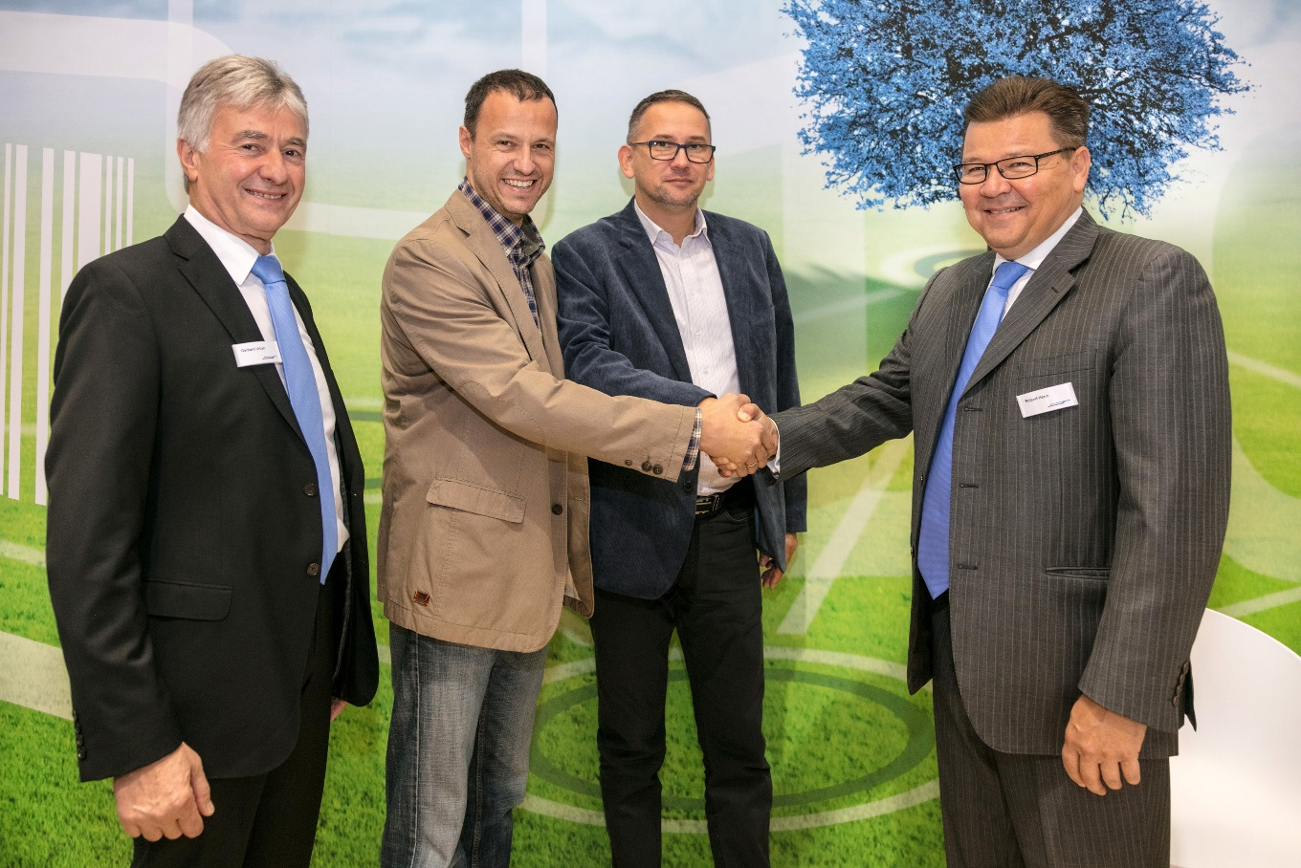
From left to right: Roland Henn (Managing Director of Muller Martini Eastern Europe), Gábor Ferenc Horváth (Head of Printing Department PLT Veszprem), László Bertalan (Printing Plant Director Mediaworks Group), and Gerhard Urban (Sales Manager at Muller Martin Martini Eastern Europe) shaking hands at IFRA World Publishing in Berlin.

Mediaworks-PLT chose the Muller Martini solution not only because the FlexLiner is highly flexible in terms of the formats that can be processed, but also because main sections can be opened with or without a low folio lap. The new systems will be delivered at the end of the year and commissioned early next year.

