Press Release

Date 05.03.2020
No. PI 2232
Number of characters 2149
Contact Muller Martini AG
Untere Brühlstrasse 17, 4800 Zofingen/Switzerland
Tel. +41 (0)62 745 45 45
info@mullermartini.com, www.mullermartini.com

The Perfect Hybrid Application

A hybrid Alegro Digital from Muller Martini allows Core Publishing Solutions, located in Eagan, Minnesota (USA), to work much more efficiently.

The company, which is part of the Thomson Reuters Group, has de facto three machines in one thanks to a special customer-specific configuration. Because the signature stack feeder is not the start of the perfect binding line for digitally printed products, but instead is located between the gathering machine and the binder, two processes can run at the same time. Digitally printed products go directly from the feeder to the binder, while the gathering machine is prepared for the next offset production or uses them to gather the signatures while the digital job is running.

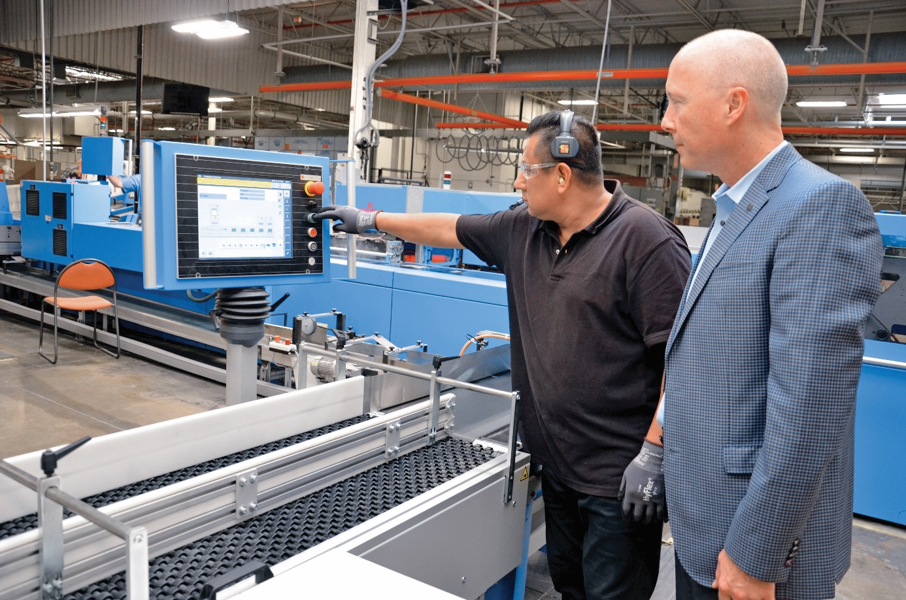

Israel Bonfil (machine operator at Core Publishing Solutions) with Eric Olsen (Sales Manager at Muller Martini North America) at the signature stack feeder for digitally printed products, which, in a specially designed configuration, is located between the gathering machine and the Alegro Digital perfect binder.

Director Steve Zweber calls this configuration for Core Publishing Solutions, “the perfect hybrid application, which has accelerated the workflow substantially and allowed us to keep pace in print finishing with the enormous growth and changes in digital printing.” At 71 meters long, the Alegro Digital in Eagan is one of the world’s largest lines. The perfect binding line stretches from the manual feed to the 27-station 3694 gathering machine, the Solit three-knife trimmer and the CB 18 book stacker to the Pluton palletizer.

At Core Publishing Solutions, the hybrid Alegro Digital really shows its strengths when printing both short-run jobs with low page counts and offset printed long-run jobs with higher page counts. Print continues to play an important role in the multimedia company’s communication mix. Core Publishing Solutions produces more than 18 million reference books, specialized brochures and updates each year. Although three-fourths of all print jobs at Eagan are processed digitally, digital printing only accounts for 15 percent of the company’s page volume.

