Media information

Date 23.04.2021
No. PI 2301
Number of characters 2320
ContactMüller Martini AG
Untere Brühlstrasse 17, 4800 Zofingen/Switzerland
Phone +41 62 745 45 45
info@mullermartini.com, www.mullermartini.com

Successful web session on digital transformation

At virtual.drupa, Muller Martini provided information in the web session "Muller Martini: Your strong partner - driving the digital transformation in print finishing" about the possibilities of digital transformation towards the Smart Factory.

Georg Riva, VP Global Sales at Muller Martini, explained to the participants why there is no out-of-the-box solution for a smart factory. Rather, he said, the decisive factor for digital transformation is that the digital workflow is perfectly tailored to the individual needs of each customer. He recommended that the audience follow a four-step process that first builds understanding of digitalization, then clarifies business needs, structures process knowledge, and finally designs the workflow for the smart factory. "We advise our clients to focus on their strengths," George Riva explained. "It is important to avoid idealistic approaches and only implement solutions that bring direct benefits."

For cost-efficient production
Co-speaker Volker Leonhardt, Group Management and Head of Global Sales at Muller Martini, presented two case studies of recently implemented projects in the second part of the presentation. In doing so, he pointed out the wealth of experience that Muller Martini has now gained from numerous projects that have already been implemented. In the first application, he showed a workfow solution for individualized mass production with full integration from prepress to the finished product. "Manual interactions are reduced to a minimum, which enables cost-efficient production," explains Volker Leonhardt. "And errors are avoided, of course."

Let us advise you!
The Book-of-One application for soft and hardcover production that is also being presented, in which each product varies in content, format, number of pages and thickness, is controlled entirely via a job ticket generated in the MIS. Barcodes are used in finishing to guarantee the quality of each product. "We are dealing here with very complex and individual solutions," Volker Leonhardt reminded the audience. "That's why I invite anyone who is considering a digital transformation of their company to seek comprehensive advice. This is where Muller Martini, as a strong partner, is happy to put its great expertise at your disposal."

((CTA))
I would like advice on digital transformation

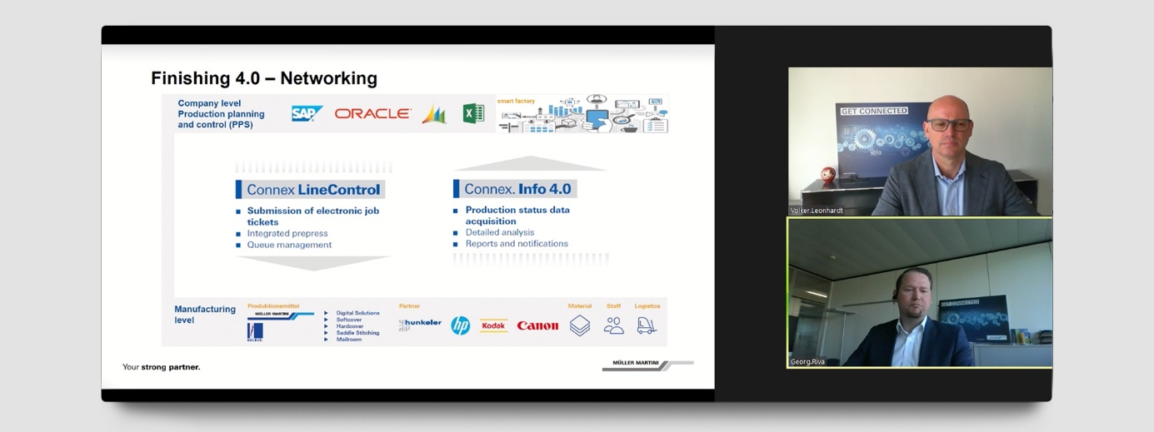

At the web session "Muller Martini: Your strong partner - driving the digital transformation in print finishing" held on the occasion of virtual.drupa, speakers Volker Leonhardt, Group Management and Head of Global Sales (above), and Georg Riva, VP Global Sales, explained why there is no out-of-the-box solution for a smart factory.

