Media Information

Date 25.03.2022
Nr. PI 2331
Character 2'123
Contact Müller Martini AG
Untere Brühlstrasse 17, 4800 Zofingen/Schweiz
Phone +41 62 745 45 45
info@mullermartini.com, www.mullermartini.com

CPB aims to maintain high softcover quality with a new Alegro perfect binder

Casa Publicadora Brasileira (CPB), based in Tatuí in the state of São Paulo, is one of the technologically leading graphic arts companies in Brazil and is once again investing in a finishing system from Muller Martini in the form of the Alegro perfect binder.

The Alegro will replace an aging Acoro in a few months and will ensure that CPB can continue to produce its softcover books in high quality. In addition to perfect binding, the company, which covers the entire graphic production chain from prepress to press and postpress, is also involved in the hardcover segment and in saddle stitching.

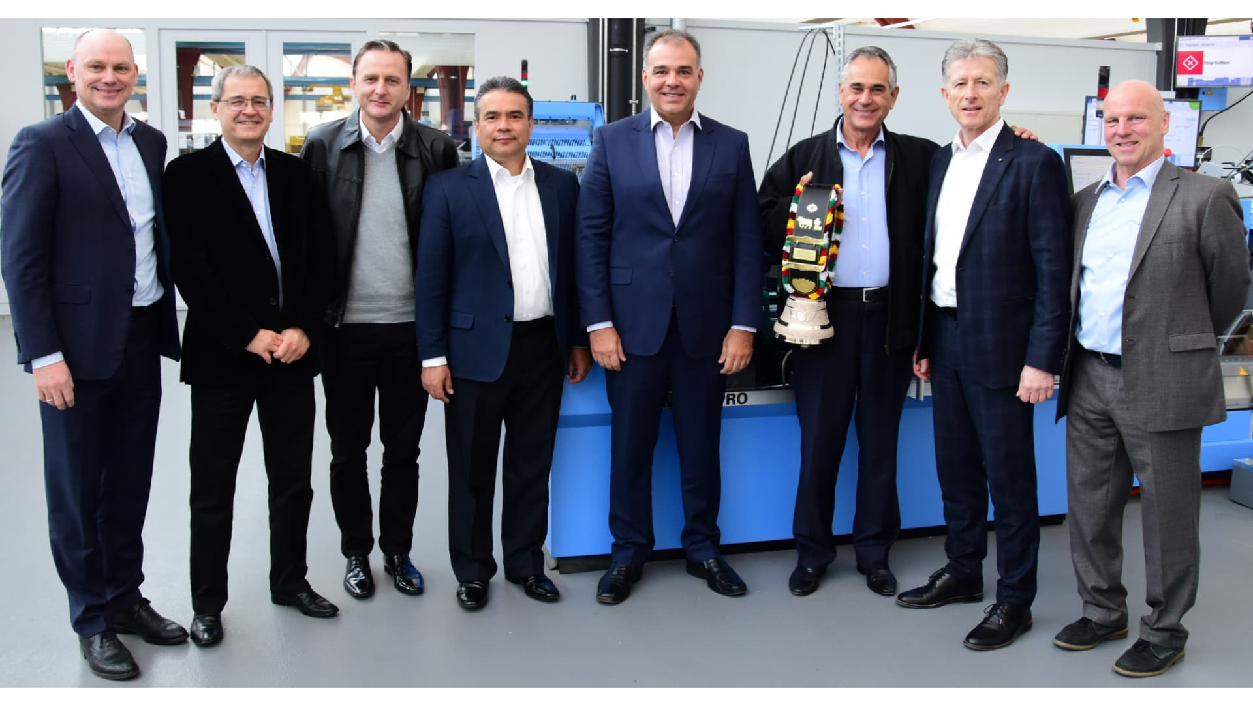
At the Print Finishing Center in Zofingen, CPB and Muller Martini sealed the sale of an Alegro perfect binder.

CPB has relied on Muller Martini and Kolbus equipment for many years – including a Vareo perfect binder with InfiniTrim three-knife trimmer, a KM 610 perfect binder, a BF 530 hardcover line and two Primera MC and Primera E 140 saddle stitchers. The latest investment in the Alegro fits in with the company's philosophy of always being at the cutting edge of technology.

Bruno Müller took the opportunity during the visit of the CPB company management – led by the new President Pastor Edson Medeiros – to the Print Finishing Center in Zofingen to celebrate the long-standing partnership between the two companies with a special honor. The CEO of Muller Martini presented José Carlos de Lima, who had recently retired, with a Swiss cowbell. The visibly moved long-time president of CPB, who is now a member of the Board of Directors, completed a storybook career from machine operator to company boss and played a significant role in ensuring that CPB has such an excellent reputation in Brazil's graphic arts industry.

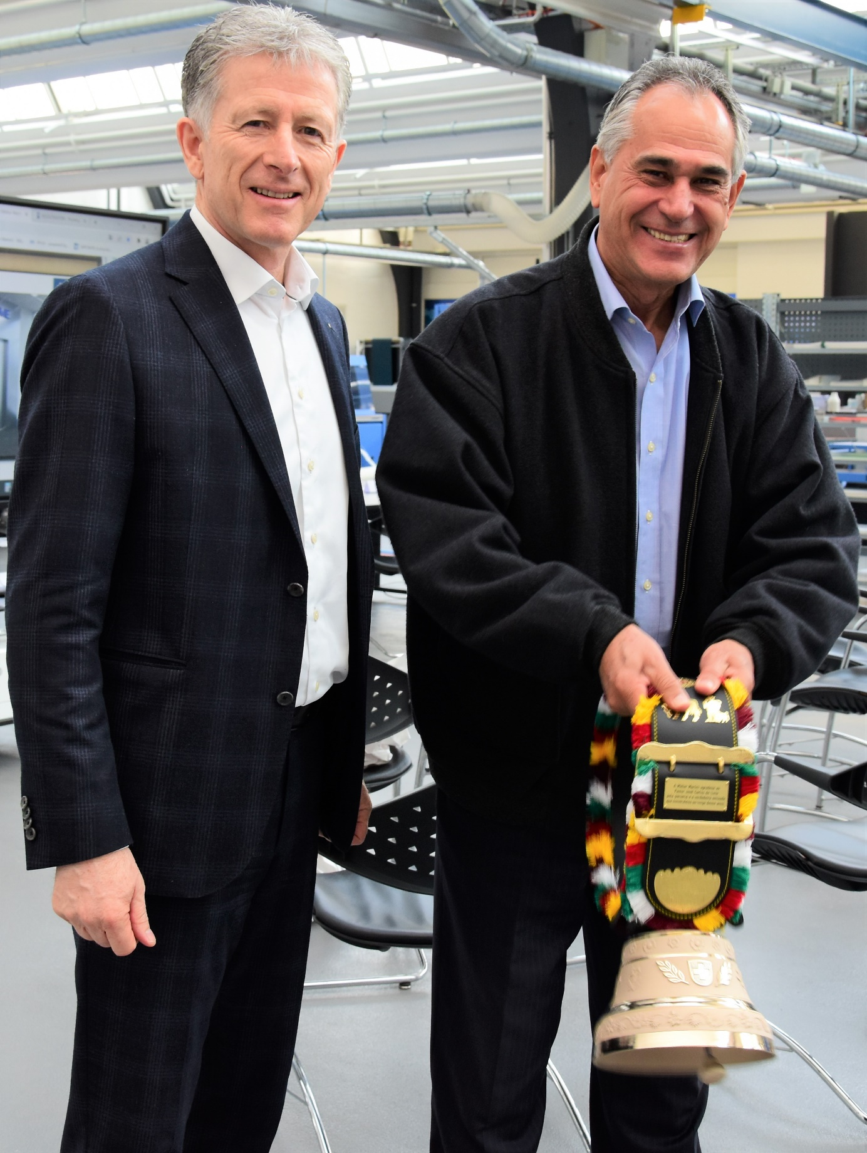
Bruno Müller (left), CEO of Muller Martini, presents long-time CPB President José Carlos de Lima with a Swiss cowbell.

