Media information

Date 21.09.2023
No. PI 2394
Number of characters 3208
Contact Müller Martini AG
Untere Brühlstrasse 17, 4800 Zofingen/Switzerland
Telephone +41 62 745 45 45
info@mullermartini.com, www.mullermartini.com

The new SigmaLine Compact: More Books per Roll

The SigmaLine Compact arrives on the market: Following last year's announcement, Müller Martini's latest innovation in digital print finishing is now available. The SigmaLine Compact enables digital roll printers to produce more end products in a smaller space with fewer staff and a lower waste rate.

With the introduction of the new SigmaLine Compact, Müller Martini is setting another milestone in digital book block production. The addition to the SigmaLine family is particularly impressive thanks to rapid changeover times. Changing the folding schemes (from 3-across to 4-across, for example) takes less than 10 seconds.

The SigmaLine Compact is variable in layout and requires a production area of just 40 m², while it also sets new standards in terms of ease of operation and low maintenance. It increases productivity and significantly reduces set-up and changeover times, thanks to the Connex workflow. Just a few metres of waste are generated during a format change; a decisive argument in view of the current high material and energy prices. With the SigmaLine Compact, Finishing 4.0 meets sustainability in the production of books, brochures and magazines.

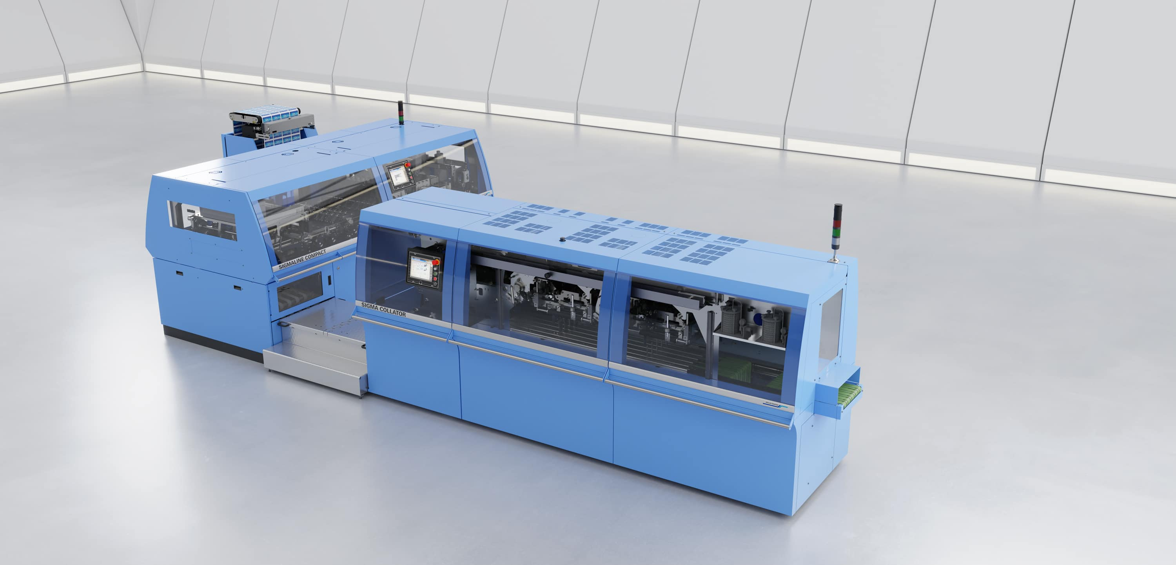
The new SigmaLine Compact covers all finishing options: Softcover, hardcover, thread sewing and saddle stitching. When operated in combination with the Connex workflow system, it takes Finishing 4.0 to a whole new level.

Designed to handle digitally printed rolls up to 22.5 inches, the SigmaLine Compact is the perfect solution for any digital printer producing pre-products for softcover, hardcover, thread sewed and saddle stitched print products in their Smart Factory. Covering all print finishing options, it sets new standards when it comes to flexibility and elevates the topic of Finishing 4.0 in conjunction with Connex to a whole new level - because the workflow system from Müller Martini ensures a fully automated production flow without manual intervention from prepress to end product. Digital printers who invest in this technology give themselves a decisive advantage: Producing more books and brochures with fewer staff in a shorter time.

The highlight of the SigmaLine Compact - which complements the tried and tested SigmaLine lll with web widths up to 42 inches - is its flexibility in book block production. While all known digital folders work with a sword, former or plow fold unit, the SigmaLine Compact uses Müller Martini's patented air knife technology for handling signatures.
"We have continuously improved the air-folding technology in recent years and use the same technology in the 22.5-inch line as we employ in the high-speed area," explains Ingolf Fritzsche. The Digital Solutions Product Manager has maintained close contact with partners in the digital printing industry for years and strongly believes that "companies operating in the digital sector have been waiting for this technology."

