Media information

Date 06.04.2021
No. PI 2294
Number of characters
ContactMüller Martini AG
Untere Brühlstrasse 17, CH-4800 Zofingen/Switzerland
Phone +41 62 745 45 75, Fax +41 62 751 55 50
media@ch. mullermartini.com, www.mullermartini.com

Current and proven machines

Muller Martini highlights at virtual.drupa 2021

At virtual.drupa, Muller Martini will be presenting the machine premieres launched during the last twelve months as well as proven systems that have been successful on the market.

In order to be able to present the new machines to customers despite travel restrictions, Muller Martini relied increasingly on new (online) channels last year. The premieres of the following machines, which will now also be shown at virtual.drupa, were celebrated in this way.

Prinova: The 9000-cycle saddle stitcher is the ideal solution for short runs, but as an all-rounder it is just as predestined for medium runs. Thanks to innovative individual feeders, the new saddle stitcher can be changed over in next to no time. In addition to motion control technology and the associated faster make-ready processes, its highlights also include the new ASIR PRO camera system developed by Muller Martini. This recognizes and compares the printed sheets using 1D/2D code and/or image comparison. Faulty end products are thus finally a thing of the past.

Primera PRO: The targeted expansion of motion control technology for the entire 14,000-cycle saddle stitcher ensures a marked reduction in job setup and throughput times and increases profitability thanks to fast and error-free setup processes. Another highlight is the completely redesigned, fully automated and variable-thickness three-knife trimmer. Thanks to servo drives, each of its format axes can be individually adjusted in the event of any corrections - without compromise and without influencing other axes.

Publica PRO: Because Muller Martini believes in the future of high-quality leaflets and brochures, a new perfect binder generation has been launched in three performance classes: 12,000 (PRO12), 15,000 (PRO15) and18,000 (PRO18) cycles per hour. The Publica PRO impresses with a high net output of top-quality products and shortest changeover times thanks to optimized processes. It also impresses with numerous innovations like new swivel-mounted touchscreens, new CoPilot system (Siemens NX), optimized clamp chain, automatic glue film length adjustment on the spine gluing unit, diagonally arranged side gluing unit discs and an optimized cover transport.

SigmaLine III: pre-gathering, variable folding, dynamic mode for cutting - the digital book block solution predestined for very short runs enables new, diverse forms of production. Until now, folding on the SigmaLine has been done using a mechanical sword. The innovative air knife technology is now used. The fold is triggered by an air pressure pulse. Thanks to the air knife, production is much more stable at high speeds. The fold becomes more perfect, and there are fewer stoppers. This ensures a significantly higher performance of the entire system of up to 1000 feet or 305 meters per minute - the highest output of digitally produced book blocks on the market. Another new feature is the dynamic cutting mode.

Proven machines
Proven machines that have been successful on the market will also be part of virtual.drupa at Muller Martini. On show will be the Vareo PRO perfect binder with end sheet feeder and InfiniTrim three-knife trimmer, the Alegro perfect binder, the Ventura MC Digital book sewing machine and the Diamant 60 bookline.

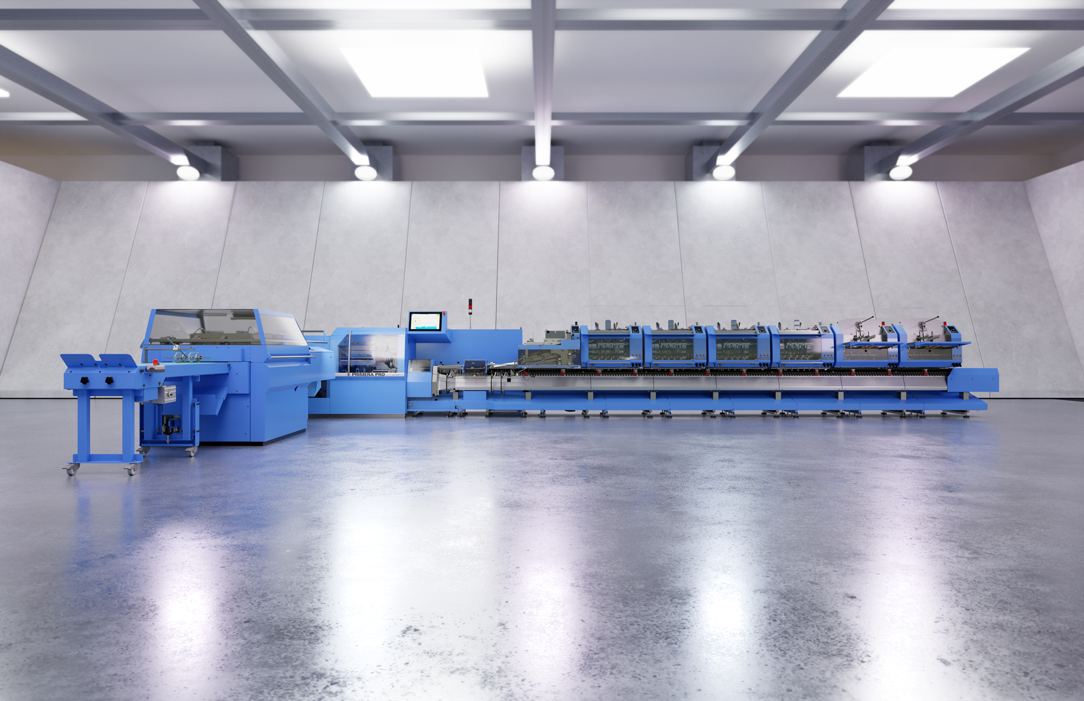

Thanks to targeted expansion of the motion control technology, the 14,000-cycle Primera PRO saddle stitcher significantly reduces job setup and throughput times and increases profitability thanks to fast and error-free setup processes.

