Media information

Date 03.03.2023
No. PI 2382
Number of characters 2573
Contact Müller Martini AG
Untere Brühlstrasse 17, 4800 Zofingen/Switzerland
Phone +41 62 745 45 45
info@mullermartini.com, www.mullermartini.com

Gremper AG Enters the Perfect Binding Market with the Vareo PRO

Gremper AG in Basel/Pratteln (Switzerland) currently has softcover products bound by partner companies. But that will change in a month's time. The family business is investing in a Vareo PRO from Muller Martini and is bringing perfect binding in-house.

According to CEO Cilgia Gremper, two important factors are prompting Gremper AG to produce perfect bound books and brochures in the medium and lower run segments in-house in the future. "On the one hand, it is of course interesting to have the entire value chain in your own books. On the other hand, a high degree of flexibility is required when dealing with customers these days, which is why short and fast routes as well as control over the entire production process suit us."

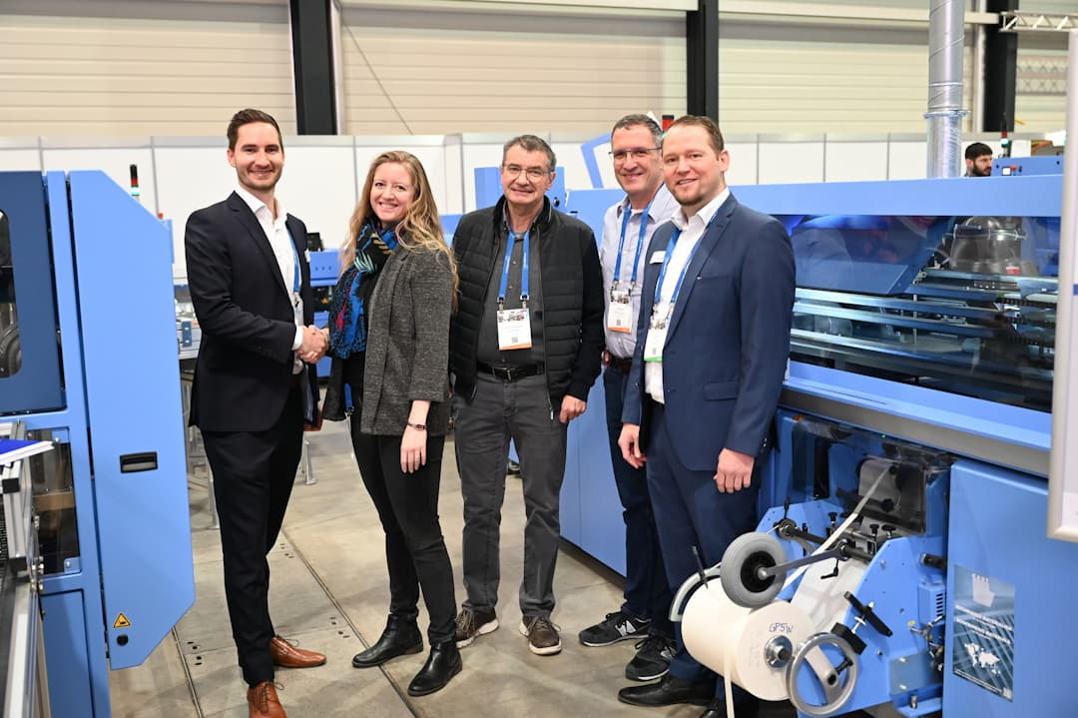From left: Pascal Ruch (Sales Manager Muller Martini, Cilgia Gremper (CEO Gremper AG), Karl Gremper (Chairman of the Board Gremper AG), Marcel Hamburger (Production Manager Gremper AG) and Georg Riva (Sales Manager for the Swiss market Muller Martini) in front of the Vareo PRO at the Hunkeler Innovationdays in Lucerne.

Because customers not only want to be served quickly, but also have high demands on the products, Gremper AG wanted a perfect binder that would meet these requirements in every respect. According to Cilgia Gremper, several technological features speak in favor of the Vareo PRO. For example, the PUR nozzle, the extensive quality controls, the glue application control, the great user-friendliness and the high level of automation. "This gives us additional security as perfect binder newcomers."

Gremper's customers want individual solutions. "Thanks to the versatile options of the Vareo PRO, we are now broadly positioned here," says Cilgia Gremper, "and can also create samples promptly and without complications – this is very valuable for extensive consulting and development together with customers."

High quality is particularly important for Gremper AG, which is active in offset and digital printing and, as of this month, produces with its own solar power, because it specializes in fine print products. For example, it has been printing on all types of paper in the world's finest FM-Staccato 10 micron screen as standard for over 15 years – high-quality image brochures as well as business stationery, mailings, miscellaneous marketing materials and packaging. The company's large customer base includes SMEs as well as major international companies from a variety of industries and renowned art and cultural institutions throughout Switzerland.

