Media information

Date 20.03.2024
No. PI 2400
Number of characters 3863
Contact Müller Martini AG
Untere Brühlstrasse 17, CH-4800 Zofingen/Switzerland
Phone +41 62 745 45 45
info@mullermartini.com, www.mullermartini.com

Müller Martini is Driving the Digital Transformation

Connex is the Key to Efficient Production
The workflow is just as important as the printing technology in the production of print products in short and ultra-short runs and book of one. With its numerous modules, the Connex system developed by Muller Martini is an important driver of digital transformation.
Repetitive tasks, in particular, should be automated as much as possible to avoid wasting resources unnecessarily as digitalization progresses rapidly. This also applies to conventional production. Even if the level of automation there is not quite as high as in smart factories, an optimal workflow solution increases the efficiency and reliability of production, reduces throughput times and minimizes error rates.

No smart factory without a workflow
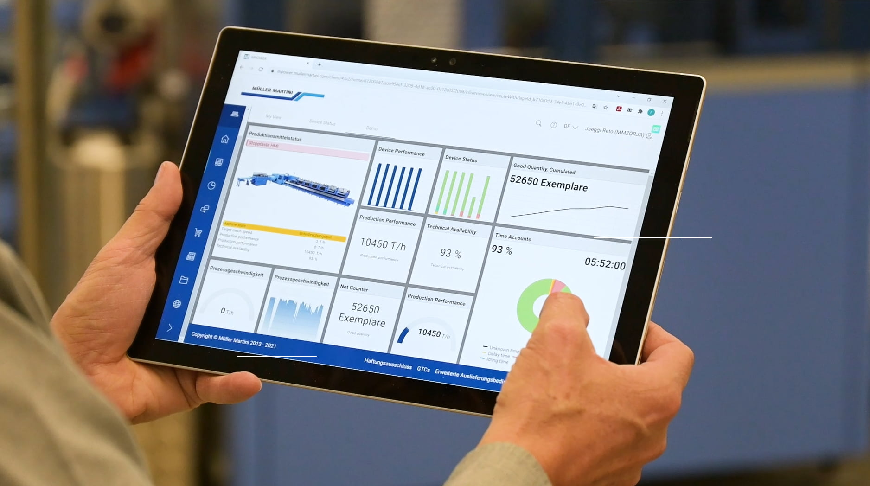
The digital transformation presents many new challenges for production companies. "You need to understand the opportunities of automation, rethink the infrastructure – in terms of focusing on the development of information technology and the use of an ERP system – build up expertise, make the right decisions regarding investment in equipment and software and overcome the 'never change a running system' mentality," says Fabian Becker, workflow expert at Müller Martini.
The dashboard of Connex Info Cloud, a module of the Connex workflow system from Muller Martini, provides a clear overview of the collected data. It can display the integrated machines and their status as well as the orders currently being processed.

The digital production of print products is inseparable from a touchless workflow. "Without this, the business model for a smart factory doesn't work - the machines have to be able to communicate with each other," emphasizes Trond Erik Isaksen, founder of Livonia Print in the Latvian capital Riga, which specializes in book production and uses over 20 Müller Martini systems. And this is where Müller Martini's workflow system Connex with its various customizable modules really shines.

Four Connex modules
Connex Line Control, an intelligent job ticket management tool, ensures flexible data integration with various ERP systems and automatically transfers production data to the production systems for printing and further finishing.

Connex ImpoWhiz, a fully automated prepress solution which carries out the correct page arrangement (impositioning) on the print web – with all the necessary marks and codes for the further finishing of high quality products.

Connex MLINK, a direct interface to the company's own Management Information System (MIS), which loads all relevant production data as JDF to the machine. The relevant production data is also send as JMF from the machine back to the MIS.

Connex Info Cloud, cloud-based data analysis tool integrated in the Muller Martini customer portal MPOWER, which is modular and can be individually adapted to each customer, supports customers in their search for optimization potential, data collection and evaluation, error prevention and planning reliability. Users access the data (production/machines) from a PC, tablet or mobile phone.

Müller Martini has a high level of consulting expertise
The experience gained in many Smart Factory projects has made Müller Martini a market leader in terms of workflow, connectivity and consulting expertise. "We are ideally prepared to support our customers with the digital transformation," says Fabian Becker. "We show customers the benefits and opportunities of automation and work with them to customize the workflow to their needs. We not only have modular finishing equipment for the cost-effective production of short runs down to run lengths of 1, but also extensive experience in the area of workflow."

Would you like to discover more about Connex? Then meet workflow expert Fabian Becker at the Müller Martini stand at the drupa, where Müller Martini will be showing four highly automated production lines integrated in the Connex workflow!

Discover more about Connex and its numerous modules in these two blogs by Fabian Becker on the Müller Martini website.

- Connex Info Cloud reduces costs and productivity increases
- Reduce manual intervention with Connex

