Press Release

Date 6/8/18
No. PI 2144
Number of characters 2382
Contact Muller Martini AG
Untere Brühlstrasse 13, CH-4800 Zofingen/Switzerland
Tel. +41 (0)62 745 45 75, Fax +41 (0)62 751 55 50
info@mullermartini.com, www.mullermartini.com

Successful open house event at Printondemand in England

Short run specialist Printondemand made a convincing presentation at its open house event in the English city of Peterborough, with its highly automated production and seamless changeovers for runs of one.

Some 70 visitors from 14 countries attended the presentation of the company’s current production line, comprised of a Screen TruePress 520 HD 1 with SC Ink, a Hunkeler book block line, the Vareo perfect binder and InfiniTrim three-knife trimmer inline duo from Muller Martini. “The fact that so many overseas visitors travelled to attend this presentation, is a clear sign that interest in inline solutions for the production of runs of one continues to rise,” says David McGinlay, Sales Manager at Muller Martini Great Britain, who answered many questions asked at the open house event about the equipment. “This confirms our decision to proceed with our Finishing 4.0 strategy, which we are using to make ourselves a strong partner for efficient solutions in the short-run segment.”

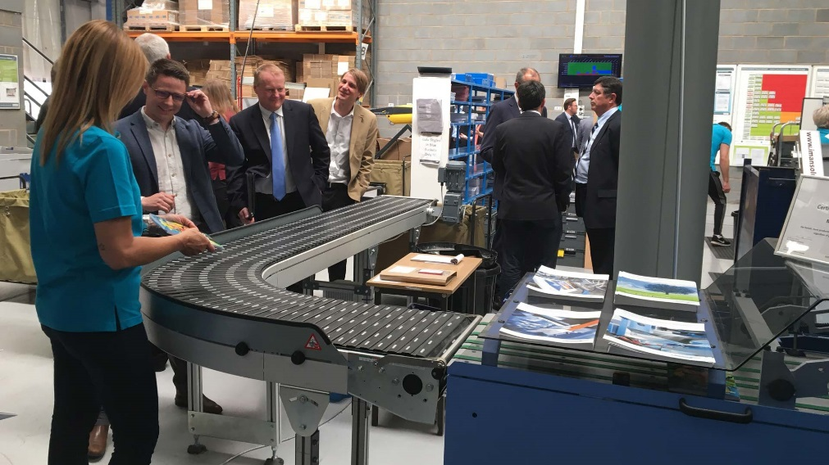
The live presentations at the open house event of Printondemand-worldwide.com – the Muller Martini InfiniTrim three-knife trimmer is pictured – was an exciting event for the people who attended from 14 different countries.
After the individual manufacturers had presented the technical highlights of their machine solutions in the morning session of the open house event, the visitors separated into two groups to visit the production hall to see the equipment under production conditions. “The production equipment presented here at the open house is groundbreaking,” said one excited visitor after the presentation.

It is groundbreaking because the inkjet printing press from Screen is the first that can print wood-free, coated paper; all of the other printing presses need specially coated paper. In addition, Printondemand, which was founded in 1995 and employs 65 people, uses the Vareo/InfiniTrim inline duo for its softcover production. “With the Vareo perfect binder and the InfiniTrim three-knife trimmer, we have a perfect touchless workflow environment,” says Andy Cork, founder and managing director of Printondemand-worldwide.com, as he accepted the Finishing 4.0 award from Muller Martini earlier this year. “Finishing 4.0 is our future. The fewer manual interventions, the better and the less likely there will be errors.”

