Press Release

Date: 18.09.2017
No. PI 2113
Number of characters 3983
Contact Muller Martini AG
Untere Brühlstrasse 13, CH-4800 Zofingen/Switzerland
Tel. +41 (0)62 745 45 75, Fax +41 (0)62 751 55 50
info@mullermartini.com, www.mullermartini.com

Open House at Resl in the Czech Republic –
a Showroom for the Future

In collaboration with Muller Martini Eastern Europe GmbH, D.R.J. Tiskárna Resl held an open-house event at its production site in the Czech town of Náchod. Some 200 visitors from the Czech Republic, Poland, Romania, Slovakia and Hungary could see for themselves the quality and productivity that the company is able to achieve with Muller Martini and Ryobi solutions.

The production hall at Tiskárna Resl is breathtaking. The company’s bookbindery is extremely broadly positioned, covering the whole range of bookbinding techniques, from wire-stitching through to thread sewing and perfect binding in both the softcover and hardcover segments. The presence of so many Muller Martini machines in distinctive laserblue gave visitors the impression of being in a showroom of the Swiss manufacturer, with the added advantage that they could observe real production processes and talk with the staff as colleagues in the industry.
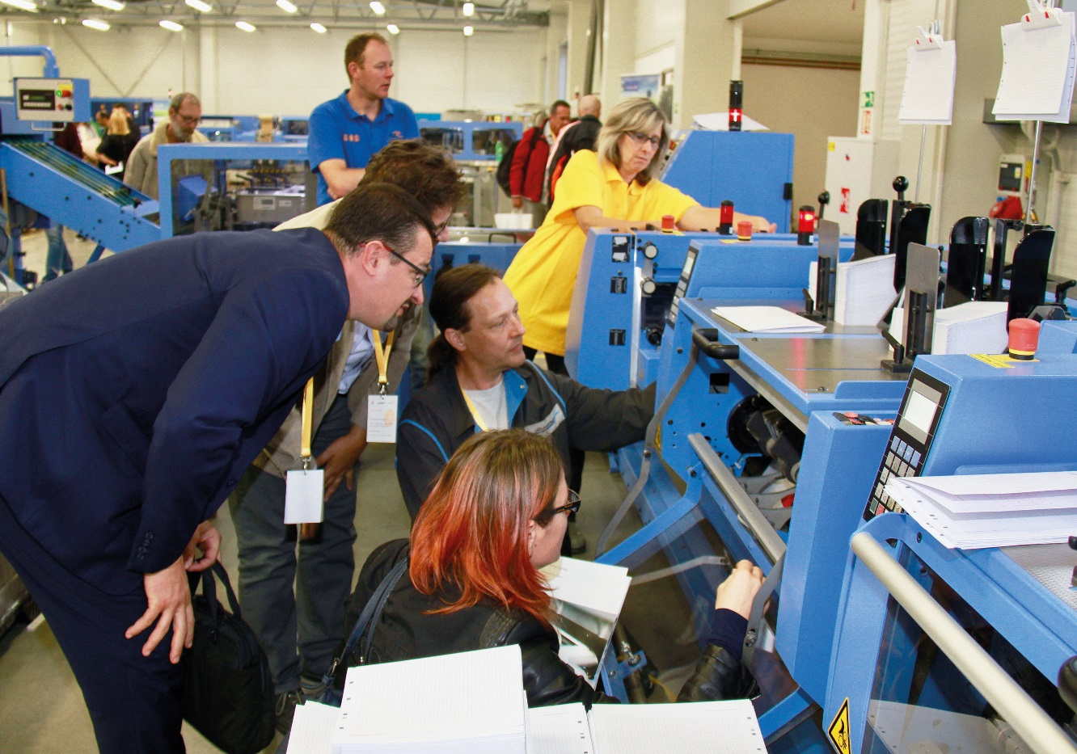
Some 200 visitors took advantage of the opportunity to learn in depth about the various Muller Martini solutions at the open-house event at Tiskárna Resl.

It is not without good reason that there are so many machines of the Swiss machine manufacturer at the plant. In 2013, D.R.J. Tiskárna Resl, as a relatively small commercial printing plant, asked itself how to make the company fit for the future. Muller Martini came on board as a partner and, together with D.R.J. Tiskárna Resl, developed a long-term growth strategy to take the company’s printing and print finishing to a new performance level. “Our wide range of production options under one roof certainly makes us one of the most capable printing plants in the Czech Republic. Working together with our sister company Resl Transport, we can respond extremely flexibly to market requirements,” says Managing Director Jiři Resl.

There is no mistaking the fact that D.R.J. Tiskárna Resl is a growing company. In December, another Ryobi printing press with four A1 printing units will be installed, giving the company a total of eight B2 printing units and twelve B1 printing units. In Eastern Europe, Muller Martini is a distribution partner for Ryobi, making such projects easier for everyone concerned. Jiři Resl says that the company’s expectations of the new concept have been fully met. Thanks to easy operation of the Muller Martini systems and short set up times, D.R.J. Tiskárna Resl’s competitiveness has increased rapidly.

Word of that has got around both within the Czech Republic and further afield, prompting many of the visitors to travel as far as 1,000 kilometers to the open-house event. Artur Chęsy from the Polish printing plant Drukarnia Pozkal is always on the lookout for new ideas. “Efficiency is key on the tough book production market. I came away from the open-house event with some valuable suggestions for our plant.”

Read Me in Warsaw is set to invest in another perfect binder in 2018. The company has used a Muller Martini Acoro-A5-perfect binder for ten years now. Currently, Read Me Managing Director Włodzimierz Bińcyzk is looking for a perfect binder with a higher degree of automation. The open-house event at Resl gave him the opportunity to take a closer look at the Alegro perfect binder, which offers precisely such capability. “We need a perfect binder with short setup times that delivers higher productivity even for short runs. Judging by what I saw at the open-house event, the Alegro might be just what we’re looking for.”

The over 200 visitors took advantage of the whole-day event to learn in depth about the various Muller Martini solutions. Luboš Kunze, Managing Director of Muller Martini Czech Republic, was delighted by the great success of the open-house event. “A partner like D.R.J. Tiskárna Resl is a stroke of luck for us because we can showcase our entire range for bookbinderies in a real production environment.”

Further images of the open-house event at Resl can be found here.

