Press Release

Date 27.06.2017
No. PI 2093
Number of characters 1976
Contact Muller Martini AG
Untere Brühlstrasse 13, 4800 Zofingen, Switzerland
Tel. +41 (0)62 745 45 75, Fax +41 (0)62 751 55 50
info@mullermartini.com, www.mullermartini.com

Andi Druk – the 4.0 World Premiere

Thanks to an integrated inline solution involving Muller Martini print finishing systems, Andi Smart Print Solutions in Maastricht is on track to produce increasing numbers of digital on-demand products.

The Dutch company, which was previously known as Andi Druk, is full of confidence in paper, even in the digital era. However, the company owners, who were inspired by the fully connected drupa machine line-up of their long-standing partner Muller Martini, appreciated that their industry needs to invest to ensure the continued success of print products. The new machine configuration is a world premiere. The paper goes inline from a Canon inkjet web printing press to a SigmaLine digital book block production line, and then on to a Vareo perfect binder or a Presto II Digital saddle stitcher.
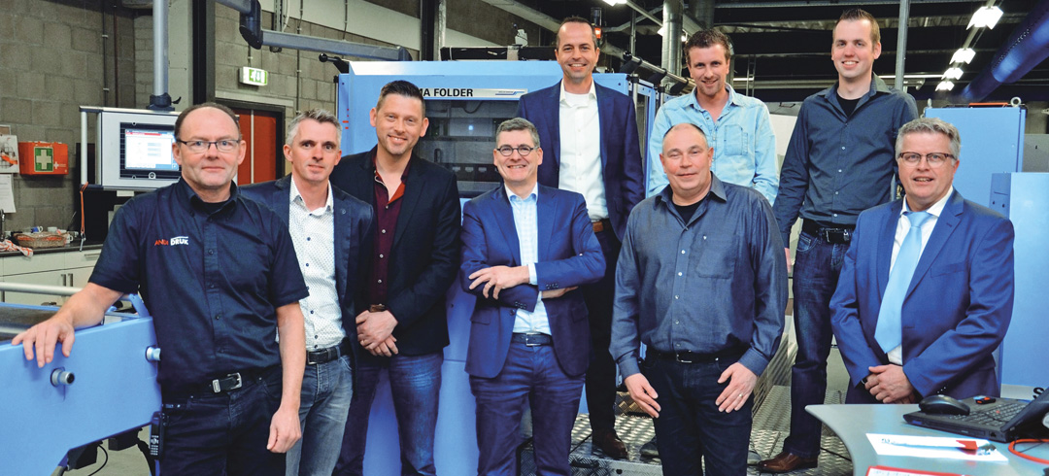

The Andi team with co-owners Frits Keulen (fourth from the left) and Dave Kremer (second from the left), and Enno Smid (far right), Sales Manager at Muller Martini Benelux.

“Our innovative solution makes us unique in the Netherlands,” say the two directors, Frits Keulen and Dave Kremer, with rightful pride. A single machine operator takes care of seamless production from the roll to the finished product. From the Océ ColorStream 3900, the paper web enters the SigmaFolder, where it is processed into individual signatures. There are then two alternative paths: either the signatures enter the SigmaCollator, the Vareo perfect binder and the Granit three-knife trimmer, or the Presto II Digital saddle stitcher.

Connex was a key factor in the investment decision of the co-owners. The data and process management system enables a seamless workflow, which embodies Muller Martini’s key drupa topic of “Finishing 4.0”. With Connex, Andi Smart Print Solutions has laid the groundwork for digital production of the majority of magazines, books, manuals, operating instructions and brochures in the run segment of 50 to 10,000 copies in the future.

