Press Release

Date 07/18/2017
No. PI 2095
Number of characters 1923
Contact Muller Martini AG
Untere Brühlstrasse 13, 4800 Zofingen, Switzerland
Tel. +41 (0)62 745 45 75, Fax +41 (0)62 751 55 50
info@mullermartini.com, www.mullermartini.com

A Bookline as a Life Line

Acabamentos Gráficos in the Portuguese city of Porto is entering the digital future with a Diamant MC 35. The Muller Martini bookline has played a defining role in the career of the company founder.

When he was younger, Alípio Ascenção used a Diamant while working as a machine operator for another business. Now he is the proud owner of a fully automated Diamant MC 35 bookline. However, he did not make the purchase for sentimental reasons alone. Instead his investment decision was clinched by numerous special features such as Motion Control Technology, Smart Press Technology at the joint forming and pressing machine, control systems, ease of operation and online assistance through MMRemote in the case of malfunctions.
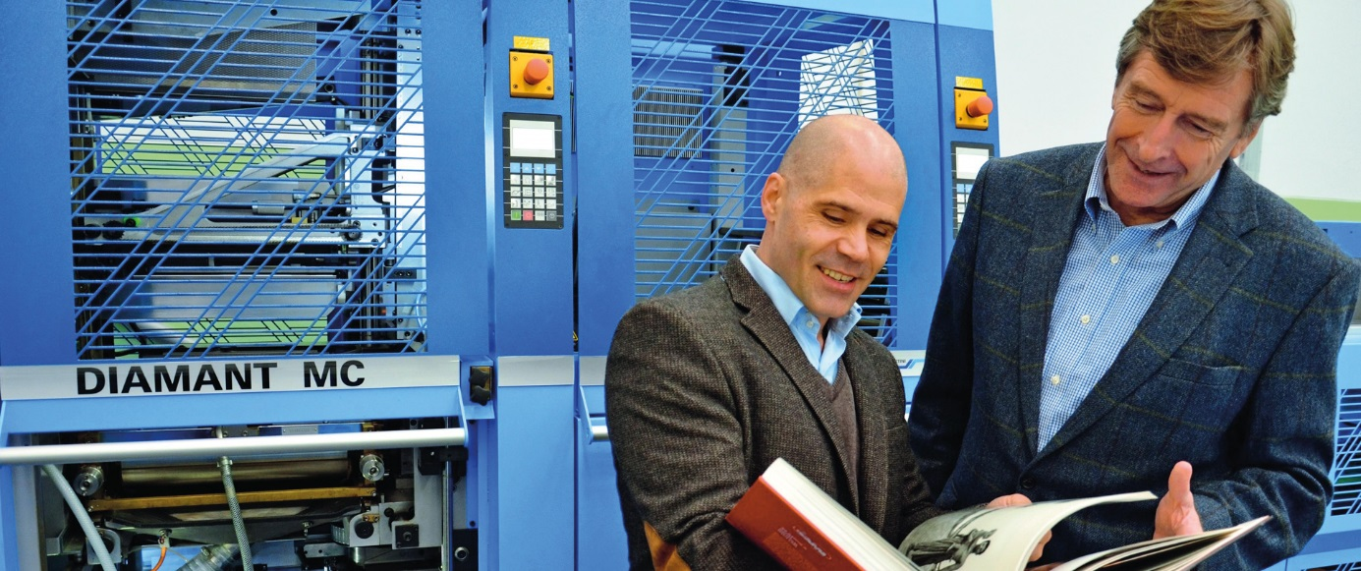

Company owner Alípio Ascenção (left) with Miguel Bos from the Portuguese Muller Martini agency MaxiTrade & Consultoria jointly admire a product that has been produced using the Diamant MC 35.

“With the Diamant MC 35, I’m ready for the digital future,” says Alípio Ascenção, emphasizing another advantage of the new acquisition. Currently, digitally produced book blocks account for just under five percent of production at Acabamentos Gráficos. However, Alípio Ascenção is convinced that the proportion of digitally produced products will rise considerably in the future. He succeeded in entering the hardcover business thanks to regular customers that praise the high quality of his products and the low density of hardcover lines in Portugal.

The print finishing business, which has a staff of six people, built a new hall when it invested in the Diamant MC 35 along with a book stacker and casing-in machine. For Alípio Ascenção, who has been working in the graphic arts industry since the age of 14, print finishing is the pinnacle of his business career, which has taken him from lamination to folding, wire binding, saddle stitching, perfect binding and thread sewing.

