Press Release

Date 25/07/2019
No. PI 2211
Number of characters 2697
Contact Muller Martini AG
Untere Brühlstrasse 13, CH-4800 Zofingen/Switzerland
Tel. +41 (0)62 745 45 75, Fax +41 (0)62 751 55 50
info@mullermartini.com, www.mullermartini.com

Open house event at Muller Martini in Japan attracts an interested crowd

The some 50 visitors to the open house event in Japan were visibly impressed by the live demonstration of the Primera MC saddle stitcher and the associated possibilities in increasing the level of automation. Additionally, they also found out more about cell production in perfect binding and the Connex workflow system in a series of specialist talks.

During the live demonstrations on the Primera MC saddle stitcher, visitors could follow on two large screens how the production processes are controlled and monitored via Connex.LineControl and Connex.Info. “Solutions for all aspects of networked processes and production analyses are becoming increasingly popular among our Japanese customers,” confirmed Takashi Gotanda, Managing Director of Muller Martini Japan, after the event. “As a result, the possible uses of our Connex workflow system generated some interesting discussions and concrete inquiries at the open house event.”

In order to demonstrate the numerous possibilities and benefits of automation following the saddle stitching process to the customers at the event, the Primera MC saddle stitcher was set up in the showroom at Muller Martini Japan in an inline configuration with a compensating stacker, labeling machine from ATS Tanner and a local bundle film wrapper. Also on show here were two 3738 stream feeders, the Asir 3 system used for quality checks in image and barcode recognition, the Semko lateral thickness control, Smart Stitch Control and a TrimWatcherPlus for inspecting the products following trimming. These exact quality controls and automation equipment are enable to run the machine by one operator.

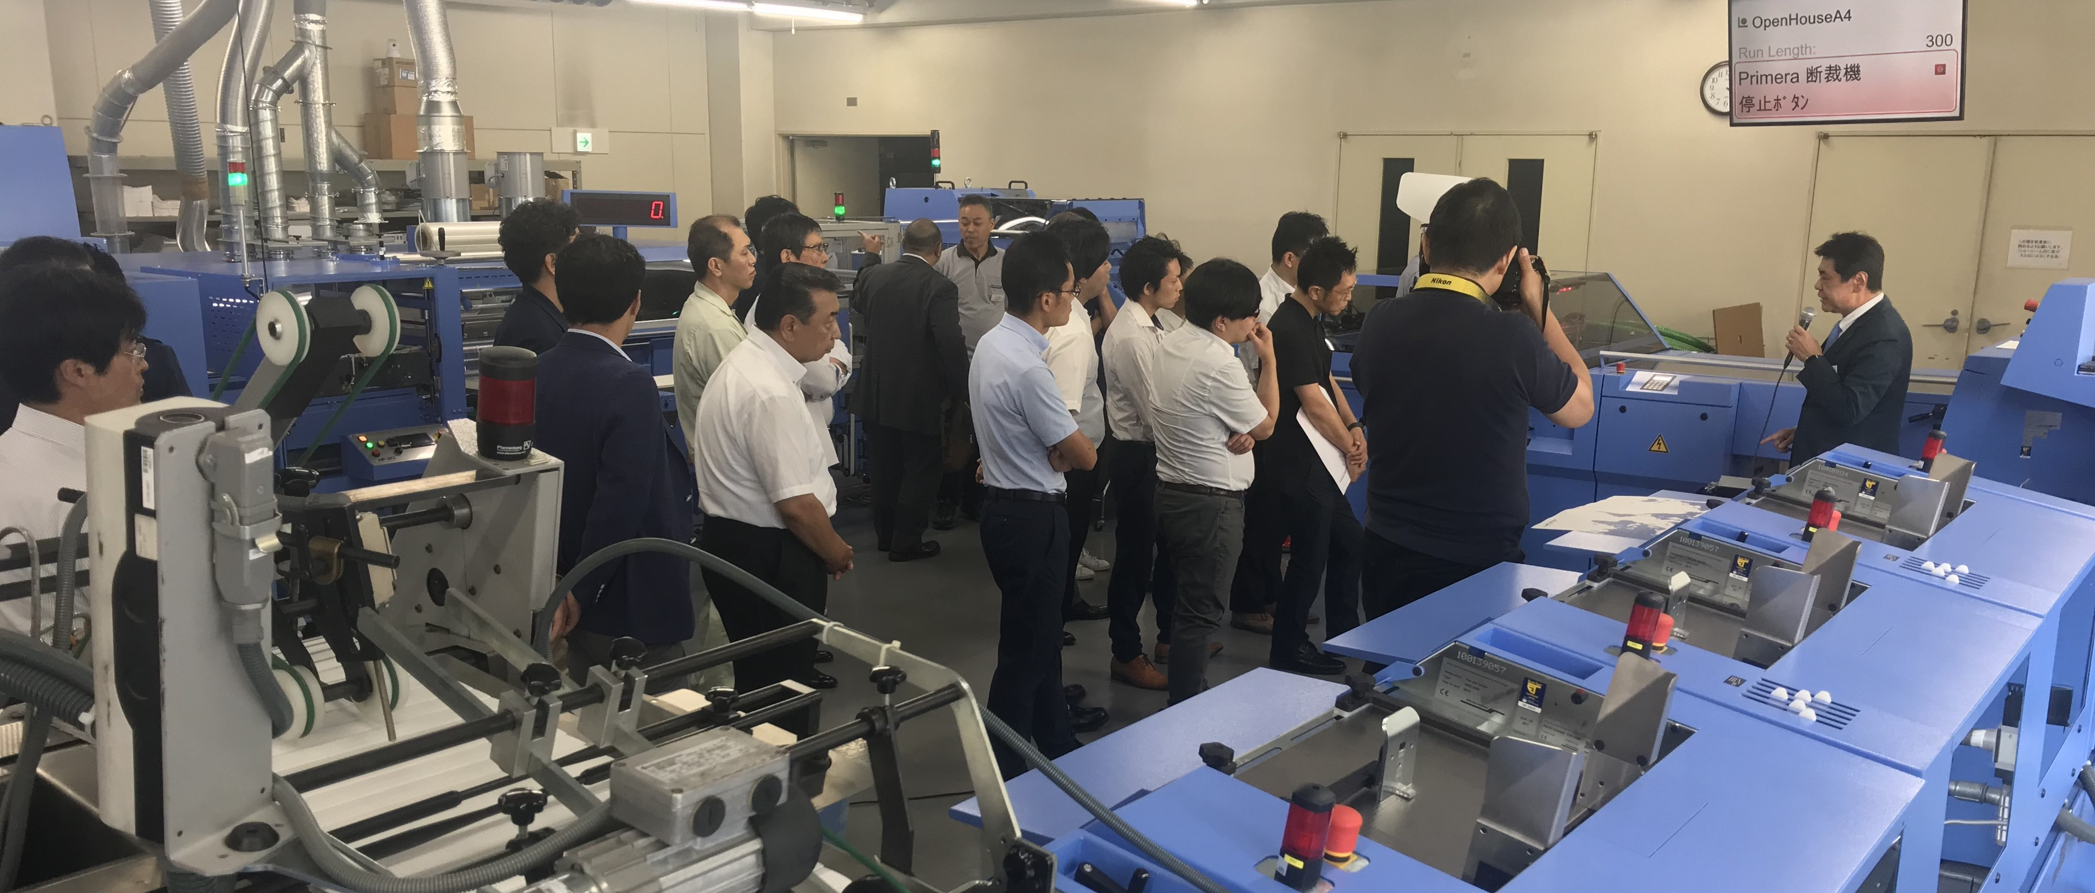
At the open house event hosted by Muller Martini Japan, the some 50 visitors saw at firsthand the many possibilities and benefits offered by increased automation via a live demonstration on the Primera MC saddle stitcher.

In a series of interesting talks, visitors gained a detailed insight into the comprehensive finishing options offered by a Primera MC. For example, they were surprised to see that a palletizer can also be connected in an inline configuration.

The presentation of the smart factory for the production of ultra-short runs and book-of-one productions in perfect binding also generated some major interest. The fact that Muller Martini can also implement decentralized production with smaller production cells thanks to the Vareo perfect binder and InfiniTrim three-knife trimmer is absolutely unique, and is also a very interesting prospect for customers in the Japanese market – which is also characterized by decreasing run sizes with an increasing number of titles.

