Press Release

Date 10.10.2019
No. PI 2216
Number of characters 2176
Contact Muller Martini AG
Untere Brühlstrasse 17, CH-4800 Zofingen/Switzerland
Tel. +41 (0)62 745 45 75, Fax +41 (0)62 751 55 50
info@mullermartini.com, www.mullermartini.com

Mastering Inserts More Flexibly

With the FlexLiner, its second newspaper inserting system from Muller Martini, Moser Holding AG, located in Innsbruck, Austria, is in an even better position to finish various products.

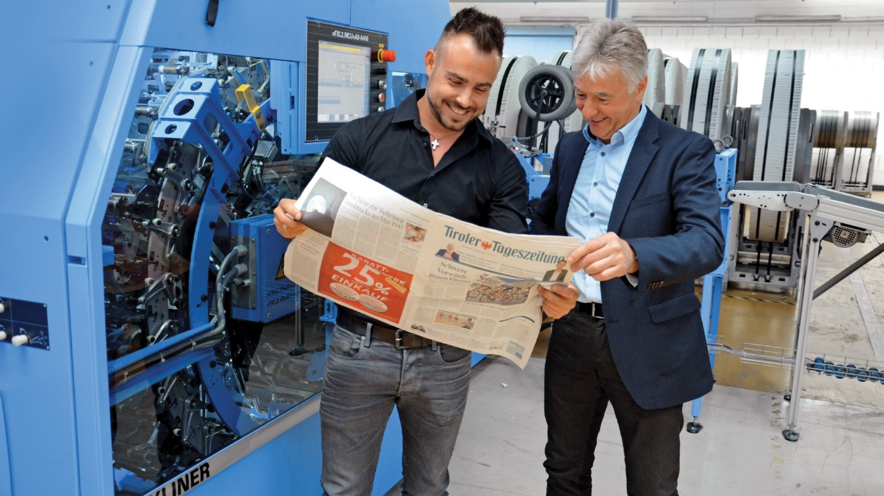
In addition to the “Tiroler Tageszeitung,” which is printed seven times a week in runs of 100,000 to 120,000, the printing company used to process weekly newspapers as well as products from commercial customers using a single inserting system. The NewsLiner, which dates back to 2003 and has eight stations as well as a promo feeder, did its best, but the preprinted local sections of the daily newspaper as well as the numerous commercial inserts that were added to the jacket pushed the operation to the limits. Since last January, the company has been using a new FlexLiner with 12 stations to produce regional newspapers with a run of around 330,000 copies.

Daniel Marent (left): “With the FlexLiner, we have become more flexible and enjoy high levels of reliability.” Pictured right is Gerhard Urban (Sales Manager Muller Martini Eastern Europe).

“By producing our two newspaper types on two separate systems while also being able to switch to a single system in critical situations, we have become more flexible and enjoy high levels of reliability,” concludes Daniel Marent, Assistant to the Managing Director, looking back at a positive first few months of operation. The FlexLiner also makes it possible to automatically add more inserts to the weekly newspaper published each Wednesday than was previously the case.

The sword opening also makes it possible to insert trimmed inserts without a low folio lap. These high-quality inserts are a specialty of Moser Holding AG. Like the NewsLiner, which was retrofitted in 2013, the new FlexLiner is equipped with an integrated card gluer that is regularly in use and allows for additional advertising opportunities. The fact that difficult inserts are no problem for the PX feeder on the FlexLiner turned out to be another major advantage this year. The new investment is also practical because the bundles formed by the two FlexPack systems are sent to the same ramp as the end products from the NewsLiner.

