Press Release

Date 07.11.2019
No. PI 2228
Number of characters 3159
Contact Muller Martini AG
Untere Brühlstrasse 17, CH-4800 Zofingen/Switzerland
Tel. +41 (0)62 745 45 75, Fax +41 (0)62 751 55 50
info@mullermartini.com, www.mullermartini.com

“We are consciously conveying a sign of strength”

Implementation of new ideas, faster setup, high end product quality in all print runs, quieter production – when the Acoro A7 perfect binder is retired at bookbindery An der Reuss in Lucerne in a couple of weeks and is replaced with an Alegro A7 the traditional Swiss company will be able to play several trump cards and live out its print finishing dreams.

The family company, which was founded in 1946 and now run by Urs Dietrich (Head of Sales), Hansjörg Dietrich (Head of Operations & Technology) and Catherine Dietrich (Controlling & Human Resources Administration), was one of the first bookbinderies in Switzerland to have a perfect binder. “Perfect binding is one of our traditions,” says Hansjörg Dietrich. The bookbindery has been in the hands of the Dietrich brothers since 2002.
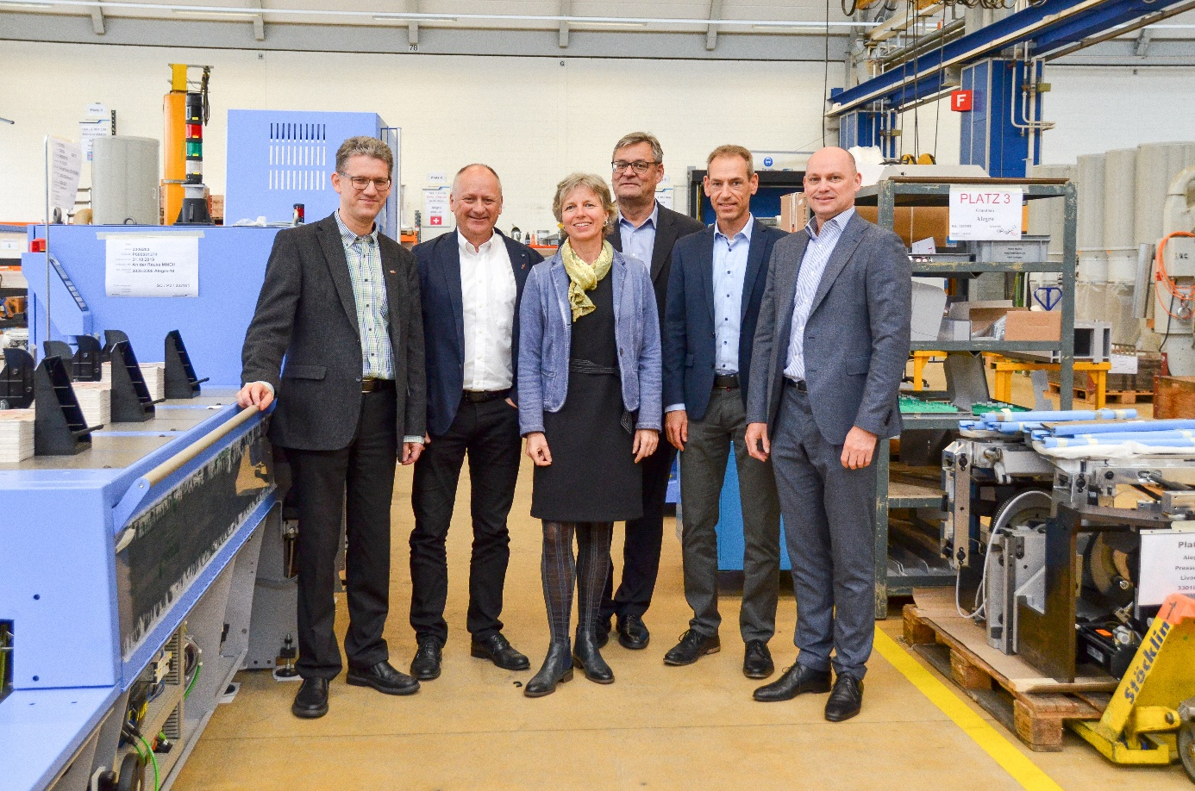
From left: Urs Dietrich, Hansjörg Dietrich, Catherine Dietrich (all of An der Reuss), Hans Leuenberger, Ralph Zängerle and Volker Leonhardt (all of Muller Martini) at the Muller Martini plant in Zofingen, where the Alegro is built.

The company’s partnership with Muller Martini has also been traditionally close. “In view of the proximity of our company to Muller Martini’s headquarters, we’d need good arguments not to invest in Muller Martini equipment,” says Urs Dietrich with a grin. In addition to the Primera E140 saddle stitcher and a Ventura thread sewing machine, An der Reuss currently has an Acoro A7 for the softcover segment as well. After 14 years of double-shift service, this latter machine will be replaced between Christmas and New Year by an Alegro A7 with a 3694B gathering machine (with 21 stations), a VPN/SPN nozzle, an AMS glue application control console, a Book Data Center (BDC), ANSY, a mull feeder and a new conveyor belt. In addition, the Merit three-knife trimmer and CB 18 book stacker will be taken from the current machine and added to the new one.

“The Acoro was an old machine,” says Hansjörg Dietrich, “but the Alegro is the most complete and most versatile machine for perfect binding specialists. With the Alegro, we’ll be able to work together with our excellent team and our many additional modern technologies to make our print finishing dreams come true. The mull feeder, for example, will allow us to put new ideas into practice that were previously not possible.”

In addition to the other advantages – faster setup and faster achievement of the desired production speed thanks to the BDC network, quieter production thanks to the new rotation accelerator on the gathering machine, reliable control systems for high end product quality in all print runs – with its investment in the new perfect binder, An der Reuss is also consciously conveying a sign of its strength in what is not an easy time for the graphic arts industry. And this sign is intended for several audiences, as Catherine Dietrich notes: “In relation to the Swiss market, where we want to underscore our leading position. Our customers, for whom we are proud to make cultural assets. And, of course, internally to our 40 employees, by showing them that we believe in the future of our company and our industry.”

