Press Release

Date 03.08.2018
No. PI 2150
Number of characters 1948
Contact Muller Martini AG
Untere Brühlstrasse 13, CH-4800 Zofingen/Switzerland
Tel. +41 (0)62 745 45 75, Fax +41 (0)62 751 55 50
info@mullermartini.com, www.mullermartini.com

Pantera Allows for In-house Perfect Binding

Thanks to its Pantera perfect binder, German printing and media service provider BWH now produces all of its print products in-house, which has boosted its added value.

Although it is now an all-round publishing company, BWH’s passion, since it first received approval from the British occupation forces in 1945, has been printed newspapers, magazines and commercial products. Previously, its print finishing activities focused on saddle stitching. However, the company’s investment in a Pantera from Muller Martini now allows the in-house production of perfect bound orders as well, which were previously completed externally. The quick and simple changeover process during production was the main reason the company purchased the machine.

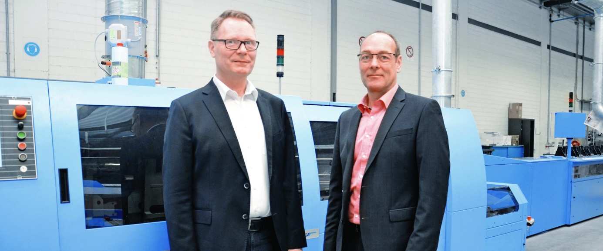
BWH Managing Director Thomas Masselink (left): “The Pantera is ideally suited to our run sizes.” Right: Matthias Kandt, Area Sales Manager at Muller Martini Germany.

The, traditional printing business, with its increasingly tight windows and price pressure, has made the flexible perfect binder indispensable for the northern German company. “Currently, the Pantera is ideal for our run sizes, but if our production and capacity utilization increase, it can be replaced with a more powerful Alegro without needing to make major changes to the system,” says Managing Director Thomas Masselink, noting one option.

BWH’s extensive new softcover system consists of a 3692 gathering machine with Asir 3 signature control, a divert gate, a Pantera perfect binder with Amrys, manual feed (for example, for digital printing or ultra-short runs), a hotmelt spine glue station, a PUR nozzle system, hotmelt side gluing, a Granit three-knife trimmer and a Uno stacker. The ^{MM}Remote capability of the perfect binding line, which allows Muller Martini’s experts to access the machine from the plant, ensures the greatest possible production reliability.

