Press Release

Date 19.10.2017
No. PI 2110
Number of characters 1997
Contact Muller Martini AG
Untere Brühlstrasse 13, CH-4800 Zofingen/Switzerland
Tel. +41 (0)62 745 45 75, Fax +41 (0)62 751 55 50
info@mullermartini.com, www.mullermartini.com

A Leap Ahead with the FlexLiner

LR Medienverlag und Druckerei GmbH in the city of Cottbus in eastern Germany has invested in the FlexLiner inserting system to cut costs and become more flexible.

By investing in the Muller Martini solution, the media company in the Lusatia region has revolutionized the insert process for its daily newspaper (run size of 80,000) and its two weekly advertisement papers (with run sizes of 226,000 and 250,000 respectively). The three titles, which are currently being produced in a total of 172 million copies per year, contain three times as many inserted products as in 2013. The FlexLiner is ideally suited to such print runs and insert volumes, and is seamlessly integrated into the whole production chain thanks to the Connex.Mailroom control system.

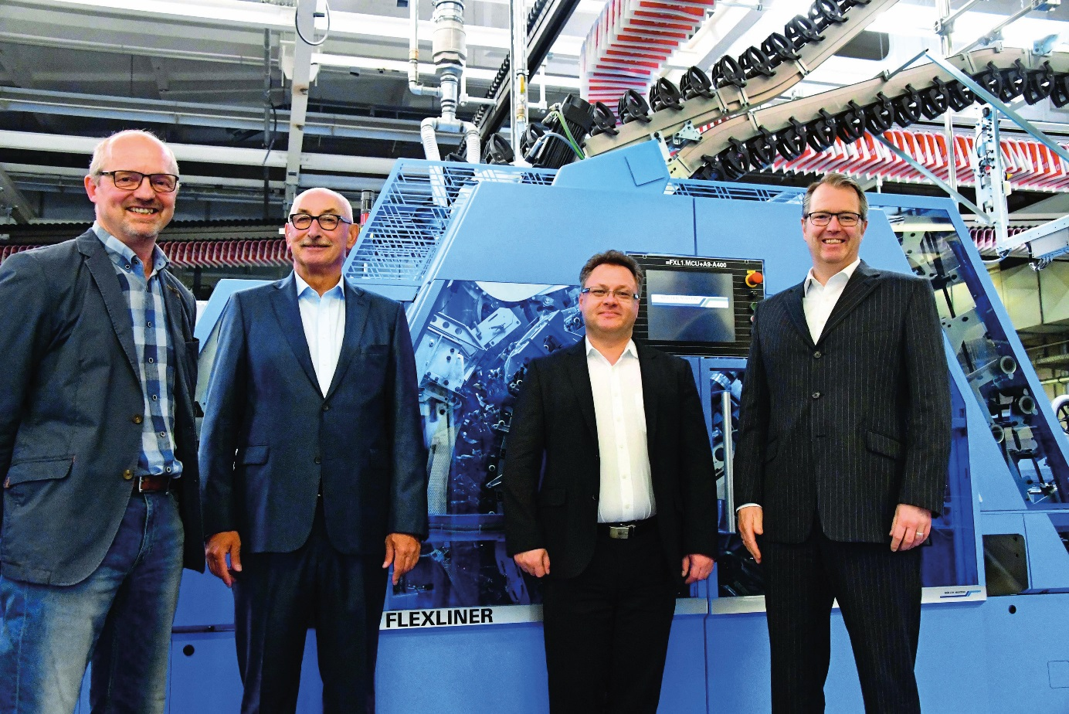
From right to left: Clemens Braun (Managing Director), Andreas Bonow (Commercial Manager), Reinhold Achtner (Sales Manager at Muller Martini Germany) and Frank Käppler (Works Manager) in front of the new FlexLiner at LR Medienverlag und Druckerei GmbH.

The optimal price-performance ratio clinched the decision of the publishing company in southern Brandenburg to switch from another supplier to Muller Martini. “The FlexLiner provides the optimal balance between the potential reduction in production costs and the investments required to achieve that,” says Commercial Manager Andreas Bonow. The FlexLiner enables quantum leaps in terms of the make-up of products and loading of the jacket with heavy inserts.

Connex.Mailroom enables short turnaround times and production runs with detailed zoning, i.e. with a large number of local editions and numerous insert zones. At the plant in Cottbus, a NewsGrip F conveyor is used to convey the newspapers directly from the printing press to the inserting system, which is equipped with 20 feeders, including mini feeders for the efficient feeding of inserts. The mailroom line also includes a NewsStack compensating stacker and two FlexPack bundle processing systems.

