Press Release

Date 12.09.2018
No. PI 2155
Number of characters 2550
Contact Muller Martini AG
Untere Brühlstrasse 13, 4800 Zofingen, Switzerland
Tel. +41 (0)62 745 45 75, Fax +41 (0)62 751 55 50
info@mullermartini.com, www.mullermartini.com

Successful Partnership Continues

Thanks to its healthy order situation, J. Thomson Colour Printers Ltd. in the Scottish city of Glasgow has again opted for solutions provided by its long-standing partner Muller Martini and is set to commission two new print finishing systems in November – a new Alegro perfect binder will replace an Acoro, which was installed in 2012, and a Primera MC saddle stitcher will replace a Primera E140, which was commissioned in 2009.

“We have a very robust investment policy and even although both machines were still performing to an acceptable level we felt that it was time to upgrade our finishing capabilities. It made sense therefore to look at a deal which involved replacing both machines at the same time,” says Managing Director Kevin Creechan. “When evaluating the new Muller Martini systems we recognized that there was a good synergy between what we needed and what the equipment could do,” he adds. Muller Martini and J. Thomson have a close and long-lasting partnership and the Muller Martini systems have continually proved to be the “best on the market” (in Kevin Creechan’s words) over the years. J. Thomson Colour Printers put considerable effort into the search for new solutions.

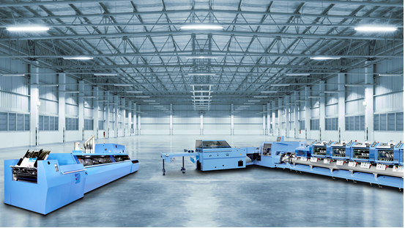
From November, J. Thomson Colour Printers will use an Alegro perfect binder and a Primera MC saddle stitcher.

“We considered all available alternatives,” says Kevin Creechan. “However, we concluded that the Muller Martini option was the best match for our production profile. The Scottish company, which was founded in 1952 and employs some 120 people, prints a wide range of magazines, tourist brochures, art catalogues, football programs, annual reports, timetables, calendars, pamphlets for the education sector, government documents, and products for the healthcare sector.

In perfect binding the average job has a run of around 4,000 to 5,000 copies, while in saddle stitching run sizes of between 5,000 and 10,000 copies are the norm however the run lengths vary from 100 to 1 million plus. As the market is changing the plant in Glasgow is increasingly producing short runs, especially in the softcover segment, as J. Thomson has digital printing to complement it’s litho offering. In future, it will also produce short runs of as little as ten copies using the Alegro – the Muller Martini perfect binder, which satisfies the high requirements in offset and digital printing and print runs of all sizes thanks to its cutting-edge, innovative drive and control technology which allows it to master such jobs with ease.

